Steps to Take if You Suspect a Harmful Algal Bloom
USU Water Quality Extension – Utah Division of Water Quality
Introduction
What are harmful algal blooms?
Harmful algal blooms (HABs) are large growths of cyanobacteria that change the water color or form surface scums, and occur in lakes, reservoirs and ponds. Cyanobacteria blooms are occurring more frequently in Utah, likely in response to increased nutrients and a warmer climate. These tiny plant-like bacteria can produce deadly toxins that are harmful to humans, livestock and pets.

For up-to-date info on algal blooms, including toxin levels check habs.utah.gov

Program overview:
USU Water Quality Extension and Utah Division of Water Quality are collaborating to supply microscopes and cyanotoxin test strips used to verify potential blooms and evaluate their toxicity.

Part of this program involves training people who commonly visit water bodies – state park employees, conservation districts, extension agents, etc. – on what these blooms look like and how to collect samples of the bloom. Volunteers then bring these samples to local scopes for further analysis.

Document outline:
These instructions will guide you through (1) examining the suspected bloom (2) documenting the extent of the bloom, (3) collecting, storing and transporting the sample for further analysis, and (4) contacting partners and uploading photos of the form and the bloom to Google Drive.

Field Supplies needed to make a preliminary field ID and to collect a sample.
Contact waterquality@usu.edu for replacement materials. Documents are available on the google drive used below and at extension.usu.edu/utahwaterwatch/monitoring/Lakes/Hab
- This HAB notebook
- Blank bloom form(s)
- 1 liter screw-cap Nalgene bottle (prevents spillage), provided. In a pinch, clean 32oz sports drink bottles work as well.
- Digital camera + GPS (smartphone)
- Waterproof gloves (shoulder length when possible), eyewear (in case of a splash), and waders.
- Fresh water and soap to wash hands and remove any cyanobacteria or toxins

Safety First
As discussed above, blooms can be dangerous to human and animal health. Cyanobacteria produce toxins that, when ingested, impact the brain and kidneys. A review of the occupational hazards related to cyanobacterial exposure (Stewart et al 2009), found moderate risks. Animals and swimmers, which often ingest surface waters, are at particular risk. According to the review, most people who ingest small amounts of the toxin report flu-like symptoms. People in contact with cyanobacteria scums have reported skin irritation (documented scientific risk) and nausea from breathing fumes (negligible risk).
Volunteers should take care to avoid falling into waters, when accidental swallowing of cyanobacteria may occur. Be sure to avoid steep banks and, and when possible, use basic tools (e.g. buckets) to collect the surface scum or whole-water samples.
Avoid exposure to cyanotoxins by following these simple safety guidelines:
- Wear elbow/shoulder length rubber or nitrile gloves, eye protection (such as lab glasses), and waders/boots during sampling.
  - If you don’t have shoulder length gloves, a simple garbage bag will suffice.
  - Waders/boots should be rinsed of algal material using tap or other uncontaminated water and disinfectant (i.e. Formula 409) before storage to remove toxins and reduce risk of transportation of aquatic invasive species.
- Do not ingest water or allow water to come into contact with exposed skin.
- Avoid inhaling spray caused by boats, wind or other water surface disturbances.
- Wash hands thoroughly with soap after sampling before eating or drinking.

Citation
Stewart I., Webb P. M., Schluter P. J., Shaw G. R. (2006a). Recreational and occupational field exposure to freshwater cyanobacteria - A review of anecdotal and case reports, epidemiological studies and the challenges for epidemiologic assessment. Environ. Health 24:6 10.1186/1476-069X-5-6

Steps to Take
- Rule out look-a-likes and examine the bloom
Before proceeding, make sure the suspected bloom is not filamentous green algae or duckweed, two common, and harmless, aquatic plants. Then, take a closer look: cyanobacteria form blooms of many different colors and forms.
Refer to the “Field Guide to Scums” for more info on common types of algae and cyanobacteria.
Verify the suspect bloom is not filamentous green algae or duckweed
Filamentous green algae
Types of green algae can look a lot like cyanobacteria and grow in similar nutrient-enriched waterbodies. Unlike cyanobacteria, green algae may form long filamentous strands that make up silky “clouds” below the surface or viscous mats on the surface.
- The stick test
Find a sturdy stick or pole and pull it through the algae. If the stick pulls out strands that look like green hair or threads, the mat on the pond is likely filamentous green algae (non-toxic). If not, you may have a harmful algal bloom. (Source: Kansas Dept. of Health and the Environment)

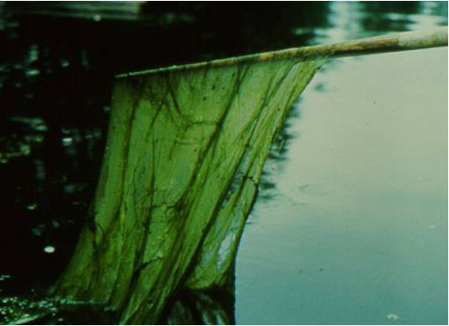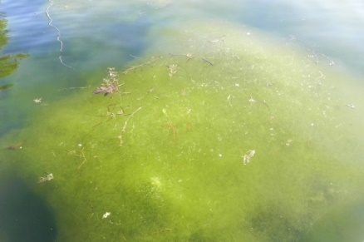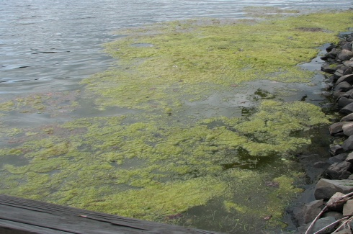
Filamentous green algae
Sources: Clemson U. (L), NYS Department of Environmental Conservation (M, R)

Duckweed
Duckweed are tiny aquatic plants with a grainy texture that can cover the entire surface of calm, nutrient-enriched ponds. If you collect them you will notice their tiny leaves and root structures.

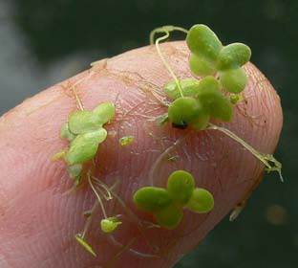

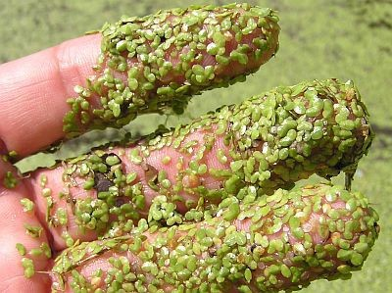

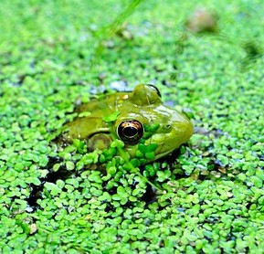

Examples of the aquatic plant duckweed.
Source: Ohio Environmental Protection Agency.
Examples of cyanobacteria
Cyanobacteria blooms tend to take two forms; they can be suspended throughout the water column (planktonic) or form a thick glop on the surface. Collect a sample if you see either of these forms of cyanobacteria.

Surface scums (likely cyanobacteria)
Often, HABs are described as looking like “spilled paint”, green, white or blue. A blooms’ color may change over time: the photos below were all taken at Utah Lake. Surface scums develop when the cyanobacteria begin to die and cannot control their buoyancy. Be careful, these scums can be especially toxic!
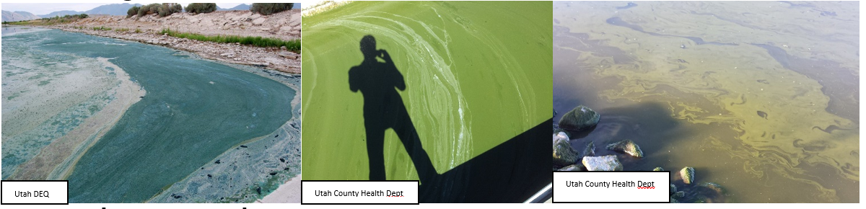

Pytoplankton (possibly cyanobacteria)
Besides cyanobacteria, many types of phytoplankton (euglena, diatoms) can form planktonic blooms. The water has been described as looking like “pea soup”. You may see clumps, which are cyanobacterial colonies (center pic).
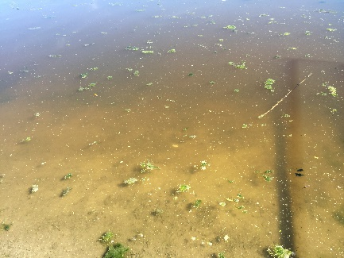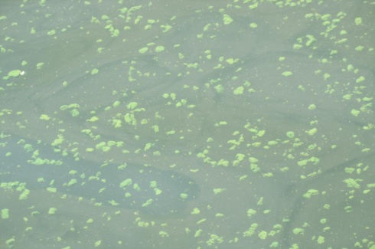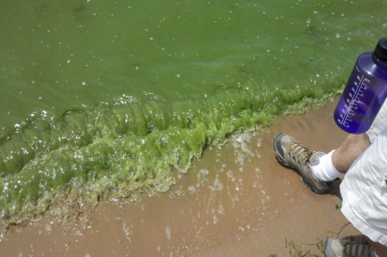
Sources: Raymond Li and the Utah County Health Department

- Photograph the bloom and fill out the Algal Bloom Report Form
Photos of the bloom will help managers assess the severity of the bloom. Keep the completed form with the sample as you transport it to the local office for analysis.
Survey the bloom
If possible, walk the perimeter of the water body. Blooms can be small and localized or cover most of a waterbody. If you visit a waterbody often, print out a map of the lake and trace the extent of the bloom on that map.
Photograph the bloom
Photograph the bloom, showing the breadth of the bloom as well as close ups (see pictures below).
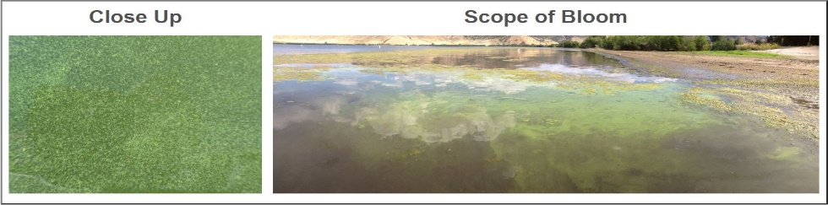

Fill out Bloom Report Form
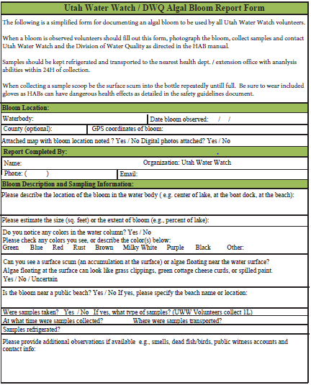
Fill out the Bloom Report Form, provided in your notebook, to the best of your ability.
- Include the GPS location of any samples collected
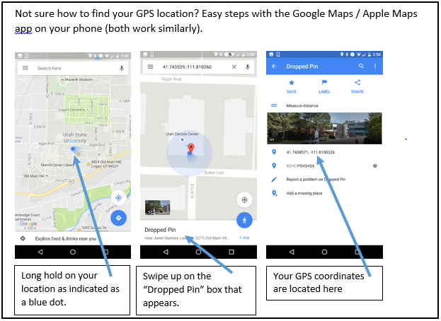
- Collect and transport phytoplankton samples
Collect the sample
Wearing gloves and being sure to keep any liquid away from your face, collect a 1L sample. Keep sample in cooler of ice and refrigerate as soon as possible. Collect the sample from the top 1-2” of the surface in an area of thick scum, pushing the sample into the bottle if necessary.

If the phytoplankton are distributed throughout the water column, fill the 1L bottle with water from an elbow-depth.

Label the 1L sample bottle using the permanent marker, included in your kit.
- Site name, your initials, date (Mmddyy)
  - Willard_EWR_053116
Transport and store the sample
Once you have collected a sample, make sure the bottle is well-sealed and kept cool. A sample may be stored up to 48 hours when refrigerated. If a sample cannot be analyzed for toxins within 48 hours, freeze the sample.

Deliver the sample, along with bloom report form and map outline to a scope; see locations and contact info on attached sheet.

- Contact the state, upload photos to Google Drive

Contacts
Submit your pictures of the bloom, as well as a scanned bloom report form to Utah Water Watch's google drive (see below). Share the new folders with the Water Quality Extension and Ben Holcomb (waterquality@usu.edu, bholcomb@utah.gov) along with any notes about the collection.

Besides sharing the photos and form with Ben Holcomb and the Water Quality Extension any bloom should be reported to the DEQ’s 24-hour spill line (801-536-4123).
Naming your pictures:
The name of the file should contain site name, volunteer initials, and the date (Mmddyy). eg: “Mantua_BNM_081417”
You can easily edit the photo’s file name via your computers file manager.

Submitting Pictures:
Photos should be saved on the Utah Water Watch's Google Drive. Go to: drive.google.com. Log out (top right) of any open accounts.
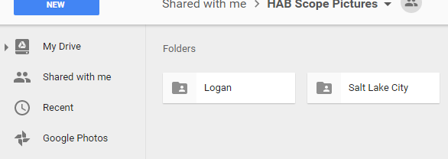
Log in using this email: utahphotopoint@gmail.com password: utahphoto. There will be a folder for each microscope site.
Click “HAB Scope Pictures” and your nearest scope location. Create a new folder (right click, then name according to site and date Mantua_120717)

Put all your photos including the documents related to the bloom in this folder by dragging them from the desktop file explorer into the new folder.

Share this folder with Utah Water Watch and Ben Holcomb (waterquality@usu.edu, bholcomb@utah.gov). Right click on the folder, select share, and then enter emails.

