Rich County Sage-Grouse Field Report – June 2021
Codi Backen, Graduate Research Assistant (codibacken16@gmail.com; 402-305-6402) and Terry Messmer (terry.messmer@usu.edu; 435-797-3975) Utah State University.
Background and Purpose
This is the June 2022 field update for the research project studying greater sage-grouse (Centrocercus urophasianus, sage-grouse) responses to livestock grazing in Rich County, Utah. Our working hypothesis is that areas managed under rotational grazing practices provide better sage-grouse habitat throughout the brooding season and in turn translate into increased recruitment. To test this hypothesis, we are studying the seasonal movements, vital rates, habitat selection, and brood success of female sage-grouse marked with global positioning system backpack transmitters. We are also sampling vegetation from both grazed and un-grazed pastures across the study area to follow growth/regrowth in those pastures.
We are also recording changes in plant phenology using a Normalized Difference Vegetation Index (NDVI). The NDVI is a satellite-derived index of the photosynthetic biomass, or ‘greenness’, of an area. We will be using this data to track the green-up of the study area, and to look at how this rate changes between the different grazing methods in either study area, as well as within each area between grazed and rested pastures. Because livestock grazing has been implicated by some groups as one potential factor associated with the sage grouse population declines, this research seeks to uncover how grazing may affect sage-grouse habitats at multiple scales and in turn population vital rates.
Study Area
The study is being completed in Rich County, located in northeastern Utah. This study area includes the southwestern portion of the Wyoming Basin Sage-grouse Management Zone II and is comprised of two research areas, Deseret Land and Livestock (DLL) and the Three Creeks Allotment (3C). The DLL is a 200,000-acre privately owned ranch, of which 160,000 acres are privately owned and 40,000 acres are federal BLM land grazed under allotments. The DLL has maintained rotational prescribed grazing practices since 1979 as well as implemented sagebrush treatments throughout lower elevation pastures. The 3C is a 146,000-acre consolidation of 29 individual BLM and USFS grazing allotments and private lands, that have begun to implement seasonal rotational grazing in the last few years.
Nesting and Brooding
We documented 16 nests this nesting season. On DLL 8 radio-marked females-initiated nests; six were depredated and two hatched successfully. One female sage-grouse re-nested after her first nest was predated. The two successful nests have broods, and we are tracking their movements and will have their 50-day brood check the week of July 18, 2022 (Table 1).
On the 3C study area, seven radio-marked females-initiated nests; three were predated and the remaining four hatched successfully. Three of the broods have failed, with one remaining brood being monitored. Females with nests/broods failed did not make any re-nesting attempts.
Table 1. Greater sage-grouse 2021 nesting and brooding percentages across the Rich County, Utah study area.

Table 1. | Nests Initiated | Nesting Rate | Nests Hatched | Hatching Rate | Number Broods as of 6/27 | Brood Survival Rate for May
DLL | 8 | 57.1% | 2 | 25% | 2 | 100%
3C | 7 | 50% | 4 | 57% | 1 | 25%
Off Site | 1 | -- | 0 | 0% | 0 | --
Total | 16 | 53.3% | 6 | 38% | 3 | 50%

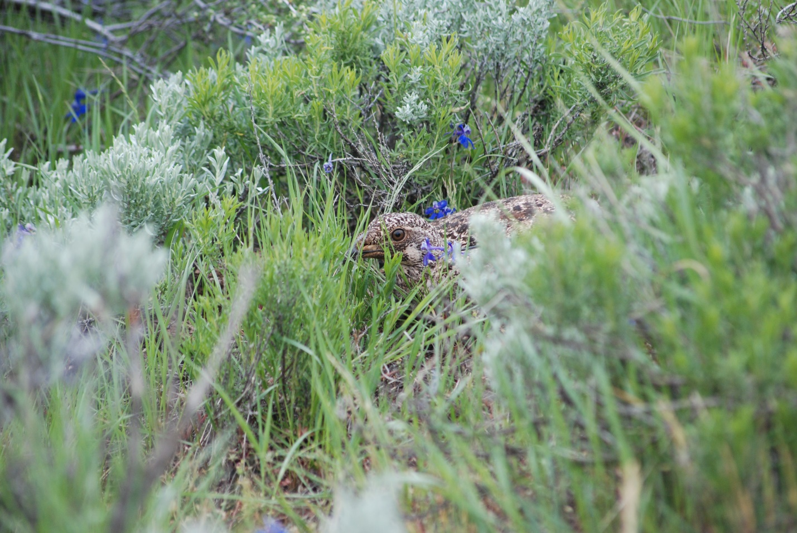
Figure 1. Female sage-grouse on DLL. This hen hatched nine chicks.

