Utah 4H Shooting Sports
SHOTGUN
Mail-in Tournament
September 1,2020 through April 1, 2021
General Rules
- Utah 4-H Shooting Sports Contest Safety & Sportsmanship form items should be followed by all youth and by Adult leaders ( See attached form)
- Participants must be enrolled in the 4-H Shooting Sport Project
- All qualifying Rounds must be shot between September 1, 2020 & April 1, 2021 & submitted before the deadline date: APRIL 1, 2021 TO blake.clark@usu.edu 208-390-7284
Registration, Materials, Info
- Each Participant must register online at 4h.zsuite.org Under Shooting Sports State Contest 2020 2021..
- Registration is required to participate in the Mail in tournament, and to be eligible to attend the State Shooting Sport Contest held on May 3,4, 2021
- Submit all Scores and Questions to Blake Clark, blake.clark@usu.edu 208-390-7284 Score sheets will be provided in excel form.
Shotgun Specific Rules
- Any 12 gauge or smaller shotgun are permitted, in semi-automatic, pump or break action. Shotguns may only be loaded with two shells at any given time at the skeet ranges, trap shooting is one shell at a time upon your turn.
- Course of fire is standard American Trap and Skeet
- Scores that have been submitted by your leaders can’t be changed.
- Shell must be factory rounds, no reloads are used.

Class Number
(Boys and girls in same classes) Ages
- 1. Shotgun (Jr) 8,9,10, yrs old
- 2. Shotgun (Int) 11, 12, 13 yrs old
- 3. Shotgun (Sr) 14-18, yrs old
  - (Sr) Level shooters age 14-18 yrs old are eligible to continue to National Events. Youth must be age 14 on or before January 1 of current year to attend the National Shooting Sports Contest in June.
Rounds
- Each round is scored at 10 points per clay
- Each group Jr, Interm, Sr Classes will shoot 2 Rounds of Trap 16 Feet and 2 rounds of standard Skeet for a total available points of 1000.
- All rounds are to be shot at any available public range close to your area that has trap and skeet ranges. Scores are to be submitted before the deadline date of APRIL 1, 2021
- To qualify for State Shotgun Contest each youth will need to submit all four rounds of shooting, 2 trap scores and 2 skeet scores signed and sent in by your leader.
- Rounds do not have to be shot all on the same day.
- Participants must use the attached score sheet which is to be signed by club leader before it is submitted.
Scoring
- Once all the scores have been submitted the committee will evaluate and decide who can attend the State national tryouts May 3,4 2021,
- All participants will receive a Certificate with a corresponding placement, BLUE, RED or WHITE.

SHOTGUN State Contest May 3, 4 2021
- Top scoring youth in each class will be invited to participate in the State shotgun shooting contest May 3,4, 2021
  - Note most youth who participate in mail in shotgun tournament with be invited to shoot at the State Contest until the total participations number goes up
- At the State Contest the youth will:
  - 1) shoot 2 Rounds of Trap at 16 yards 50 shots 10pts per = 500 total points
  - 2) 2 Rounds of skeet Standard 50 shots 10pts per =500 total points
  - l3) 2 Rounds of 5 Stand, which is similar to a Sporting clay range. 50 shots 10pts per = 500
Any questions can be directed to Blake Clark at blake.clark@usu.edu
SKEET FIELD LAYOUT:
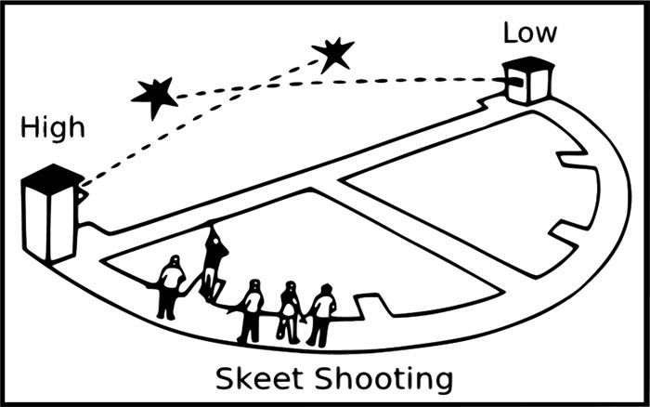

TRAP FIELD LAYOUT:

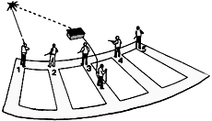

4-H Shooting Sports Contest Safety Rules
SECTION 1 AND 2 BELOW SHOULD BE READ TO ALL YOUTH PARTICIPATING BEFORE EACH SHOOT.
- SHOOTING SPORTS SAFETY
⃝ Muzzle always pointed in a safe direction
⃝ Action Always Open, empty and exposed to view until ready to shoot
⃝ Trigger is not touched until ready to shoot
⃝ Ammunition: proper gauge of caliber
⃝ Wears eye and ear protection
⃝ Obeys Range commands
⃝ No horse play
⃝ Keeps firearms racked or tabled until instructed to pick up
⃝ Assures safety of others while on or off the range
- SHOOTING SPORTS SPORTSMANSHIP
⃝ Be Courage: fair, courteous,
⃝ Have good judgment: follows team, county, state rules
⃝ Show Integrity: fair and courteous during events,
⃝ Shows compassion and friendship in victory and defeat
⃝ Show Perseverance, persistent in spite of opposition
⃝ Exhibit patience and the fortitude to try again
⃝ Most important is to always try to have FUN
