Utah 4H Shooting Sports
.22 RIFLE
Mail-in Tournament
September 1,2020 through April 1, 2021

General Rules
- Utah 4-H Shooting Sports Contest Safety & Sportsmanship form items should be followed by all youth and by Adult leaders ( See attached form)
- Participants must be enrolled in the 4-H Shooting Sport Project
- All qualifying Rounds must be shot between September 1, 2020 & April 1, 2021 & submitted before the deadline date: APRIL 1, 2021 TO blake.clark@usu.edu 208-390-7284
Registration, Materials, Info
- Each Participant must register online at 4h.zsuite.com Under Shooting Sports State Contest.
- Registration is required to participate and to be eligible to attend the State Shooting Sport Contest held in May 3,4, 2021
- Submit all Scores and Questions to Blake Clark, blake.clark@usu.edu 208-390-7284

Rifle Specific Rules
- All .22 Caliber Rifle to be use by youth will need to comply following Specifications for each rifle contest found in the .22 Rifle Competition Leaders Guide.
  - NRA 3 Position
  - CMP Sporter
  - NRA Small-bore Silhouette
- Scores that have been submitted by your leaders can’t be changed.
- Shell must be factory rounds, no reloads are accepted.

Class Number
(Boys and girls in same classes) Ages
- 1. Rifle (Jr) 8,9,10, yrs old
- 2. Rifle (Int) 11, 12, 13 yrs old
- 3. Rifle (Sr) 14-18, yrs old
  - (Sr) Level shooters age 14-18 yrs old are eligible to continue to National Events. Youth must be age 14 on or before January 1 of current year to attend the National Shooting Sports Contest in June.
Rounds
- Each youth will shoot the NRA 3 Position and the NRA Small-bore Silhouette competitions to submit.
- The CMP Sporter competition will not be shot for the mail in tournament only the two listed below.
- All 3 shoots will be shot at the State Competition
- 1) NRA 3 Position shoot which includes shooting on a NRA A-51 Target seen below.at 50 yards.
  - Each Youth will need 3 targets to shoot
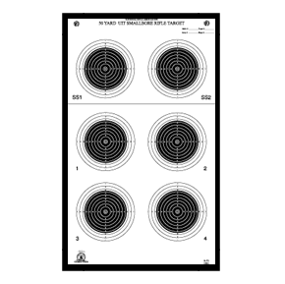
    - 1 target standing – 5 shots per bull below the line 20 total shots
    - 1 target prone
    - 1 target kneeling
  - Follow Leaders Guide for instructions
- To qualify for State .22 Rifle Contest each Leader will need to submit 3 signed and scored targets per youth.

- 2) NRA Small Bore Silhouette Shoot that will be shot on a TQ-14 50 foot Rifle
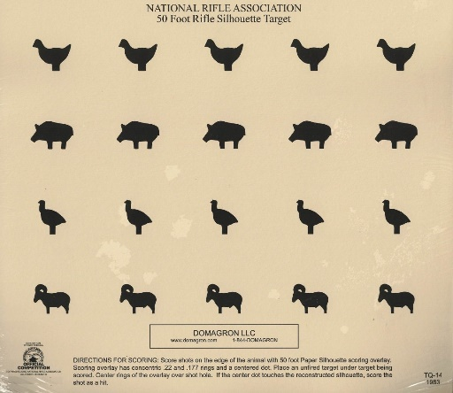
- Each youth will shoot one round at each silhouette on the target
- There should only be 20 shots or holes in the target to be scored
  - A point is scored when the bullet breaks any part of the target outline.
- Each youth will shoot two targets to submit for scoring to the state.
- Name of youth,leader,date and signature of leader should be on back of target when submitted.
=Scoring
- Once all the scores have been submitted the committee will evaluate and decide who can attend the State national tryouts May 3,4 2021,
- All participants will receive a Certificate with a corresponding placement ribbon, BLUE, RED or WHITE.
RIFLE State Contest May 3,4 2021
- Top scoring youth in each class will be invited to participate in the State .22 Rifle shooting contest May 3,4, 2021
  - Note most youth who participate in mail in Rifle tournament with be invited to shoot at the State Contest until the total participations number goes up
- At the State.22 Contest the youth will Shoot all 3 contest
  - 1) NRA 3 Position
  - 2)CMP Sporter
  - 3) NRA Small Bore Silhouette

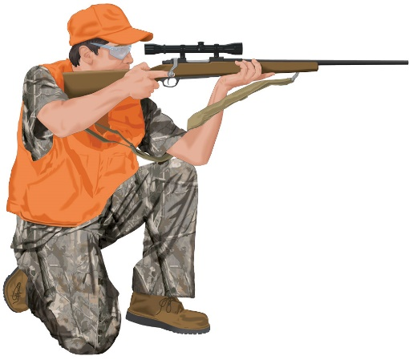
4-H Shooting Sports Contest Safety Rules
SECTION 1 AND 2 BELOW SHOULD BE READ TO ALL YOUTH PARTICIPATING BEFORE EACH SHOOT.
- SHOOTING SPORTS SAFETY
⃝ Muzzle always pointed in a safe direction
⃝ Action Always Open, empty and exposed to view until ready to shoot
⃝ Trigger is not touched until ready to shoot
⃝ Ammunition: proper gauge of caliber
⃝ Wears eye and ear protection
⃝ Obeys Range commands
⃝ No horse play
⃝ Keeps firearms racked or tabled until instructed to pick up
⃝ Assures safety of others while on or off the range
- SHOOTING SPORTS SPORTSMANSHIP
⃝ Be Courage: fair, courteous,
⃝ Have good judgment: follows team, county, state rules
⃝ Show Integrity: fair and courteous during events,
⃝ Shows compassion and friendship in victory and defeat
⃝ Show Perseverance, persistent in spite of opposition
⃝ Exhibit patience and the fortitude to try again
⃝ Most important is to always try to have FUN

