Utah 4H Shooting Sports
ARCHERY
Mail-in Tournament
September 1,2020 through April 1, 2021
General Rules
- Utah 4-H Shooting Sports Contest Safety & Sportsmanship form items should be followed by all youth and by Adult leaders
- Participants must be enrolled in the 4-H Shooting Sport Project
- All qualifying Rounds must be shot between September 1, 2020 & April 1, 2021 & submitted before the deadline date: APRIL 1, 2021 TO blake.clark@usu.edu 208-390-7284
Registration, Materials, Info
- Each Participant must register online at 4h.zsuite.org Under Shooting Sports State Contest 2020 2021..
- Registration is required to participate in the Mail in tournament, and to be eligible to attend the State Shooting Sport Contest held on May 3,4, 2021
- Submit all Scores and Questions to Blake Clark, blake.clark@usu.edu 208-390-7284 Score sheets will be provided in excel form.
Archery Specific Rules
- Compound Bow and recurve bow are eligible to use.
- We will be taking a Compound Bow Team to Nationals in 2021 and a Recurve Bow team hopefully in the future. You may still compete with a recurve but will not be able to advance to nationals for the 2021 competition.

Class Number
(Boys and girls in same classes) Ages
- 1. Archery (Jr) 8,9,10, yrs old
- 2. Archery (Int) 1, 12, 13 yrs old
- 3. Archery (Sr) 14-18, yrs old
  - (Sr) Level shooters age 14-18 yrs old are eligible to continue to National Events. Youth must be age 14 on or before January 1 of current year to attend the National Shooting Sports Contest in June.
Rounds
- Each group Jr, Inter, Sr Classes will shoot 2 Completed archery shoots specified in this form (FITA & FIELD)
- All rounds are to be shot at any available public range close to your area. Scores are to be submitted before the deadline date of APRIL 1, 2021
- To qualify for State Archery, contest each youth will need to submit the 2 completed Archery shoots scores (FITA and FIELD) specified in this form.
- AT STATE CONTEST ON MAY 3, 2021 YOUTH WILL SHOOT ALL 3 SHOOTS, 3D, FIELD AND FITA ROUNDS
- Rounds do not have to be shot all on the same day.
- LEADERS must submit youths scores to Blake.clark@usu.edu before or April 1, 2021 and make sure they are registered.
Scoring
- Once all the scores have been submitted the state committee will evaluate and decide who can attend the State national tryouts May 3,4 2021,
- All participants will receive a Certificate with a corresponding placement, BLUE, RED or WHITE.

Archery State Contest May 3, 4 2021
- Top scoring youth in each class will be invited to participate in the State archery shooting contest May 3,4, 2021
  - Note most youth who participate in mail in Archery tournament will be invited to shoot at the State Contest until the total participations number goes up
- At the State Contest the youth will shoot 3 archery competitions. See the following
  - 1) 3D Archery Shoot – Youth will shoot ONE arrow at each of the 10 3D Targets and record score 3D Targets will vary in distances 6ft to 50 ft.
    - 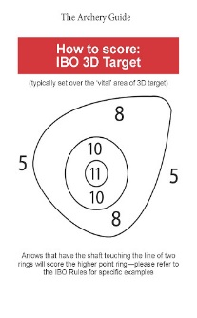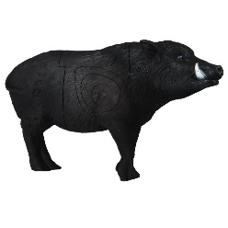
    - TOTAL POSSIBLE POINTS - 110
  - 2) FIELD ARCHERY SHOOT - Youth will shoot 4 arrows at 5 various distance targets. 25,30,35,40,50 yards.
    - 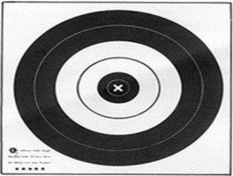
    - The targets size is 50cm
    - The scoring is 5 points for center black area 4 points for inner white area and 3 points for outer black area and 0 points for not hitting any area of the circle
    - 20 Arrows shot with POSSIBLE POINTS 0f 200

  - 3) FITA ARCHERY SHOOT – Youth will shoot:
  - 3 Arrows at 50 meters 3 times(ends) at the below target (122cm target)
  - 3 Arrows at 60 meters 3 times (ends) at the below target (122cm target)
  - 3 Arrows at 30 meters 3 times (ends) at the below target (122cm target)
  - 3 Arrows at 40 Meters 3 times (ends) at the below target (122cm target)
  - 36 total Arrows shot with a possible score of 360.

  - The targets are 122 cm target 10 ring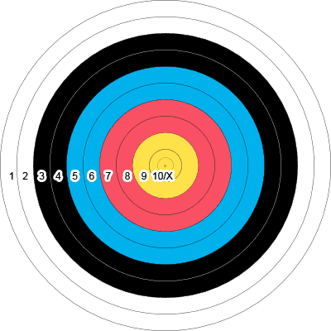

  - 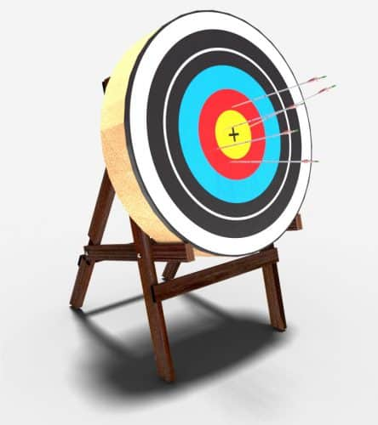

  - Target can be on a stand or the ground.

Any questions can be directed to Blake Clark at blake.clark@usu.edu

