2024 4-H Member Fair Information

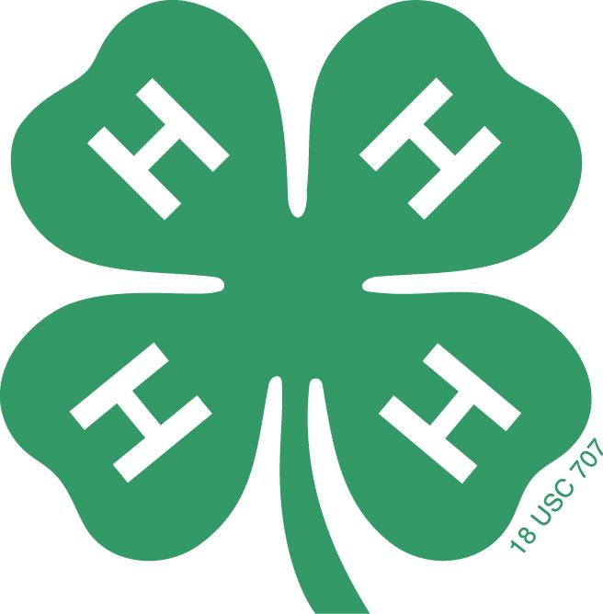

READ FIRST: Fair Information for Everyone 2
Exhibit requirements for County and State Fairs 3
Premiums 6
What the ribbons mean 7
Changes to the Fairbook 8
Intake and Pick Up Information 9
Volunteer Information 10

Contact the 4-H Office or email Emily Van Wagoner with any questions or concerns.
Please be aware that our office will be closed July 18-20 and July 24.

READ FIRST: Fair Information for Everyone

We are beyond excited to see everything our 4-H Youth have done this year at our Indoor exhibits! We have many hard working members who will show their amazing talents through a wide variety of projects. The 4-H Staff want to do our best to support our youth and celebrate their work.To do this, we are working closely with the Fairboard and State Fair to make sure we are successful. We thank you for your patience and support as we make adjustments to the Fair during these next few years.

Watching all the amazing things our 4-H youth have accomplished this past year, we were reminded of the true purpose of 4-H events. We are a community who thrives on “Learning by Doing” and strive to always “Make our Best Better.” As such, we are taking care to make sure we keep in mind the purpose of the Utah County Fair 4-H Indoor exhibits - to celebrate youth’s work and learning journeys, and to offer them a chance to get feedback and grow - so that we can provide the best experience for all those involved. Please read through the following information carefully, as we shift the way we run our Indoor Exhibits to better reflect an environment of growth and celebration.

Our Indoor Exhibits purpose is to celebrate every step of our youth’s learning journeys. While we do ask youth to submit their best work, it’s important to remember that best does not mean perfect, and that everyone’s best work looks different. Someone who’s been doing photography for years will not have the same “best work” as someone who only just picked up a camera for the first time. We highly recommend reading through the “What the ribbons mean” section to better understand what the different colored ribbons represent. We also encourage you to include a notecard (see requirements for state, notecard section) with your project. This will be especially helpful if you are just starting out in a project area and would like to make the judges aware that you are new to it.

Again, we ask that you please read through all the information provided as there have been some changes this year in regards to the Fairbook, premiums, state requirements, and volunteer opportunities.

To further support our Indoor Exhibits reflecting learning, we are introducing two new components to the Fair this year. We will have one or two booths with various activities inside the Indoor Exhibit building. Our STEM TRY Team will help with these booths, and we are looking for volunteers to help with them as well. We are also excited to introduce a Goosechase event. This event will consist of various challenges to complete throughout the fair via the Goosechase app. The point of this is to encourage everyone, 4-H families and non-4-H families alike, to explore the fair and learn more about 4-H. There will be prizes for 1st, 2nd, and 3rd place.

We will send out more information about these two opportunities closer to the fair.

Exhibit requirements for County and State Fairs

All 4-H Indoor Exhibits must follow the guidelines found in the 2024 Fairbook and listed below. Please look carefully as some project areas have specific requirements which need to be followed in order to get a red or blue ribbon or to qualify for state.

We ask that Cloverbudes (K-2nd grade) submit a maximum of 8 projects.

General requirements:
- All exhibits must have their completed exhibit card attached securely to it. If the exhibit has more than one part, each part of the exhibit will need to have an exhibit card attached numbered 1 of 3, 2 of 3, etc.
- Exhibits must be well made so they are stable enough to be moved.
- Items to be returned (hangers, pie pans, cake stands, etc) must be clearly marked with the name of the exhibitor and a phone number.
- Indicate if the item was made from a kit. Items made from kits will be judged separately from those of someoneone’s own design.
- Posters must be 22”x33” or smaller
- Notebook binders must be 2 inches or smaller
- Displays must be 4’x4’ or smaller, and must be free standing

Project-specific requirements:
- Some exhibits in Quilting, Home Environment, Child Care, and Food Preservation require certain information (such as a recipe) to be included with the project. These requirements can be found under each division in the Fairbook.
- Collection boxes must be 325 square inches from bottom measurement or smaller, and glass covers must open at the top or side of the box; the glass must be secured so that it will not move when the box is properly displayed at the fair
- Food items must be able to last at least 5 days without refrigeration. Any items that can not last that long, especially frozen food products, can not be accepted as a fair project. Do not send food items which will spoil quickly.
- Baked products and gardening exhibits will not be returned without prior special arrangements. Unless otherwise arranged, all food products will be sprayed with acrylic spray to maintain their appearance after judging and throughout the fair. These food items will be inedible after they have been sprayed.
- 4-H will not provide plates for food or garden entries. Exhibitors must provide their own plate, preferably disposable. After judging, entries may be moved to a green plate to make the ribbon more visible.
- Table setting- one place setting, centerpiece, and table covering (be aware it will be displayed with other projects, not on its own table). Include your plan for the full table and dinner set-up so that the judges can get a better idea of how your place setting will work in a larger set up but this is not required.

Please note: 4-H Indoor Exhibits are 4-H specific projects, not school homework. If part of the entry was done in school, please have the youth include what additional things they did to make it into a 4-H project on their notecard.

Please remember that you may enter more than one department and division, but may only submit one exhibit per class. The only exception to this is with plants where you can submit two per class.

Important: Starting this year, in order to qualify for the state fair this year through our county, all entries are required to include a notecard with information for the judges. This notecard must include important information for the judges to be aware of, including but not limited to: what the project is, what they learned while making it, how long they’ve been creating things in this project area, etc, and will need to be composed on a separate notecard/page than the project tag. This information will help our judges gain a better understanding of our 4-H youth and their projects so that they can judge it more accurately. We have found that including how long you’ve been doing that project (ie 1st year painting vs 8th year painting) is especially helpful for the judges to be aware of. Cloverbuds do not need a notecard, but are welcome to include one.
Entries not including a notecard are still welcome to enter into the Utah County Fair, but they will be ineligible to continue onto the Utah State Fair. Notecards will not replace the exhibitor tag. Entries will include both the required exhibitor tag and a notecard.

Please include your name, division/class of the project, and your project description in case your notecard gets separated from your project so that we can reunite them. See the “Note” below for an example of what the notecard might look like.
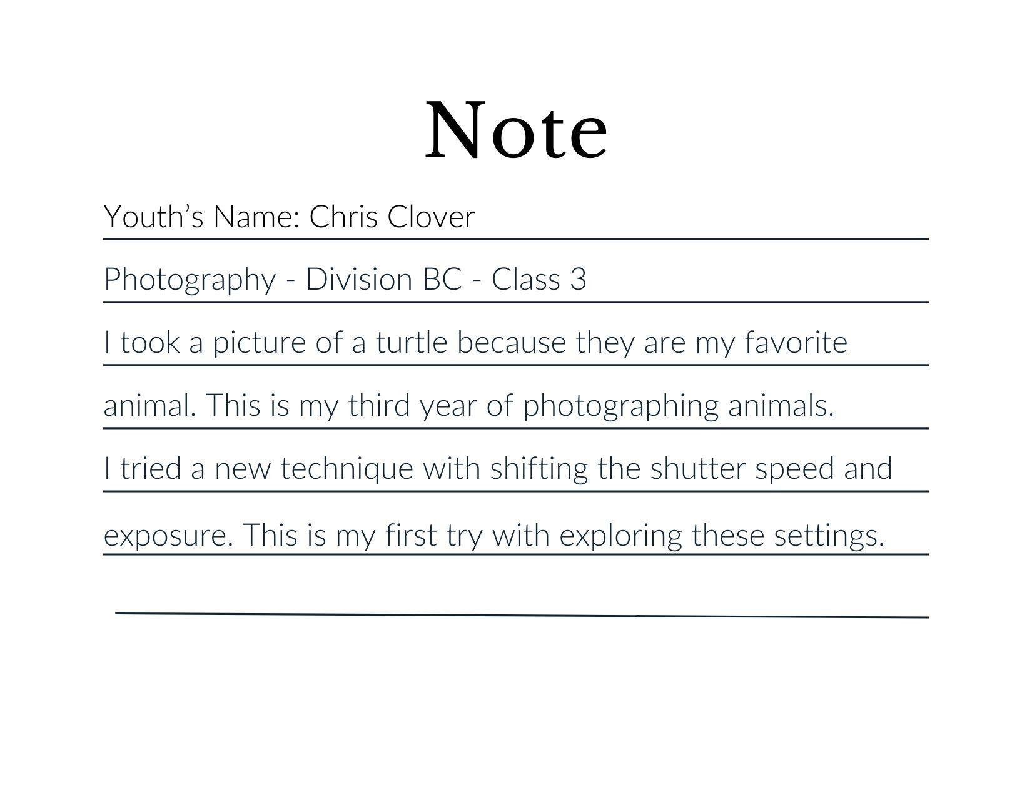

Important: the project notecard is different from the project description. As mentioned above, the notecard is intended to provide judges with additional information that will help them to judge the youth’s project, and is a requirement for qualifying for state. The project description is something you will include while registering your project. Its purpose is to help us identify and locate your project if the tag gets separated from it. Please make sure you include a good description of your entry, including color. A “title” is not helpful.
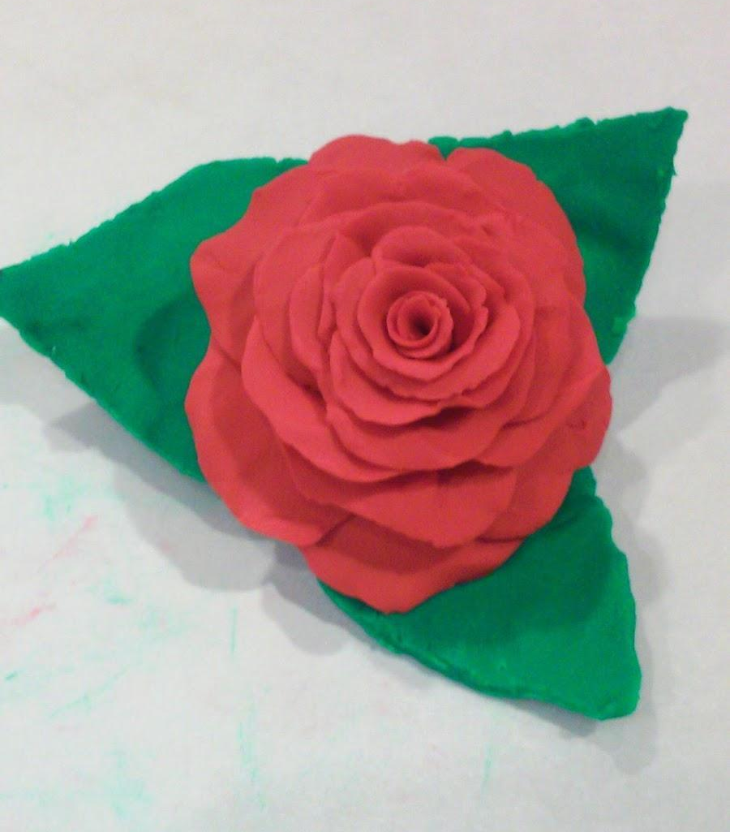

Ex: X: Rose
✓: Red play-doh rose with green leaves

Tag info: the 4-H office will send a digital copy of the tags for families to print the Friday before the fair. If you are tagging your club’s entries for them, please send us an email notifying us of who you will be tagging for so that we can make sure the tags get sent to the right person. Please print your tags on cardstock if possible and have them attached prior to arriving at your designated drop off time.

Premiums

4-H is grateful for the Utah County Fairboard for all their help in making all our Fair Programs possible. Our County and Fairboard believe in the growth and celebration of our 4-H youth, and have done so much to support us in our efforts in providing opportunities for 4-H youth to practice a variety of skills and receive feedback on their work. The county supports this effort by providing funds for premiums to celebrate the work of our youth. As such, we have adjusted the premiums to more accurately represent the growth and learning we aim to achieve. Included below are our premium amounts for this year. Please note that there have been some slight changes to better reflect our goal of celebrating youth during every step of their learning journey.

Best of Show - $23
Selected for State - $5
Blue - $2
Red - $1.50
White - $1
Commissioner's Choice - $25 + Plaque
County Choice - $10 + Plaque
Cloverbud: a green ribbon and small toy (given out at pick up) to celebrate our Cloverbuds’ work. They do not go on to state.

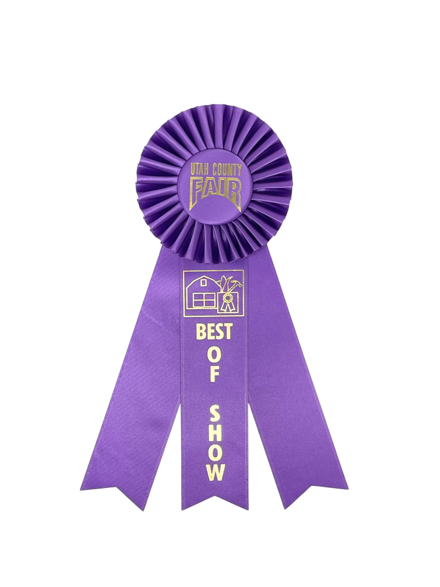
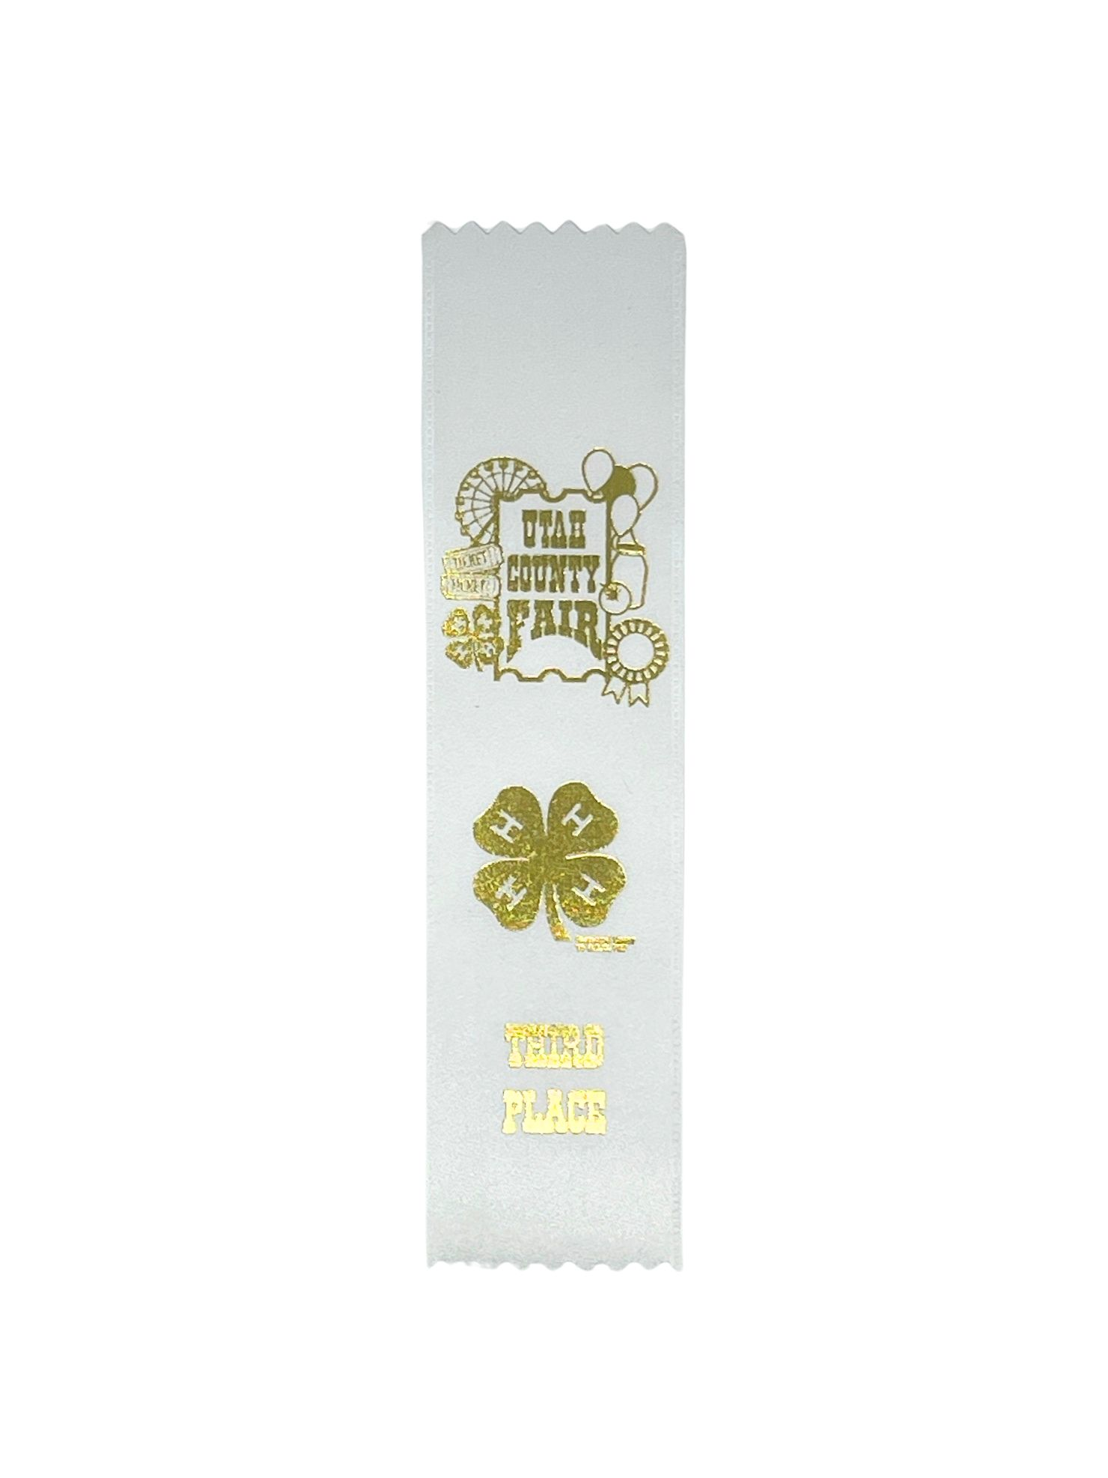
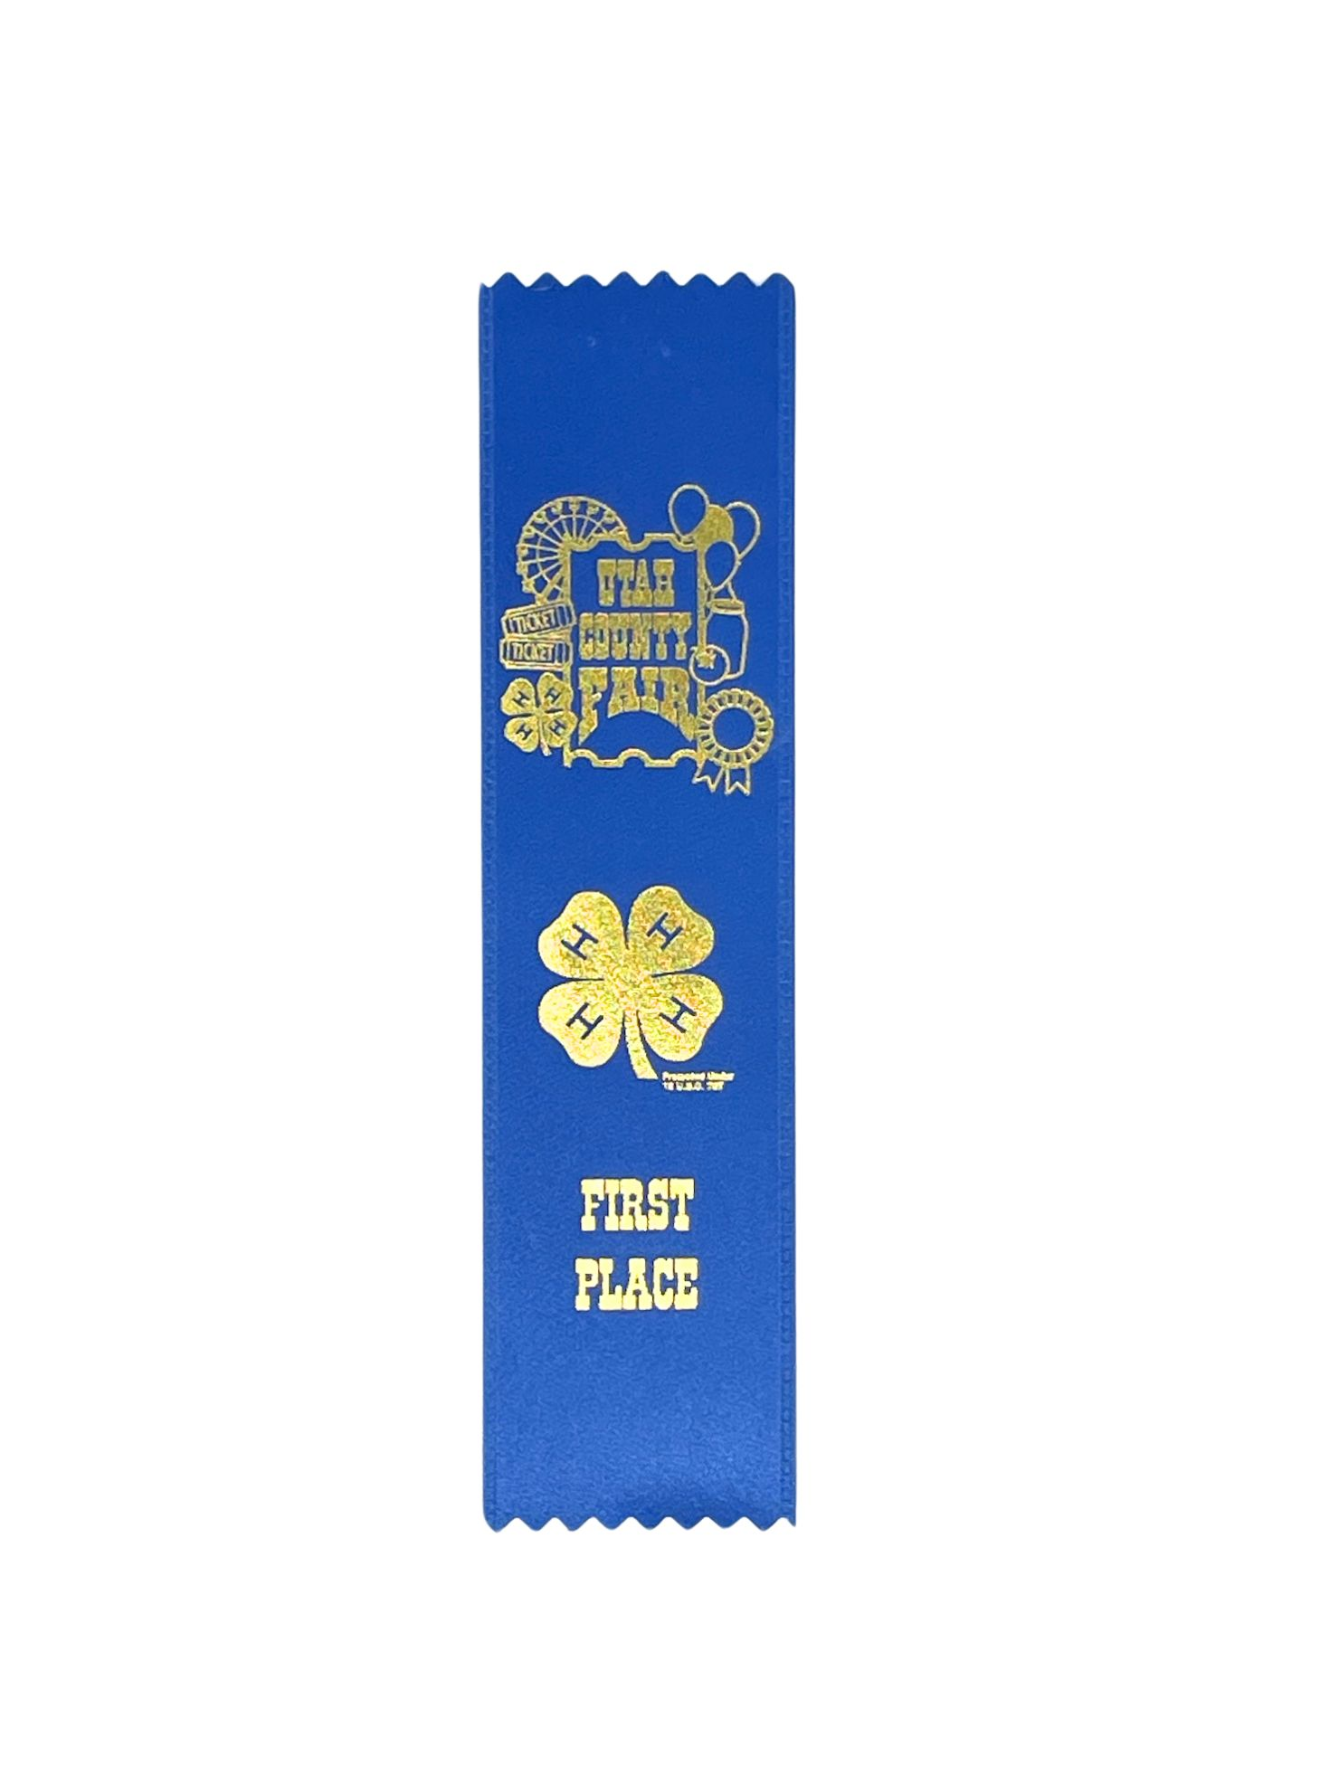
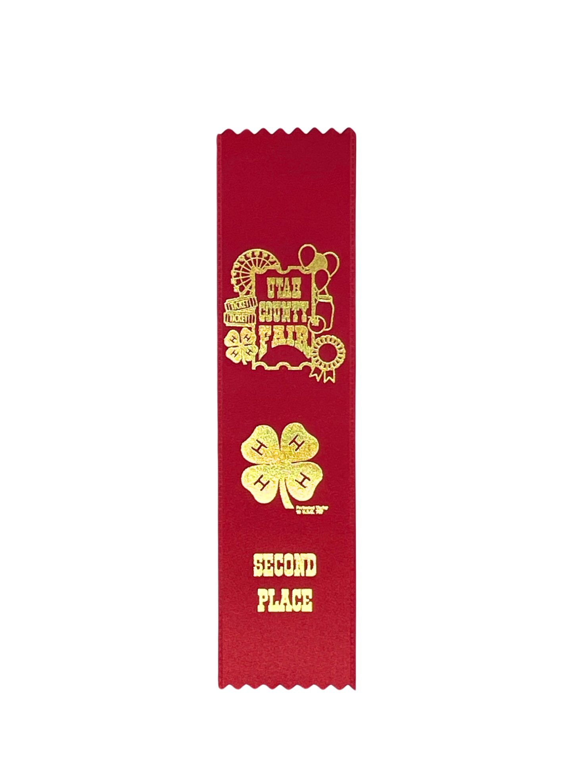
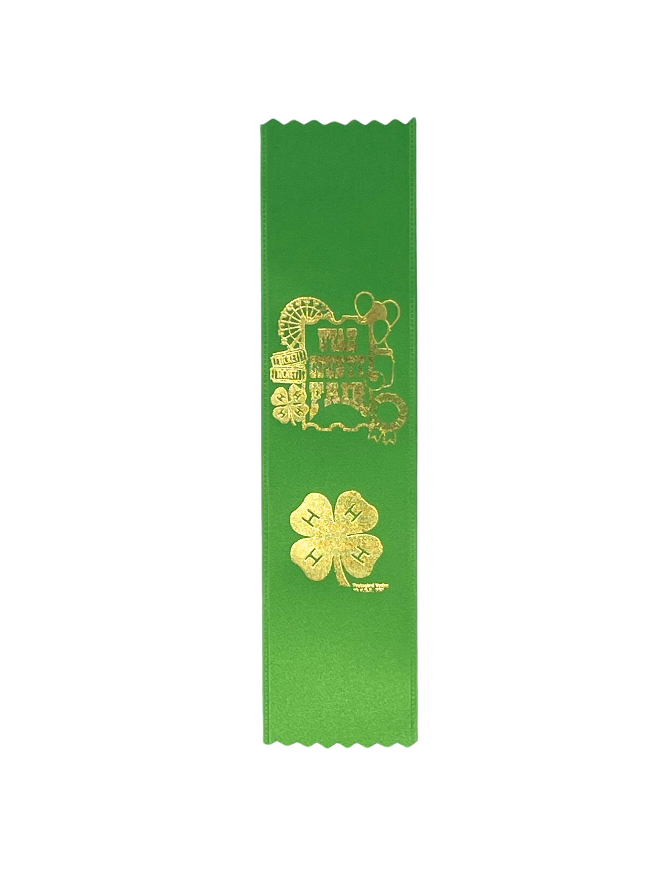

What the ribbons mean

White: a ribbon to celebrate the start of learning. These typically are awards to youth who are just starting out in a project area. White ribbons means there are areas for growth, and the feedback youth receive can help them with that.

Red: a ribbon to celebrate the work of 4-H youth. These represent growth and solid performance. Think of it like a “C” in school, it’s a passing grade where there’s skill, but still areas for improvement.

Blue: a ribbon to celebrate the accomplishments of 4-H youth. These are given to youth who have gone above and beyond the expectations for youth their age. There are always areas for growth, so blue ribbons may still have feedback on them, but overall represent some form of mastery in an area.

Qualifier: a ribbon or sticker signaling that the project is going on to state, ours are purple. These projects must always have a blue and be qualified to move on (in our case, be registered as a 4-H member, follow all exhibit rules, have a notecard attached, and secured for traveling such as gluing for legos). Not every blue ribbon project will move on and the amount that can qualify for state is based on the total number of entries in each department.

Best of Show: a rosette awarded by the project area judges as a group. This ribbon recognizes youth who have gone above and beyond the expectations for a blue ribbon. Best of Show projects are selected from those moving on to state. These projects get a rosette and a qualifier ribbon.

County: a plaque awarded by various Utah County staff. This award recognizes the appreciation county staff members have for our 4-H youths’ projects. These include plaques given by the Utah County Assessors, Recorders, Surveyors, Attorney, Treasurers, Clerks, Auditors, Sheriff, and Commissioners (3).

Changes to the Fairbook

The 2024 Fairbook can be found on the Utah County 4-H website. To navigate there, select the County Fair page which can be found under Quick Links. Please note that there have been some changes to the Fairbook this year.

For those entering STEM based projects, please pay special attention to your section as our state staff have been working to update the STEM based exhibit options.

For everyone, we have adjusted our terminology to match with the state fair’s. Our exhibits are now broken up into Department, Division, and Class.

Departments are the larger categories exhibits are broken down into, such as Consumer Science vs Art.
Division focuses on specific groups within Departments like Arts & Crafts vs Fine Arts.
Class, previously known as lots, focuses on specific types of projects/techniques, such as Afghans vs Loom Knitting in the crochet division.

Example: Red play-doh rose with green leaves would be in Depart B - Art, Division BB - Fine Arts, Class 5 - clay sculpture.

We understand that it is sometimes difficult to determine which Class to list your project under. If you are uncertain about what Class your project is in, please reach out to our main office phone number or email Emily Van Wagoner (emily.vanwagoner@usu.edu) for help.

Intake and Pick Up Information

Intake Day is July 29th 9 am - 12 pm. Pick up/take down day is August 5th 9 am - 12 pm.

In order to make intake and pick up as quick and easy as possible, we ask that whoever will be handling the exhibits for your family/club be the one to sign up for Intake and Pick Up day.

We will update this document and send out an email with more information the week before the fair. If you have any questions or concerns in the meantime, please contact the 4-H office or email Emily Van Wagoner at emily.vanwagoner@usu.edu.

Volunteer Information

We are thankful to everyone for being so willing to help with our fair. This event is only possible through the amazing efforts of our wonderful volunteers. We also appreciate your patience as we work on getting everything organized. We are still working on figuring out the details for volunteering this year, so for now we ask those who are interested to please fill out the form below so that we know who is interested in helping.

Volunteers ages 18+: we have several opportunities for our adult volunteers this year.

Monday, July 29th - Fair Set Up, moving tables and other manual labor
Tuesday, July 30th - Intake Day, organizing projects and prepping for judging
Wednesday, July 31st - Judging Day, stapling ribbons and assisting judges
August 1st to 3rd - Fair Days, running an activity booth, assisting 4-H staff
Monday, August 5th - Take Down, organizing projects for pick up, moving tables

Volunteers grades 6th-12th: we have a special opportunity for these youth starting this year.

We invite youth in 6th-12th grade to help with our Cloverbud entries. We love it when our Cloverbuds participate in Indoor Exhibits. Although their entries are not judged and do not receive a Premium or go on to State, we would still like to have them participate and learn about the fair. Starting this year, we would like to have our 4-H youth to help provide positive feedback and support for our youngest members so that they, too, can see their strengths and areas to grow. We believe that this will also help our older members to get a glimpse of the fair from a “judges” perspective to better understand how their own projects are judged.

Other opportunities for volunteers grades 6th-12th:

Monday, July 29th - Fair Set Up, moving tables and other manual labor
Tuesday, July 30th - Intake Day, organizing projects and prepping for judging
Wednesday, July 31st - Judging Day, stapling ribbons
Important: after youth help with the Cloverbud entries, they are welcome to assist in stapling ribbons for other fair projects. However, we ask that youth volunteers assist with areas they do not have a project in. For example, a youth who has a sewing project entered in the fair will not assist with stapling ribbons for the sewing projects, but might help with the fine arts section instead. We will go over this more on Judging Day.
August 1st to 3rd - Fair Days, running an activity booth, assisting 4-H staff
Monday, August 5th - Take Down, organizing projects for pick up, moving tables

Youth grades K-5th: we do not have any volunteer opportunities at this time, but do ask for participation when possible.

August 1st to 3rd - Fair Days, visit the Indoor Exhibits and other 4-H Fair experiences,
participate with your family in our Goosechase and Booth activities, find your
individual project(s), high-five the 4-H staff, play free kids games throughout the
fair, and have fun!

Important: Please fill out the link below so that we know who is interested in helping with what. We will send out more detailed information as soon as it is available. Thank you!

https://docs.google.com/forms/d/e/1FAIpQLSf2Ea0OHl8BHa-Wkvz9wvY3uDG2sqq_6PGQ1e8UsjOA2PhxEA/viewform?usp=sf_link

