- UBJLS Winners

Grand Champion Goat
Exhibited by Hadlee Owens
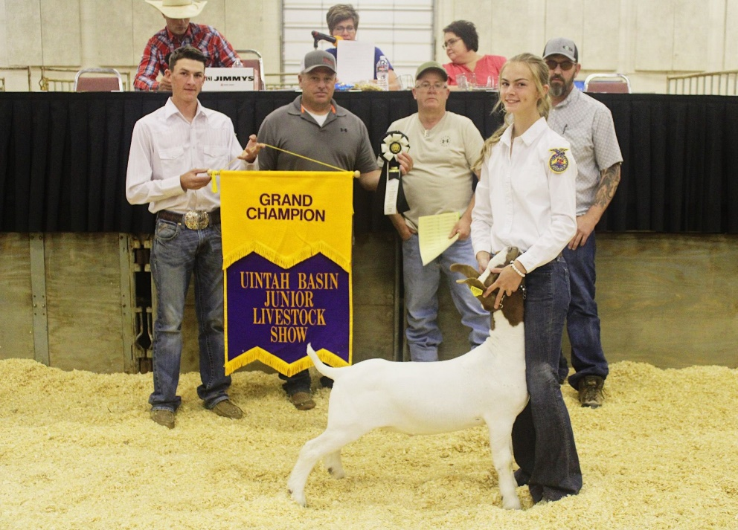
Bought By: Roofing World, L&S Trucking, Sadlier CS Bar Ranch, Koda Resources, Wicked Show Lambs, Kevin Owens, Robin Sadler



Reserve Champion Goat
Exhibited by Blake Holmes
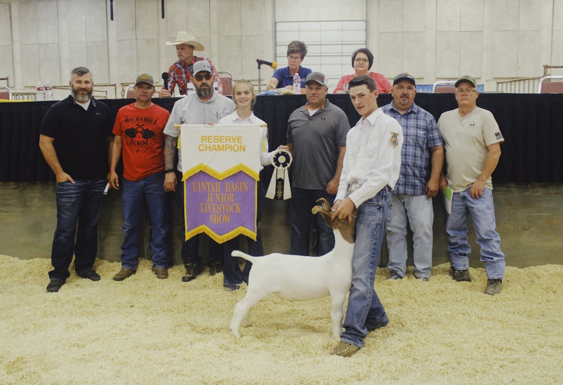
Bought By: B&D RV Center, Roofing World, Triple H, Doyle and Tammy Holmes, Holmes Club Lambs, Sadlier CS Bar Ranch, Walk Boer Goats, Koda Resources, Kevin Owens



Grand Champion Hog
Exhibited by Tucker Vincent
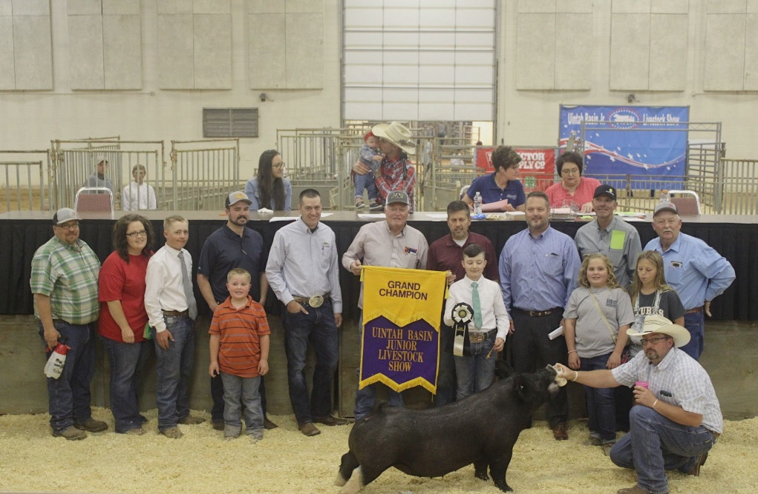
Bought By: IFA of Vernal, Moon Lake Electric, Ashley Valley Veterinary Clinic, Robert Kay, Murray Motor, Western Ag Credit, Big B Equipment, RV Bar Angus, Snow’s Show Swine, Don Fitzerald, Napa, HighLine Show Swine, Chiro Center Inc, Key Lix, Weldon Construction, Crozier Oilfield Service, Hall Farm & Show Pigs, Jim Snow, Split Mountain Insurance, Kendall Murphy, Horox Outfitters

Reserve Champion Hog
Exhibited by Brooklyn Ivie
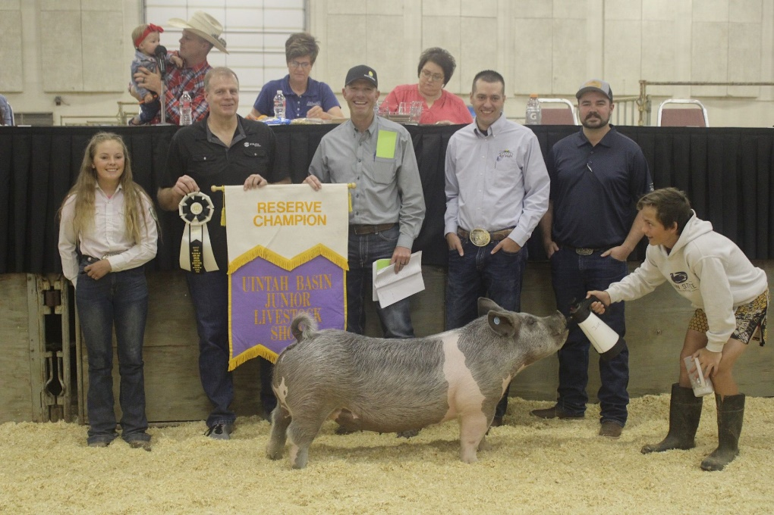
Bought By: Strata Networks, B&D RV Center, IFA of Vernal, Moon Lake Electric, DC Welding, Western Ag Credit, Wild West Meats, TJ’s Tire Pro, Chucks Meat, Superior Lube, Uintah Vet, Kelsey Birchell

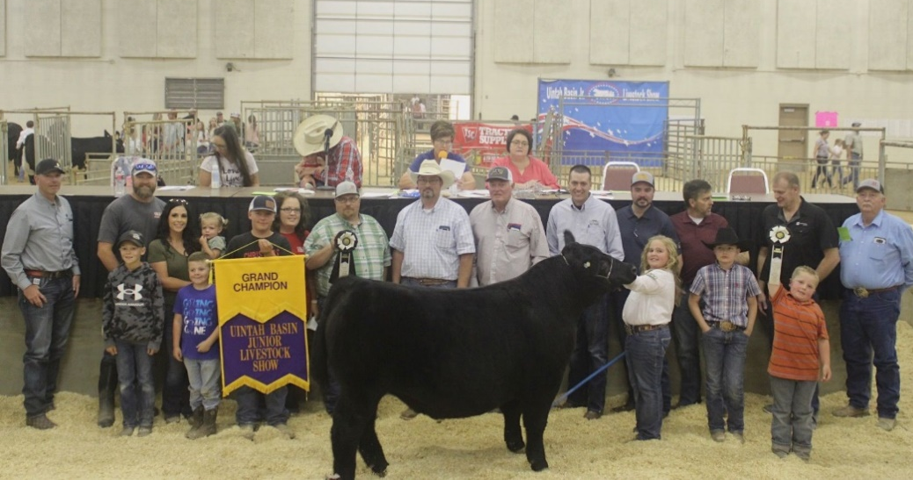
Grand Champion Steer
Exhibited by Josee Wilkins

Bought By: IFA of Vernal, Strata Networks, Snow Distributing, B&C Quick Test, Ashley Valley Veterinary Clinic, Horox Outfitters, Robert Kay, Murray Motor, Western Ag Credit, GM Fertilizer, Big B Equipment, Kelsey Birchell, RV Bar Angus, Deb Wilkins, Larson & Company CPA’s, Don Fitzgerald, Weldon Construction, Crozier Oilfield Service, Jim Snow, Kendall Murphy, Key Lix, Moon Lake Electric, Napa, Chiro Center Inc, Split Mountain Insurance, Ivie Insurance Agency, Derk Price Farms, La Cabana, Mariah Johnson, Troy Gregory, Brett Sabey, Champion X, High Voltage Inc

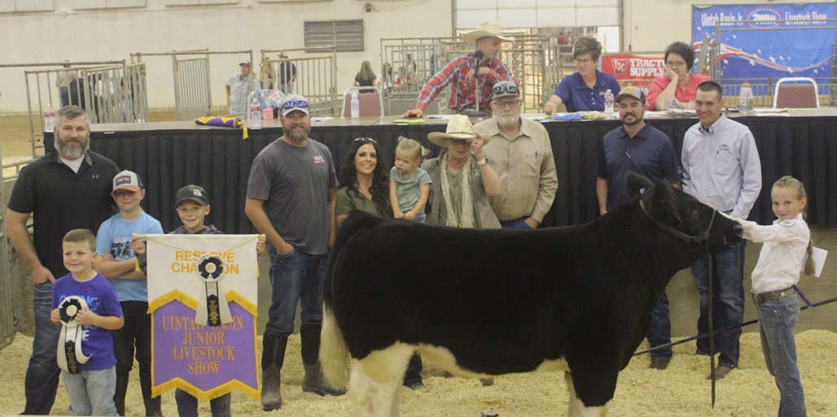
Reserve Champion Steer
Exhibited by Dalli Horrocks

Bought By: Circle Dot Ranch, Jones & DeMille Engineering Inc, Ikon Energy Solutions, B&D RV Center, Tu & Frum Inc, Brad and Susan Horrocks, Western Ag Credit, Big B Equipment, Ross Feed & Seed, Lexco, Stickman, Woods Construction, Horox Outfitter
Grand Champion Lamb
Exhibited by Cooper Jackson
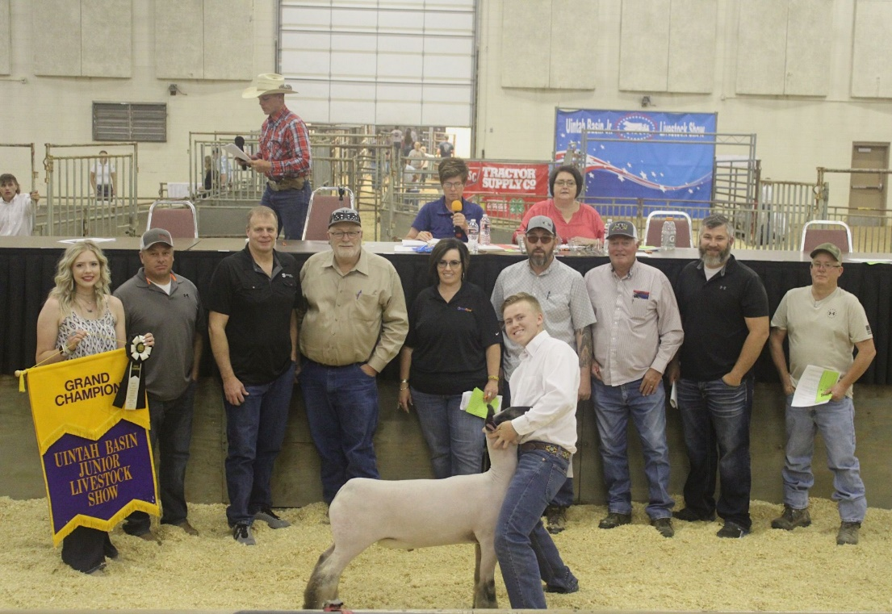
Bought By: Strata Networks, B&D RV Center, Roofing World, Brad and Susan Horrocks, Morcon Speciality Inc, Reladyne, C/J Rodeo, Koda Resources, Kevin Owens, Weldon Construction

Reserve Champion Lamb
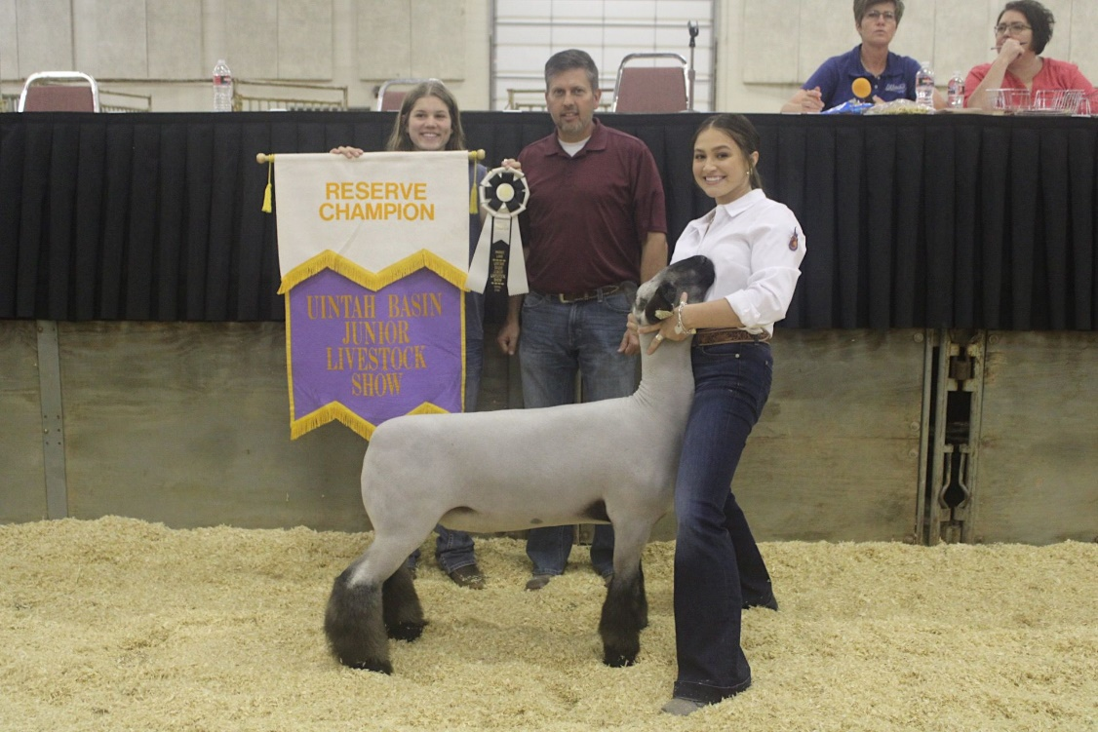
Exhibited by Kylie Kunzler
Bought By: IFA of Vernal

