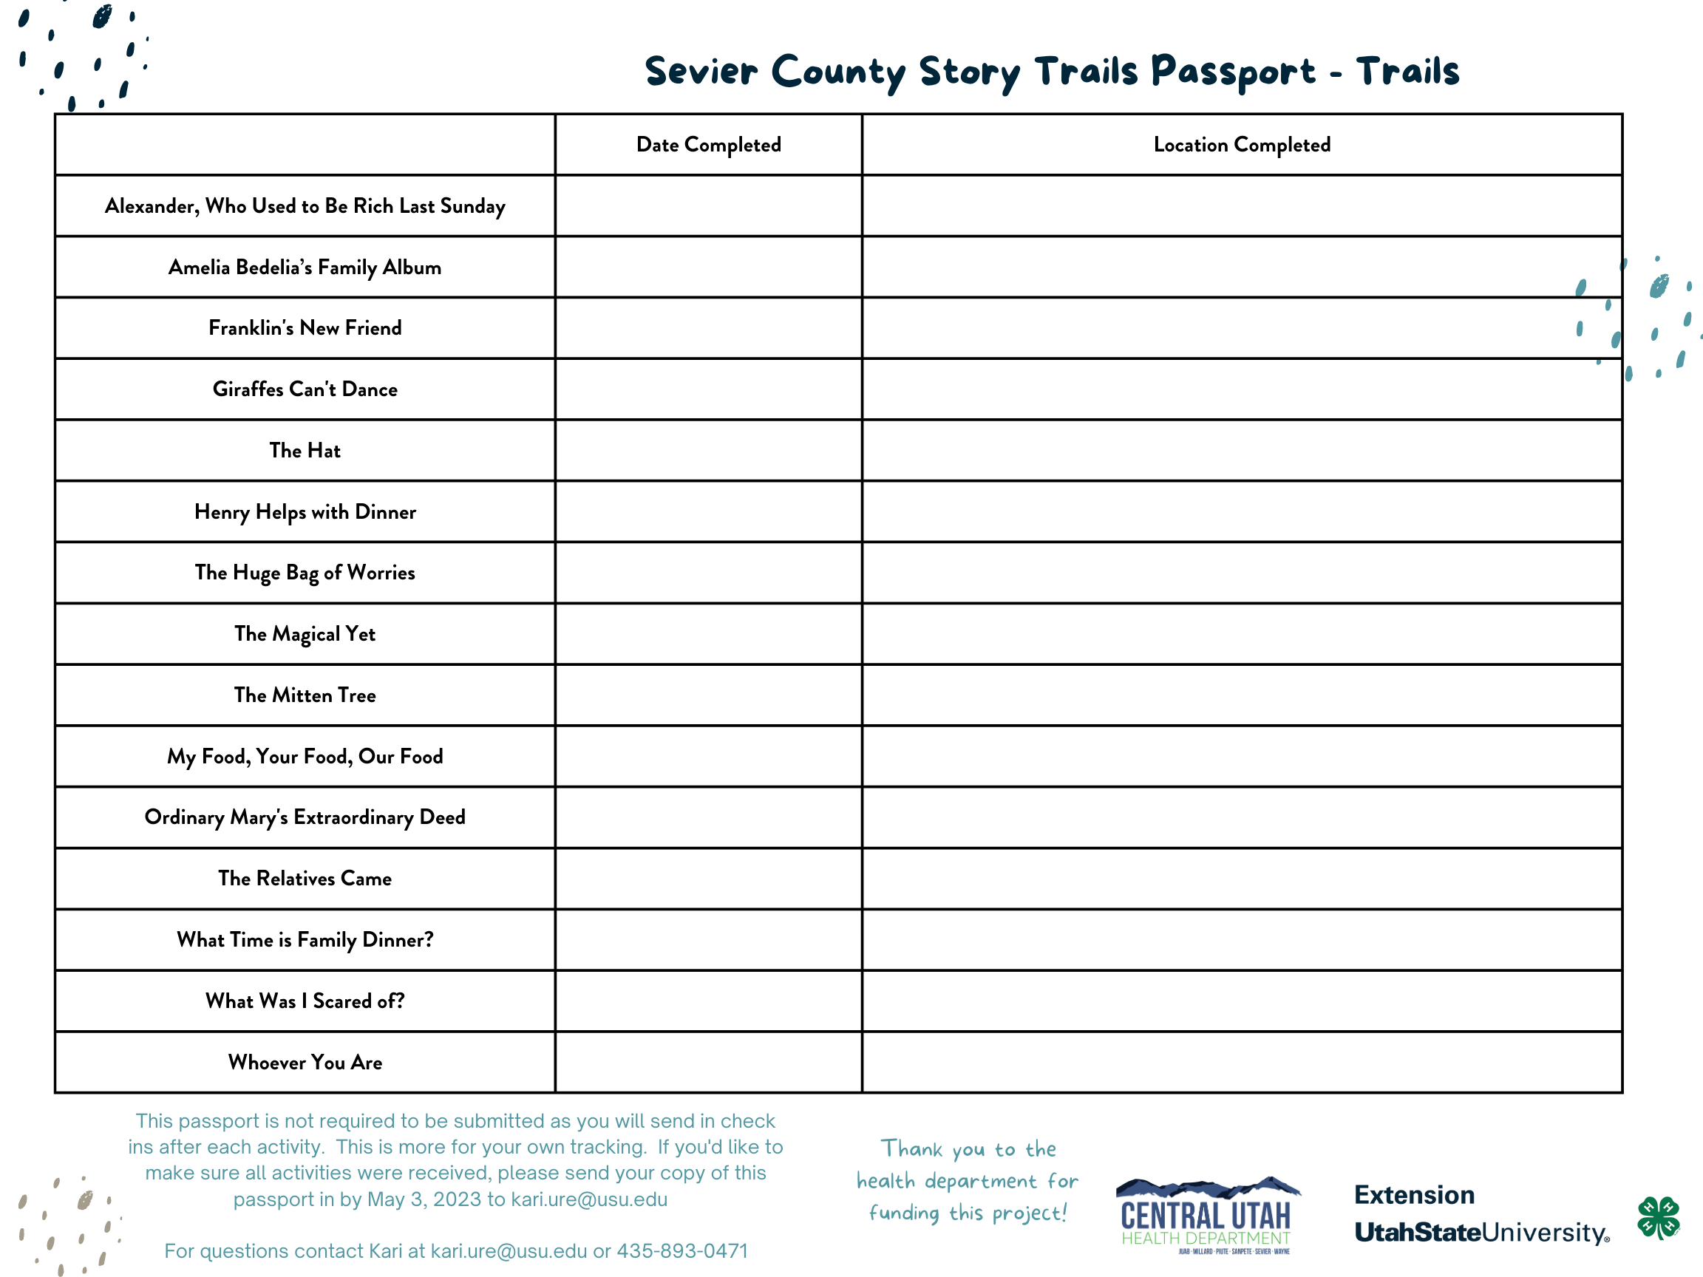
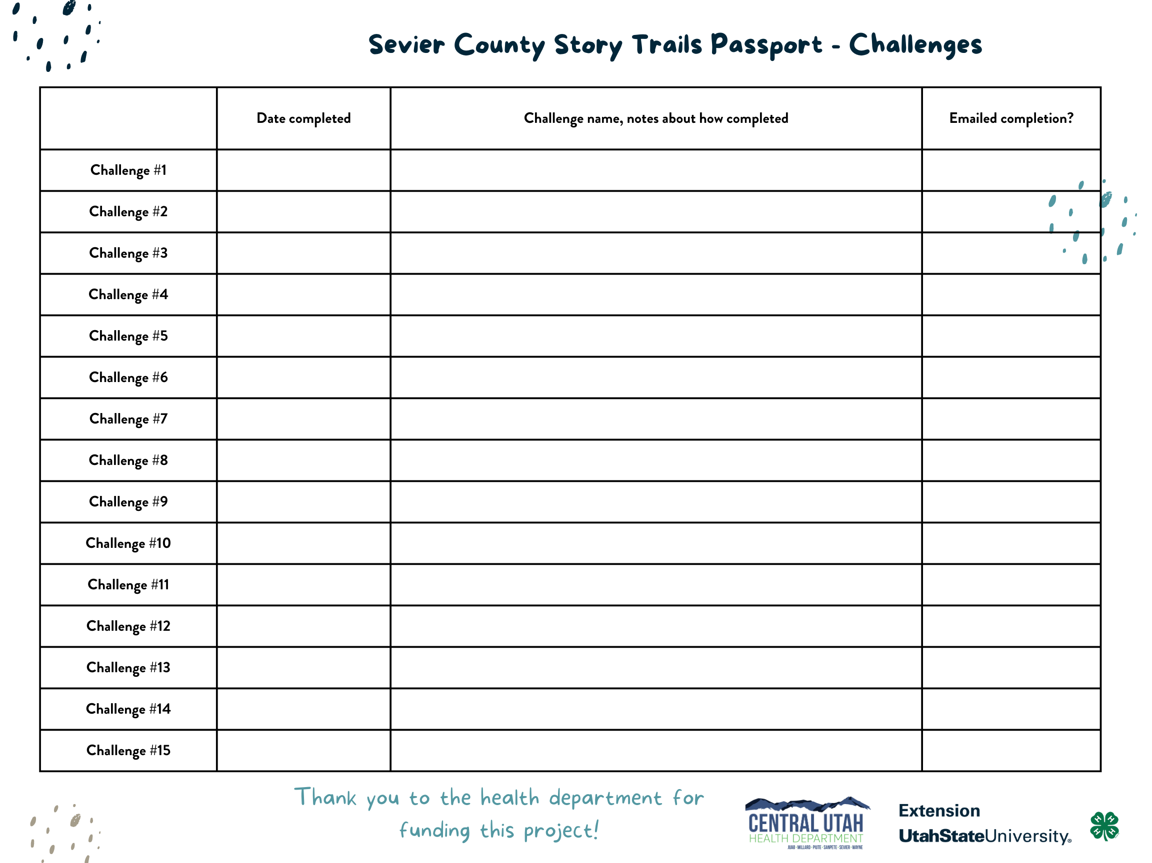
Story Trail Schedule
*Stories are changed on Mondays and Thursdays and timing varies. Match the number with the key below to find the stories by location.*
 | April 3-6 | April 6-10 | April 10-13 | April 13-17 | April 17-20 | April 20-24 | April 24-27 | April 27-30
Richfield (Central Utah Food Sharing) | 1 | 15 | 14 | 13 | 12 | 11 | 10 | 9
Redmond City Park | 2 | 1 | 15 | 14 | 13 | 12 | 11 | 10
Salina (Bike Trail) | 3 | 2 | 1 | 15 | 14 | 13 | 12 | 11
Aurora City Park | 4 | 3 | 2 | 1 | 15 | 14 | 13 | 12
Sigurd City Park | 5 | 4 | 3 | 2 | 1 | 15 | 14 | 13
Koosharem | 6 | 5, 13 | 4, 12 | 3, 11 | 2, 10 | 1, 9 | 15, 8 | 14, 7
Glenwood City Park*** | 7 | 6 | 5 | 4 | 3 | 2 | 1 | 15
Annabella Community Center | 8 | 7 | 6 | 5 | 4 | 3 | 2 | 1
Central Valley City Park | 9 | 8 | 7 | 6 | 5 | 4 | 3 | 2
Monroe City Park | 10 | 9 | 8 | 7 | 6 | 5 | 4 | 3
Joseph City Park | 11 | 10 | 9 | 8 | 7 | 6 | 5 | 4
Elsinore City Park/Library | 12 | 11 | 10 | 9 | 8 | 7 | 6 | 5
Richfield Head Start | 13 | 12 | 11 | 10 | 9 | 8 | 7 | 6
***When the park is reserved, trails will not be present***
Key for story numbers:
- Alexander, Who Used to Be Rich Last Sunday
- Amelia Bedelia’s Family Album
- Franklin’s New Friend
- Giraffes Can’t Dance
- The Hat
- Henry Helps with Dinner
- The Huge Bag of Worries
- The Magical Yet
- The Mitten Tree
- My Food, Your Food, Our Food
- Ordinary Mary’s Extraordinary Deed
- The Relatives Came
- What Time is Family Dinner?
- What Was I Scared of?
- Whoever You Are

