Utah 4-H Rabbit Program
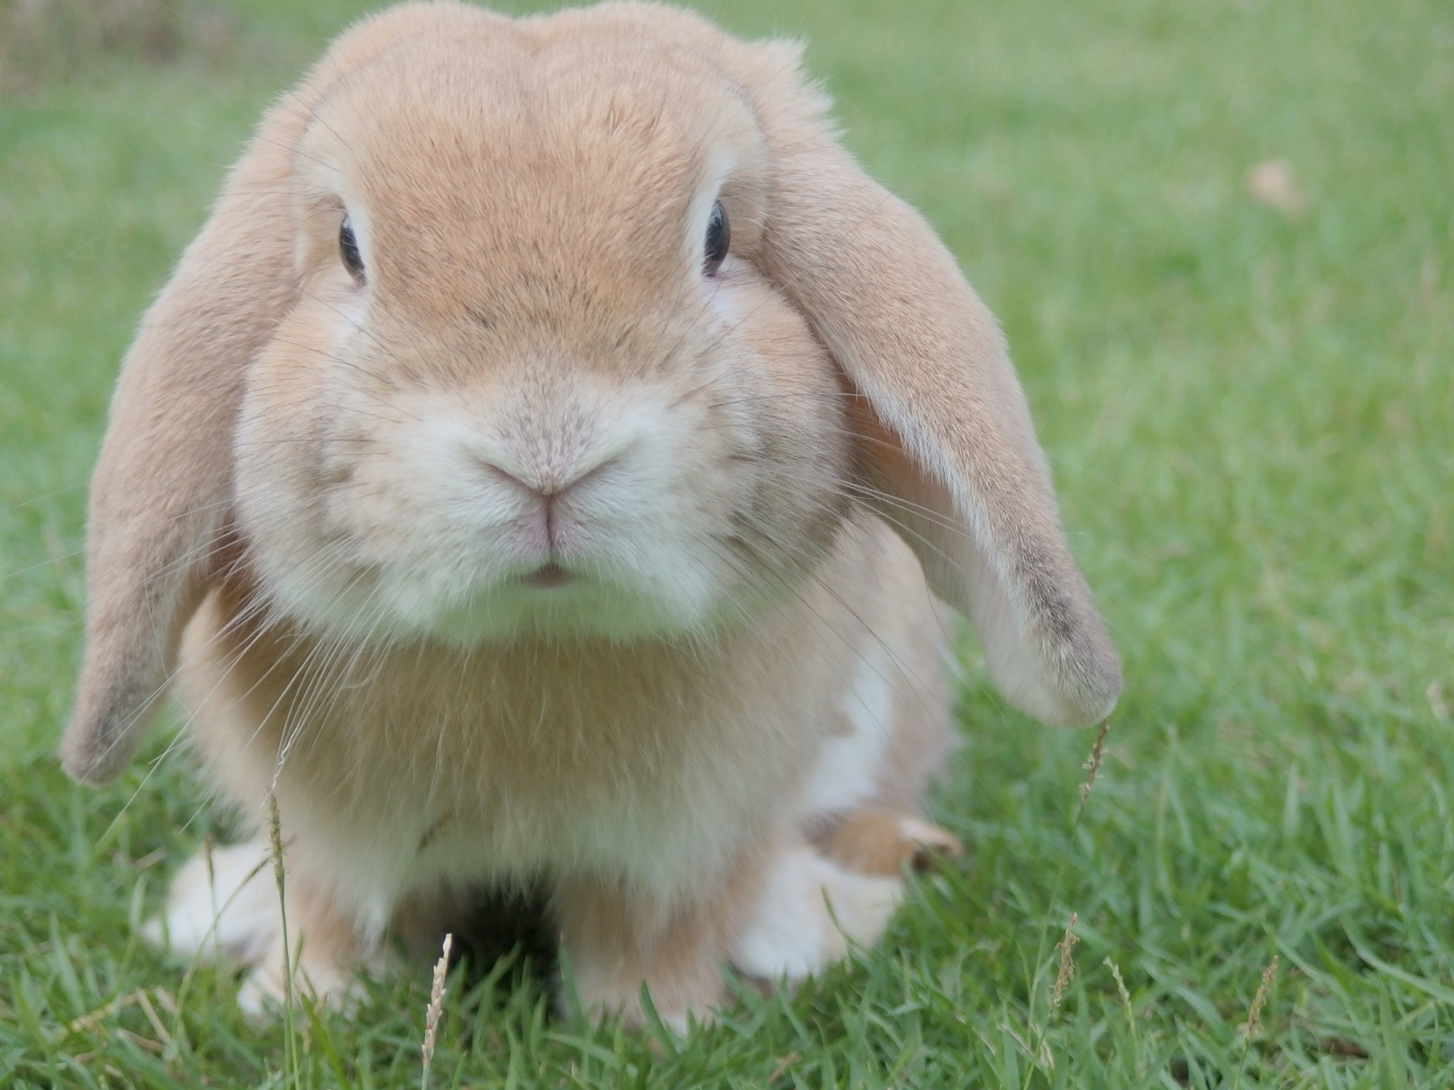

Rank Advancements

This book belongs to: ________________________________________
And my rabbit: _____________________________________________

Rank Advancement Level 1
This rank covers the very basics of handling rabbits and being safe and successful with a pet in the home. This rank should be easily achieved by all ages, including youth who are not yet 8.
Name ________________________________________ Rabbit’s Name ___________________________________
Club Leader ___________________________________ Phone_____________________________________
County Agent __________________________________Phone_____________________________________
Date Completed ____________________________________________________
Handler/Rabbit Team Skills  Pick 3 or more of the following | Date | Initials
Demonstrate how you would praise and reward your rabbit for good behavior.
Demonstrate how to approach a rabbit that appears frightened.
Demonstrate how to hold a rabbit that is frightened.
Demonstrate the proper way to hold a rabbit while standing.
Demonstrate how to properly take a rabbit in and out of its cage.
Demonstrate how to properly put a harness on your pet rabbit.
Mastery and Education  Pick 2 or more of the following | Date | Initials
Ask your leader to interview you on your rabbit project.
Show where the dewlap, saddle, loin, and hock are located.
Answer the following questions:
What are three popular purebred rabbit breeds in the U.S.?
What does ARBA stand for?
What is “buck” and “doe”?
What are three methods to keep your rabbit from being injured while being handled?
What are safe items for rabbits to chew on?
Citizenship and Personal Development  Pick 1 or more of the following | Date | Initials
Submit a portfolio to county or state contest.
Hold a leadership position in your club or at the county level.
Participate or help plan a community service project.
Work with a parent or club leader to set goals for your rabbit project and make a plan to achieve them.

By signing this form, I am verifying that the exhibitor mentioned has completed these tasks in a satisfactory manner and is ready to move on to the next level.
4-H Member ________________________________________ Club Leader Signature____________________________

Rank Advancement Level 2
This rank covers the basic skills and knowledge of nutrition and care needed to be safe and successful with a rabbit project in the areas of show, pet and breeding. This rank is designed to be achievable by youth 8 – 11 years of age.
*Level 1 must be completed to achieve a Level 2 Rank
Name ________________________________________ Rabbit’s Name ___________________________________
Club Leader ___________________________________ Phone_____________________________________
County Agent __________________________________Phone_____________________________________
Date Completed ____________________________________________________

Handler/Rabbit Team Skills  Pick 3 or more of the following | Date | Initials
Spend 15 minutes daily for a week reading or talking to your rabbit
Spend 15 minutes daily for a week with your pet in a pet proof area to let them get used to you (may be combined with above requirement)
Demonstrate how to check your rabbit for ear mites
Pass off the Utah 4-H Companion Animal Endorsement for Rabbits (coming soon!)
Demonstrate how much water a rabbit needs each day.
Demonstrate how to sanitize a rabbit’s cage, feeder, and watering system.
Demonstrate how to keep a rabbit cool in the summer months.
Demonstrate how to properly fit a harness to your rabbit and pros and cons of different styles including leashes
Work with a parent or club leader to come up with your own skill option.
Mastery and Education  Pick 3 or more of the following | Date | Initials
Create a poster or presentation on the proper diet for your pet rabbit including feed components and water. Present it to your club or similar audience
Participate at a county, regional or state 4-H Rabbit Workshop.
Ask your leader to interview you on your rabbit project.
Participate at county or state 4-H contests giving a public speech or demonstration on a rabbit related topic (discuss age appropriate options with leader).
Answer the following questions:
What is biosecurity and why is it important?
How often do you sanitize your rabbit’s cage?
What do you do if your rabbit did not eat their food from yesterday?
Does a rabbit’s nutritional and care needs change from summer to winter?
How often does a rabbit need fresh water?
How often should you check on your rabbit?
Learn how to introduce your rabbit to a new feed.
Go to a non-4-H Rabbit show or event and observe.
Work with your club leader or county staff to come up with your own Mastery option.
Citizenship and Personal Development  Pick 2 or more of the following | Date | Initials
Submit a portfolio to county or state contest.
Hold a leadership position in your club or at the county level.
Volunteer to help at a rabbit show.
Participate or help plan a community service project.
Work with a parent or club leader to set goals for your rabbit project and make a plan to achieve them.
By signing this form, I am verifying that the exhibitor mentioned has completed these tasks in a satisfactory manner and is ready to move on to the next level.
4-H Member ________________________________________ Club Leader Signature____________________________

Rank Advancement Level 3
This rank is for handlers that have owned a rabbit for two or more years. Youth that are junior and intermediate 4-Hers should be able to obtain this rank.
*Level 2 must be completed to achieve a Level 3 Rank.
Name ________________________________________ Rabbit’s Name ___________________________________
Club Leader ___________________________________ Phone_____________________________________
County Agent __________________________________Phone_____________________________________
Date Completed ____________________________________________________

Handler/Rabbit Team Skills | Date | Initials
Pick 7 or more of the following. Repeated skills from Level 1 or 2 MUST be re-done in the current year. For example, if the exhibitor participates in county, regional or state rabbit workshop, they must attend a second time to pass off that requirement for Level 3.
Demonstrate how to show the five points of view of a rabbit.
Demonstrate how to properly flip a rabbit onto its back and safely hold it there
Demonstrate how to check for diseases during your showmanship presentation
Demonstrate how to properly trim your rabbit’s nails. Identify the quick
Demonstrate how to pick up a lop-eared rabbit.
Pass off the Utah 4-H Companion Animal Endorsement for Rabbits (coming soon!)
Participate in a rabbit showmanship contest
Demonstrate how to properly handle and pose 3 different breeds of rabbits.
Train your rabbit to go over a small jump
Train your rabbit to use a litter box
Teach your rabbit how to pose according to its body type and hold for 1 minute
Mastery & Education | Date | Initials
Pick 5 or more of the following. The requirements for Level 3 Mastery need to be completed within 2 years of the time the youth wishes to achieve this rank. A limit of 3 options can be the same (but completed again) from previous years.
Attend an ARBA Rabbit Show
Prepare and teach a presentation on the five different rabbit body types
Create a poster about a rabbit related topic and present it to your club or submit it for county contest.
Demonstrate how to prepare your rabbit for show
Prepare a speech or demonstration on a topic related to your rabbit project. Present it to your family or club members (discuss age appropriate options with leader).
Participate in county 4-H contests giving a public speech or demonstration on a rabbit related topic (discuss age appropriate options with leader).
Ask your club leader to interview you on your rabbit project.
Teach others how to do rabbit showmanship.
Work with your club leader or county staff to come up with your own Mastery option.
Citizenship and Personal Development  Pick 3 or more of the following | Date | Initials
Submit a portfolio to county or state contest achieving a blue ribbon score.
Hold a club or county leadership position.
Be a show secretary at a rabbit show.
Participate in a countywide community service project.
Organize a community service project for your club.
Participate or help organize a Pet Show or Rabbit Workshop at the local level or participate in a show’s youth committee.
Work with a parent or club leader to set goals for your rabbit project and make a plan to achieve them.

By signing this form, I am verifying that the exhibitor mentioned has completed these tasks in a satisfactory manner and is ready to move on to the next level.
4-H Member ________________________________ Club Leader Signature____________________________________

Rank Advancement Level 4
This rank is for 4-H youth that have been showing and raising rabbits for several years and have developed excellent skills and knowledge about their rabbit project. Level 4 is a good goal for senior aged exhibitors to strive for. The requirements for this level do not need to be completed within the same year (unless they are repeats from previous years), but have to be completed within at least 3 years of the time the youth is seeking to obtain this level
*Level 3 must be completed to achieve a Level 4 Rank
Name ________________________________________ Rabbit’s Name ___________________________________
Club Leader ___________________________________ Phone_____________________________________
County Agent __________________________________Phone_____________________________________
Date Completed ____________________________________________________

Handler/Rabbit Team Skills | Date | Initials
Pick 10 or more of the following. Repeated skills from Level 3 MUST be re-done in the current year. For example, if the exhibitor passes of all the skills on the Agility Verification Form to complete Level 3, it must be completed again to count for
Level 4.
Compete in an ARBA Showmanship Contest.
Play the judge and evaluate your rabbit with your club as the audience.
Demonstrate how to palpate a doe to see if she is pregnant
Enter your rabbit into a course jumping show with at least three other rabbits
Earn a blue ribbon at a county or state level showmanship contest
Demonstrate getting you rabbit ready for a show: head to toe
Pass off the Utah 4-H Companion Animal Endorsement for Rabbits (coming soon!)
Demonstrate how to provide basic first aid to an injured rabbit
Design a nesting box for a pregnant doe and describe the process
Demonstrate how to pose and handle 5 different breeds of rabbits.
Teach your rabbit to come to its name
Teach your rabbit a simple trick (jumping on command or begging)
Teach your rabbit to “walk” on a leash
Design a maze or obstacle course for your rabbit and teach them to go through it
Teach your rabbit how to pose according to its body type and hold for 2 minutes
Participate in a 4-H rabbit show and win a blue ribbon or quality
Work with a parent or club leader to come up with your own skill
Mastery and Education | Date | Initials
Pick 12 or more of the following. The requirements for Level 4 Mastery do not need to be completed within the same year, but have to be within at least 3 years of the time the youth is seeking to obtain this level.
Write a rabbit related news story or article to be published in the local newspaper or newsletter.
Create and write a blog with a minimum of 10 posts related to animal husbandry and rabbit ownership.
Participate in or organize a county level rabbit showmanship or jumping contest.
Run a summer project club related to the rabbit project (minimum of 6 hours).
Create a lesson plan and teach your club on one of the following topics: health, first aid, nutrition, sanitization, or other rabbit project related event.
Help plan a countywide or regional rabbit clinic and teach at least one class on showmanship, nutrition, or an event specific clinic.
Participate at state 4-H contests giving a public speech or demonstration on a rabbit related topic (discuss age appropriate options with leader).
Volunteer or work at a pet hospital/veterinarian clinic for 20 or more hours.
Volunteer, shadow, or intern for a rabbit producer for 20 or more hours.
Volunteer, shadow, or intern for a certified ARBA Registrar for 20 or more hours.
Work with an animal rescue to foster and rehome a rabbit in need.
Be able to prepare your rabbit head to toe for a show.
Be a mentor to someone who is just getting started with their rabbit project.
Work with your club leader or county staff to come up with your own Mastery option.
Citizenship and Personal Development | Date | Initials
Pick 4 or more of the following. The requirements for Level 5 Citizenship do not need to be completed within in the same year, but have to be within at least 3 years of the time the youth is seeking to obtain this level.
Submit a portfolio to the state contest achieving a blue ribbon score.
Hold a county or state leadership position.
Organize a countywide community service project.
Help organize a statewide community service project.
Help organize a pet show or exhibition at the county level.
Contribute to your club, county, or state program by taking photos, posting to social media accounts, or other forms of publicity.
Organize and Teach a Rabbit Showmanship Clinic.
Help organized a rabbit course jumping show.
Work with a parent or club leader to set goals for your rabbit project and make a plan to achieve them.

By signing this form, I am verifying that the exhibitor mentioned has completed these tasks in a satisfactory manner and is ready to move on to the next level.
4-H Member ___________________________________ Club Leader Signature__________________________________

Rank Advancement Level 5
This rank is for 4-H youth that have truly excelled in their rabbit project. Youth that complete Level 5 are prepared to move from the 4-H program into the world of adulthood. These individuals have developed skills pertinent to various careers within the rabbit industry and are prepared to give back to the community. Level 5 is the highest level and is the hardest to obtain.
The requirements for this level do not need to be completed within in the same year (unless they are repeats from previous years), but have to be within at least 3 years of the time the youth is seeking to obtain this level.
*Level 4 must be completed to achieve a Level 5 Rank
Name ________________________________________ Rabbit’s Name ___________________________________
Club Leader ___________________________________ Phone_____________________________________
County Agent __________________________________Phone_____________________________________
Date Completed ____________________________________________________

Handler/Rabbit Team Skills | Date | Initials
Pick 10 or more of the following. Repeated skills from Level 4 MUST be re-done in the current year. For example, competing in an ARBA Showmanship Contest, but this accomplishment can only be counted once. If this is achieved in Level 4, it must be accomplished a second time to be counted for Level 5.
Demonstrate how to pose and handle 5 different breeds of rabbits. One breed for each rabbit body type.
Demonstrate how to tattoo a rabbit and teach about different types of tattoos. If possible, tattoo using different methods to discuss differences
Know and be able to demonstrate a complete veterinarian exam using information found in the ARBA Raising Better Rabbits and Cavies book.
Receive a blue ribbon at a county 4-H showmanship contest
Receive a blue ribbon at a county 4-H quality contest
Receive a blue ribbon at a state 4-H showmanship contest
Receive a blue ribbon at a state 4-H quality contest
Participate in an ARBA showmanship contest receiving first or second place out of 5 or more competitors
Participate in a county pet show/demonstration with your rabbit and receive a blue ribbon
Participate in a rabbit jumping course with 5 or more rabbits, placing first or second
Practice being the judge and evaluate three different breeds of rabbits with your club as an audience
Pass off the Utah 4-H Companion Animal Endorsement for Rabbits (coming soon!)
Teach two or more rabbits to pose next to each other according to their body type for 1 minute
Teach your rabbit to come to its name
Teach your rabbit a simple trick (must be different from previous Ranks)
Teach your rabbit to “walk” on a leash and demonstrate using obstacles
Work with a parent or club leader to develop your own skill
Mastery and Education | Date | Initials
Pick 15 or more of the following. The requirements for Level 5 Mastery do not need to be completed within the same year, but have to be within at least 3 years of the time the youth is seeking to obtain this level.
Write a news story or article to be published in the local newspaper or newsletter.
Create and write a blog with a minimum of 15 posts related to animal husbandry and rabbit ownership, rabbit careers, or other rabbit related topics.
Help organize a county or state rabbit show or contest.
Run a summer project club related to the rabbit project (minimum of 6 hours).
Create a lesson plan and teach your club on one of the following topics: health, first aid, nutrition, biosecurity, or other rabbit project related event.
Help plan a countywide or regional rabbit clinic and teach at least one class on showmanship, nutrition, or an event specific clinic.
Determine which are your best quality of rabbits and rank them. Enter them into a show and compare your placing to the judge’s.
Teach a workshop on starting a rabbit breeding program including pedigrees, records, and good animal husbandry
Participate at state 4-H contests giving a public speech or demonstration on a rabbit related topic (discuss age appropriate options with leader)
Volunteer or work at a pet hospital/veterinarian clinic for 40 or more hours (20 additional hours from level 4)
Volunteer, shadow, or intern for a rabbit producer for 40 or more hours (20 additional hours from level 4)
Work with an animal rescue to foster and rehome a rabbit in need
Explore a rabbit related career and set up a job shadow. Report on your experience in a presentation, blog post, or article to share with your club.
Know and be able to demonstrate a complete veterinarian exam of your rabbit.
Shadow or be an intern for a certified ARBA Registrar for 40 or more hours (20 additional hours from level 4)
Judge a rabbit showmanship contest.
Judge a rabbit quality show.
Complete a breeding project demonstrating an understanding of responsible and ethical rabbit breeding.
Be a mentor to someone who is wanting to start their own rabbit breeding program.
Work with your club leader or county staff to come up with your own Mastery option.
Citizenship and Personal Development | Date | Initials
Pick 5 or more of the following. The requirements for Level 5 Citizenship do not need to be completed within in the same year, but have to be within at least 3 years of the time the youth is seeking to obtain this level.
Submit a portfolio to the state contest achieving a blue ribbon score.
Hold a county or state leadership position.
Help organize a statewide community service project.
Help organize a rabbit show or exhibition at the regional or state level.
Organize and Teach a Rabbit Breeding Clinic.
Contribute to your club, county, or state program by taking photos, posting to social media accounts, or other forms of publicity.
Start your own county rabbit show.
Become a certified ARBA Registrar.
Become a certified rabbit Judge.
By signing this form, I am verifying that the exhibitor mentioned has completed these tasks in a satisfactory manner and is ready to move on to the next level.
4-H Member ___________________________________ Club Leader Signature_________

