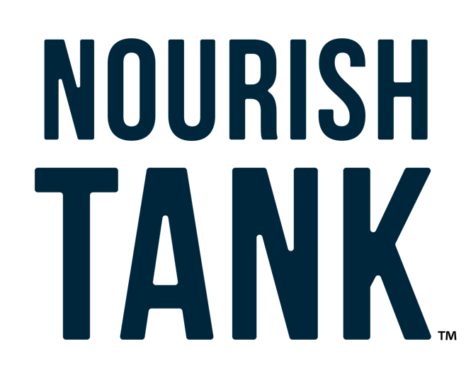

2023 USU Nourish Tank
Brainstorm Worksheet

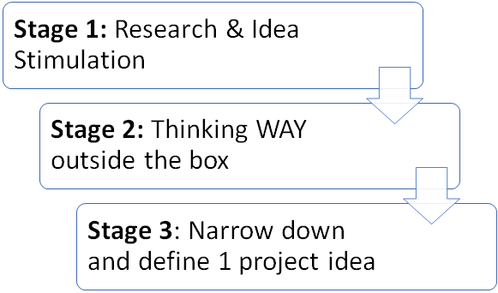

Stage 1: Research and Idea Stimulation

Review the purpose of the program:
Nutrition security means that all [people] have consistent and equitable access to healthy, safe, affordable foods essential to optimal health and well-being. (USDA Definition)

The USU Hunger Solutions Institute is looking for project proposals to combat nutrition insecurity in unique, innovative, and sustainable ways.

The Hunger Solutions Institute plans to apply for funding and implement the winning proposal over the two years following the Nourish Tank event. This means that proposal plans should be able to be implemented in two years or less. Solutions should be designed for a specific population (immigrants, single mothers, ex-convicts, etc.).

Research and list 5-10 organizations addressing factors impacting nutrition insecurity. Look for local, national, and world-wide programs to help you with your brainstorming.
Local Organization Examples
Local foodbanks, community gardens, local stores doing food drives, local governments, wellness fairs, crisis centers, recreation centers, schools, etc.

State or Regional Organization Examples:
Hunger Solutions Institute, USU Extension, Food Security Councils, Health Department, LDS Humanitarian Center, Utahn’s Against Hunger, Harmons Grocery Store, Utah Food Bank, Smith’s Grocery Stores, Associated Food Stores, Zion’s Bank, Intermountain Healthcare, Dominion Energy, etc.

National Organization Examples:
Feeding America, Meals on Wheels, Habitat for Humanity, United Way, AmeriCorps, Salvation Army, etc.

International Organization Examples:
Action against Hunger, Heifer International, World Food Programmed, The Hunger Project, Bread for the World, UNICEF, Gates Foundation, Lifting Hands International, etc.

 | Organization Name | Local, State, national, international, etc. | How is this organization addressing factors that impact nutrition security?
1

2

3

4

5

6

7

8

9

10

Choose a specific population you would like to focus on. Be as specific as you can:
(Population definition: A group, section, or type of people)
Examples: Low-income single parents in Utah, Refugee families in Cache County, WIC participants in rural counties, Latino children in low-income families in Salt Lake City, families without homes in Utah, low-income students on university campuses, etc.

Stage 2: Think WAY Outside the Box

Rapid fire big picture brainstorm: If you had 0 limitations, what would you do? Set a timer for 20 minutes and start writing down as many big ideas as you can think of. Keep going until you start listing creating silly/radical/out of the box ideas… and then keep going for another 5-10 minutes. (Try to aim for 25 or more ideas)

List 5-10 different industries (not specific companies) and creatively think of how they could each address nutrition security. Again, think outside the box. They may not be working with nutrition security yet, but they may have resources that would be supportive in your future projects. Connect at least one of your solutions from your brainstorm in stage 2 (previous page) to each of the industries.

 | Industry  (Transportation, grocery stores, dining, engineering, theater, etc.) | Describe how this industry could support nutrition security  (Skills, financial, volunteers, connections, tools, etc.) | Which Stage 2 brainstorm solutions could this connect to?
1

2

3

4

5

6

7

8

9

10

Stage 3: Narrow down to 1 idea
Now review your ideas- do you see any ideas or themes that spark your interest?
List your ideas here:

Focused Goal:
Write down a specific nutrition security problem you would like to address in your project.

In this project, I will address:

Project Description:
Now that you have your focused goal- decide on the most creative and meaningful project to reach your goal. The project is:

Success looks like:
What is the end goal- how do you know that your project was a success?

Barriers to Success:
What would get in your way of succeeding?

Solutions to Potential Barriers:
Brainstorm solutions to some potential barriers that the project may come across.

Timeline:
Write out a general timeline for your idea.

Materials List:
What tools and resources would you need to make this project successful? (Use this list to help you make the budget in your proposal)

Project Team & Partners:
If the Hunger Solutions Institute implemented this project, who are some potential partners that could strengthen the project? Think about potential partners and resources who might be willing to support this project.

Additional Brainstorm Notes/ Ideas:
Example topics to consider:
- Creative name/ title of your program
- Sustainability of the program

