Call for Abstracts

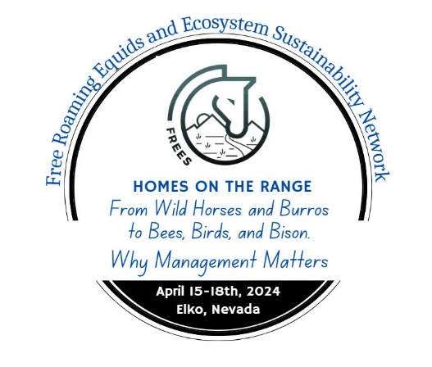

Submit an Abstract
Wild horses and burros are considered to be "symbols of the historic and pioneering spirit of the West" (1971 The Wild Free-Roaming Horses and Burros Act of 1971) and as such are protected and an integral part of public lands. However, management of wild horses and burros must consider the needs of wildlife. The goal of this year’s Summit is to provide context and information about wild horse and burro interactions with wildlife and their habitats.
Poster Session - In addition to our oral presentations, we will host a live poster session to present work currently in progress, preliminary results, and concepts across a wide range of issues. Posters will be displayed throughout the Summit with a separate time frame within the conference agenda for authors to interact with attendees.
Abstract Submission* - The body of the abstract must be 250 words or less. Abstracts are due by March 15, 2024. Abstracts received after the deadline will be considered if space is available. Presenters will be notified of acceptance by April 1, 2024.
Questions about abstract submission should be directed to Dr. Kate Schoenecker (schoeneckerk@usgs.gov).
Information needed for abstract submission:
- First and Last Name of presenter
- Email
- Phone #
- Student (Y or N)
- Organization
- Program/Research Type: (Current/Ongoing, Finished, In Progress/Developing)
- Topic
- Abstract Body (250 words or less)

