USU Extension Grant 2016 – Final Report

Project Leader: Marion Murray, Department of Biology
Project Title: Improving Delivery of Pest Management Recommendations for Utah Fruit Growers
Project Duration: June 1, 2016 – May 30, 2017
Total Requested: $9,858

Project Summary
A need for mobile and desktop access to simple, yet informative fruit pesticide information has been illustrated via feedback to the Utah Integrated Pest Management Program biennial surveys, and to county extension offices. To meet this need, this project updated a relational database to contain 160 USU Extension-recommended insecticides and fungicides, including commercial and residential products, including detailed attributes. Those materials were then displayed to the public in two ways to help them make an informed treatment decision. We added a customized pesticide search feature on intermountainfruit.org, and updated the existing mobile app, Fruit PestFinder, to show lists of the products for commercial and residential use.

Project Results
- Collaboration between on- and off-campus faculty
During this project, we worked with the Box Elder and Utah county offices, which represent the two primary fruit growing regions in the state. Faculty in those offices helped to determine the need for this project by sharing their feedback, and they reviewed the search feature through its development, and have distributed a flyer to market the Fruit PestFinder app and intermountainfruit.org.

- Outputs, Outcomes/Impacts
The outputs include:
- An updated mySQL database and companion administrative website. After the update, 160 commercial and residential pesticides and their attributes were entered.

- Mobile-friendly, customizable pesticide search feature on intermountainfruit.org. Users can search by crop, crop stage, pest, organic or conventional, and more. The search results help users to make an informed decision to manage for pesticide resistance, pollinator and beneficial insect health, efficacy, residual action, and human health. The figures below show the simple search interface, and one result example.

- Inclusion of commercial and residential pesticides in the “management tab” of the existing Fruit PestFinder app, divided into conventional and organic lists. A screenshots of the app is also shown below.
Screenshots of the pesticide search feature and an example result on intermountainfruit.org, and the pesticide options tabs on the Fruit Pestfinder app.
.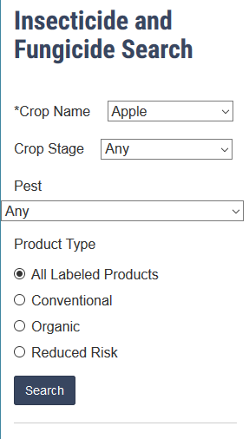 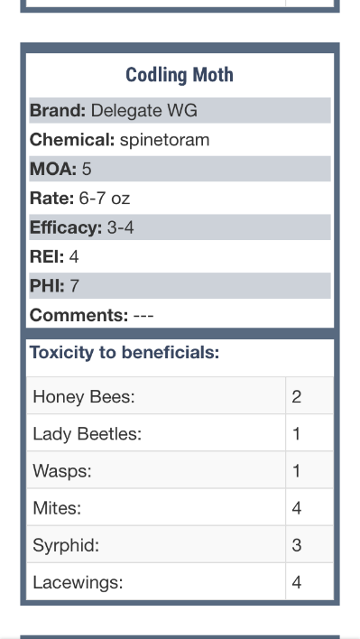 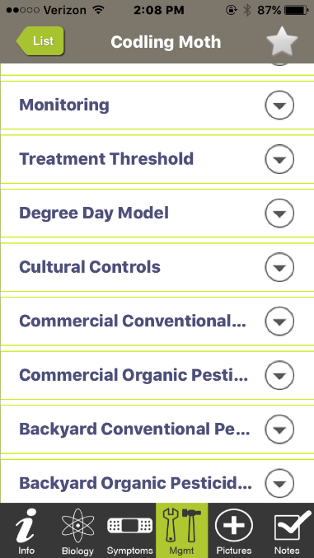
Outcomes/impacts:
The project was evaluated using Qualtrics surveys. For the intermountainfruit.org search, we added a link to a survey (n=35) on the search page, and for the Fruit PestFinder app, we created a message (with a link to the survey) that displayed after 3 months of use (n=72).

A prior survey conducted in 2015 showed that approximately 73% of commercial growers in the Intermountain West use intermountainfruit.org. In this project’s pesticide search survey, 85% of users found the search helpful, and 92% would recommend it to others. The survey for the Fruit PestFinder app showed that 100% of users used the app to identify and treat at least one new pest. The results also showed the following impacts:

  - Preferential selection of reduced-risk pesticides. The app and the search feature highlight organic and reduced-risk pesticide options. And the search feature also includes toxicity information for beneficials, plus efficacy ratings. Users can look at these pieces of information to select the products that are safe on beneficials, yet work effectively. In the app, most users (87%) ranked the homeowner organic product listing as their top go-to section of the app. In the search feature, 58% of users noted that they selected products based on low toxicity to beneficials.

  - Preventing pesticide resistance: The search engine clearly identifies the mode of action of each material, allowing growers to easily select products that conform to a recommended rotation strategy, and 68% of users responded that the search results helped to select products representing different pesticide groups.
  - Economic advantages: With access to an easy-to-use search feature and app, growers can quickly find the information they are looking for, allowing them to free up time for other important activities. Users of the app estimated an average of 2 hours saved in determining the safest pesticide treatment. When asked about the benefits of the search feature, respondents ranked “savings of time in pest management” as the second most beneficial feature.

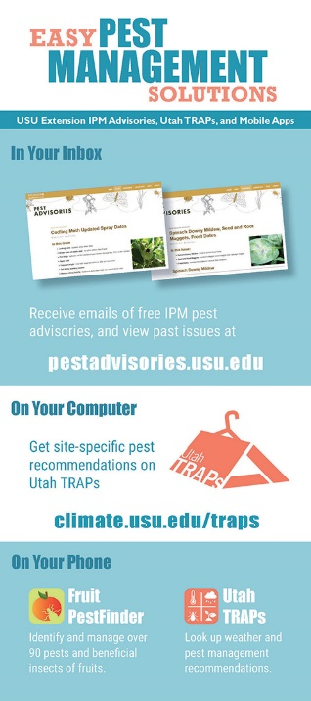
- Efforts to Produce Scholarly Materials
There will be no formal publication from this project, as it was strictly outreach. However, we did develop a rack card (shown at right) to market the outputs in county extension offices, farm supply stores, and garden centers.

- Efforts to Secure Extramural Funds
We applied for two grants. One was through Utah Department of Agriculture and Food to further develop outreach offerings to Utah fruit growers, and the other was through USDA NIFA to support a variety of activities, including programming work on the app and website. We received both of these grants.

Project Presentation
The project was presented briefly at the 2017 annual conference. A more in-depth discussion will be presented to members of the Bushwhackers group, which is comprised of on- and off-campus Hort and Ag faculty and staff. This meeting will take place in either fall 2017 or during annual conference 2018.

