Intermountain Beef 3910 – Utilizing Latino Packer Trainers as Beef Carcass “Experts”

Kim Chapman, Regional Livestock Specialist, Richfield Utah
Dale Zobell, Beef Specialist, Animal, Dairy and Vet Sciences
Dept, USU

The ten year evolution of the Intermountain Beef 3910 program (IB 3910) sponsored by Utah State University Cooperative Extension and the College of Agriculture has helped producers, consumers, and packer/processors better understand how to improve and strengthen markets for quality Utah beef. The IB 3910 program introduces participants to:
- grading criteria and live animal evaluation
- use of live animal ultrasound as a management tool
- beef quality assurance management practices
- value-added beef products that improve consumer demands
- beef carcass breakdown and evaluation
- electronic ID and traceability of animals from ranch to plate
- consumer acceptability and perception of beef products
- genetic selection for Value-Based marketing of beef
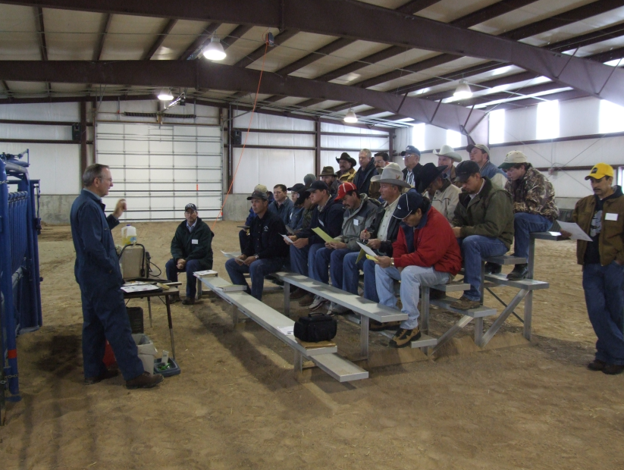
IB 3910 integrates the knowledge and skills of participants who are ranchers/farmers, packer/processors, feed lot operators, agricultural technicians, and others interested in the improvement of a quality beef product. Since the implementation of IB 3910, restructures and improvements have taken place in the program. For example, during a brainstorming session Dick Whittier, Dale Zobell, Kim Chapman and Randy Balls from JBS Swift, formed the idea of integrating trainers from the packing industry as hands-on key experts to the IB 3910 program.

The Intermountain Beef 3910 program planners identified a need to evaluate the beef carcass breakdown process, an integral part of the program, but did not have the skilled trainers to assist in the program and so employed the skills of JBS Swift trainers to assist in this area. Many of the trainers in the JBS Swift processor/packer facility located in Northern Utah, are Latino/Latinas and are relied upon to train other employees in the local packing industry These trainers bring with them a plethora of skills including the ability to communicate with packing management who may not be bilingual. Also, their firsthand knowledge and ability to train others in the effective breakdown process of a beef carcass for wholesale distribution, makes them a valued asset to the industry. As a result of using the JBS Swift trainers, beef producer participants were introduced to the evaluative skills of the trainers. Additionally, the trainers gained an appreciation for what beef producers must do to provide quality beef to the processor/packer. The timely help of the Latino/Latina trainers worked well for the IB 3910 since trainers were readily available to assist the program during timeframes when campus facilities were open for IB 3910 sessions.

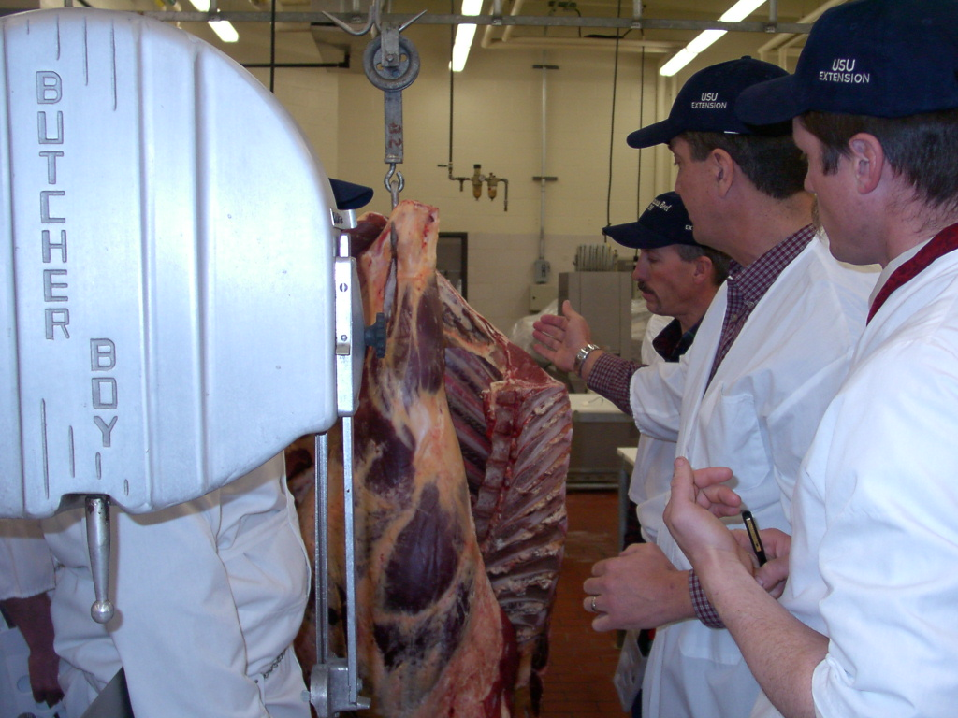
The Latino/Latina trainers have become an integral part of IB 3910 serving as “experts” to the program. Program participants view the Latino/Latina trainers as highly skilled and knowledgeable in the beef packing industry. The partnership with processor/packers and producer/participants has significantly enhanced the program while utilizing the talents of a here-to-for underutilized diverse training resource.

Lessons Learned

- Recognize the potential expertise found in diverse audiences and then capitalize on it.
- Engage partners who bring synergy and perspective to problem solving in planned programs.

D.L. Holmes 11.10

Further information on program adoption in your area contact:
Kim C. Chapman, County Director Sevier County 435-893-0475.
Dale R. Zobell Beef Specialist ADVS 435 797-2144.

