USU Extension Grant – Final Report

Project Leader: Beth Burritt (A00015925); Range Area Extension Agent; Department of Wildland Resources

Project Title: Understanding Aspen Chemistry to Reduce Aspen Herbivory in Western Landscapes

Beginning and End Date: June 1, 2015 – May 30, 2016

Total Requested Amount: $9,993.20

Objective: To identify and quantify the chemistry (nutrients and toxins) of different aspen stands and the grasses, forbs and shrubs growing in the aspen understory based on the elk browsing intensity of aspen. This project will help land managers identify aspen stands that may not regenerate due to browsing by elk, deer, cattle, and/or sheep.

Results
- The higher elevation sites were more likely to contain higher amounts of grass (P=0.03) in the understory and less dead plant material (P=0.06) than lower elevation sites.
- Higher elevation stands tended to have more crude protein (P=0.14) and less total digestible nutrients (TDN a measure of energy) (P=0.13) in the understory than lower elevation sites.
- As the levels of salicortin (P=0.08) and total phenolics (P=0.10) declined in aspen leaves, the percentage of browsed aspen leaves and stems in a stand tended to increase.
- The number of fecal of pellets in the aspen understory and the nutrient biomass were not correlated.
- However, there was a negative correlation between understory crude protein biomass/ha (P=0.09) and fecal pellet counts.
- While there was no significant correlation between aspen recruitment and nutrient biomass in the understory, recruitment tended to be greater in aspen stands with higher amounts of crude protein and TDN (P= 0.12 and 0.15, respectively) biomass in the understory.

Discussion
Our results show that higher levels of crude protein in the understory of an aspen stand decreased the likelihood that aspen trees were browsed. Crude protein in the understory was inversely related with stand use (fecal pellets) and positively related with recruitment. Our results were in agreement with Holeski et al. 2016 showing that deer avoided aspen trees with higher levels of nitrogen when high nitrogen forages were growing near aspen trees. There was a negative relationship between the percentage of browsed aspen stems and the level of salicortin and total phenolic glycosides in aspen leaves. Our findings agree with the findings of others studying aspen defensive chemistry (Bailey et al. 2007, Wooley et al. 2008, Villalba et al. 2014). We found more forbs in the understory, higher levels of protein and nutrient biomass, and less shrub biomass at high elevation compared to low elevation sites. Stands with higher protein levels in the understory and greater defenses in aspen leaves discouraged aspen use.

Conclusion
There is an interplay between in aspen chemistry, animal nutritional state, and nutrients in the understory. High forage availability and high levels of protein may discourage aspen use on landscapes. However, during pen studies, animals that received a high-protein supplement ate more aspen than control animals. In addition, restricting energy also encouraged aspen use. Therefore, animals foraging on a landscape with low forage biomass that is also low nutrients will likely eat more aspen. Supplementing with protein under these conditions will enable animals to eat even more aspen.

Avoidance of aspen is not always dependent on the chemical defense in aspen. Under certain conditions, nutrients rather than aspen’s chemical defenses drives preference for aspen leaves. However, when chemical defenses in aspen do reduce aspen intake, it is in a dose dependent manner.

In order to minimize the impacts of browsing of aspen by elk on the landscape, managers should focus their efforts on aspen stands with low amounts of nutrients and biomass in the understory. Providing a supplemental diet balanced for energy and protein to meet an elk’s nutritional needs will likely minimize intake of aspen by elk. To reduce browsing of aspen by ruminants, managers should improve the nutrient content at these sites using supplements, hay, or food plots that reduce aspen use. They may also want to consider adding aspen bark to the supplement.

Currently, there is a huge controversy over the decline of aspen due to browsing by large ruminants (elk, deer, cattle and sheep). This research may help wildlife and livestock managers to decrease aspen use by ruminants. We will disseminate our results to individuals in the state who deal with aspen management in Utah (Extension, Forest Service, and Division of Wildlife Resources). As part of our outreach efforts, we will write one or two facts sheets, an article for Rangelands and another for the Journal of Chemical Ecology, and post results on the USU Rangelands Website.

Juan Villalba, a member of this project, received funding from private land owners in Colorado to build upon this work. Dr. Villalba received a grant for $28,800 from August 2016 to August 2017, which may be renewed depending on results. Results from the Colorado study will be directly applicable to Utah.

This grant helped to support a graduate student in her third year of research. The study was conducted during the summer of 2015. Unfortunately, laboratory results and statistical analyses were not completed until February 2017.

______________________________________________________________________

Beth Burritt (Project Leader)

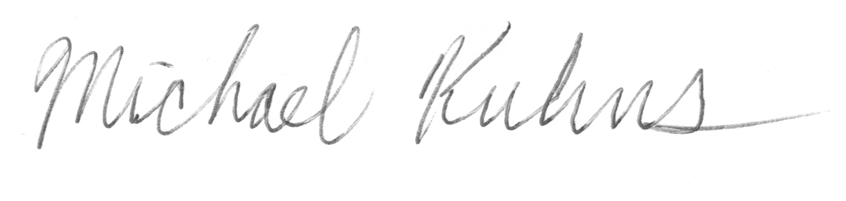

_________________________________________________________________________

Mike Kuhns (Department Head)

