
- Download the GooseChase Android or iPhone app.
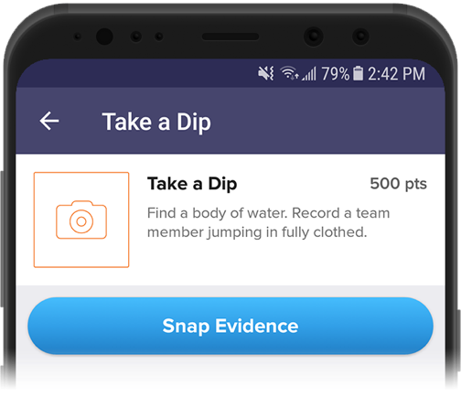
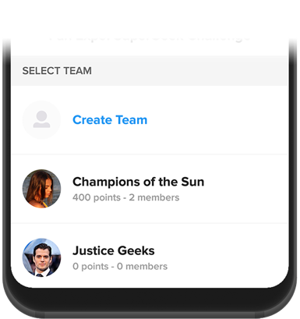
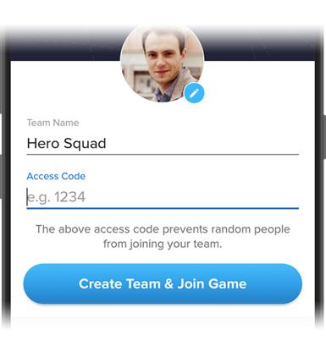
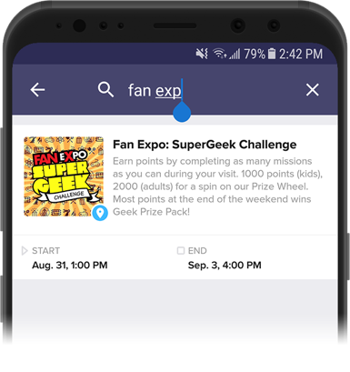
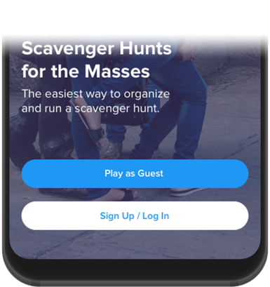
- Choose to play as a guest; or register for a personal account with an email, username, and password of your choice.
- Tap the search icon and enter the name of your game, or game code (given to you by your game organizer.)

- If you're playing as part of a team, create your team or select your team from the list if it's already been created. If you're playing individually, enter your player name or select your player profile if it’s already been created.

- Once in the game, you’ll be presented with the missions you or your team are attempting to complete. Mission types can include Photo/Video, Text or GPS check in. To complete a mission, select it from the list and hit the “Snap Evidence” button.
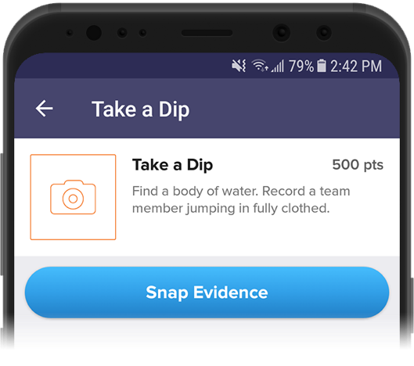

- Make sure you’re completing missions accurately! (e.g. “take a picture with a zebra” means take a picture with a real zebra, not next to a zebra on a computer screen)

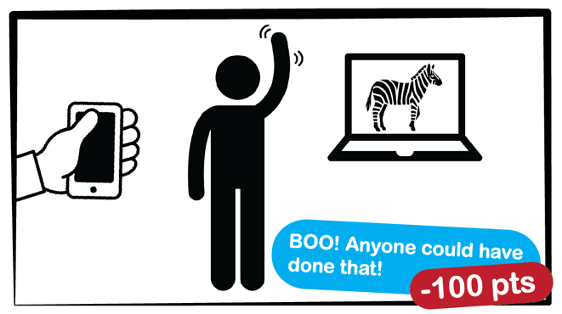
Your game organizer can deduct points from your team if your submission falls short.

Bonus points can also be awarded to missions accomplished in extraordinary
fashion!

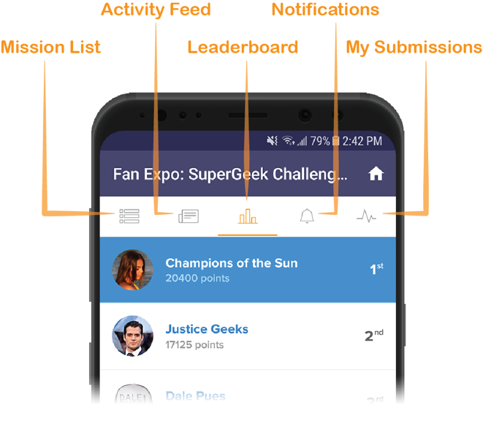
- Using the navigation tabs, you can keep track of how you are doing via the activity feed and the leaderboard, see notifications from the game organizer or review (and resubmit) your previous submissions.

- Most importantly, Have fun! Get really creative, interact with your fellow players and organizers and don’t be shy!

