All Shows
Junior Showmanship

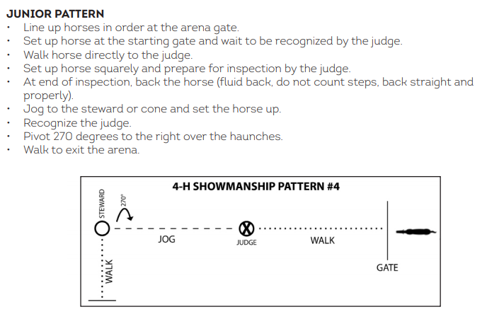
Show #1
Senior Showmanship
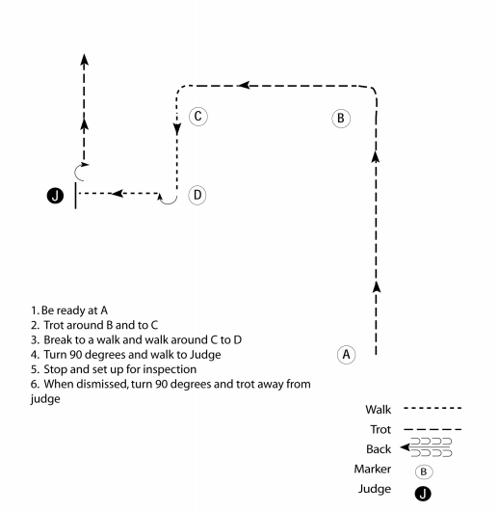

Show #2
Senior Showmanship
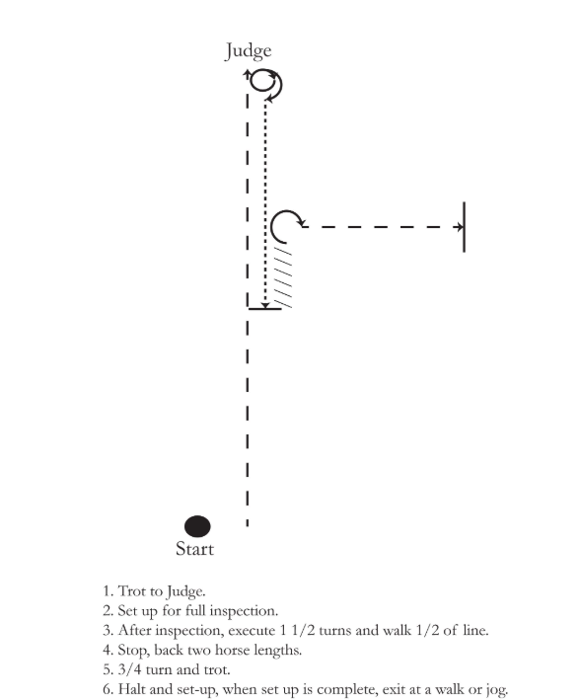

Show #3
Senior Showmanship
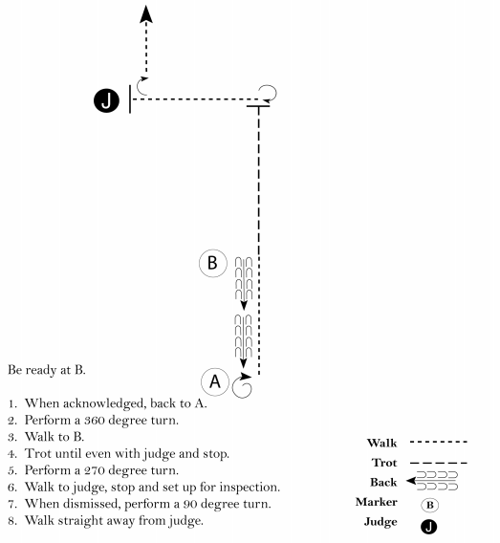

Show #1
Intermediate Showmanship

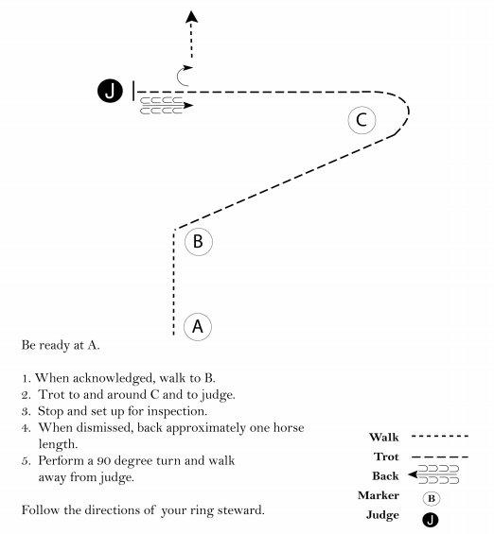
Show #2
Intermediate Showmanship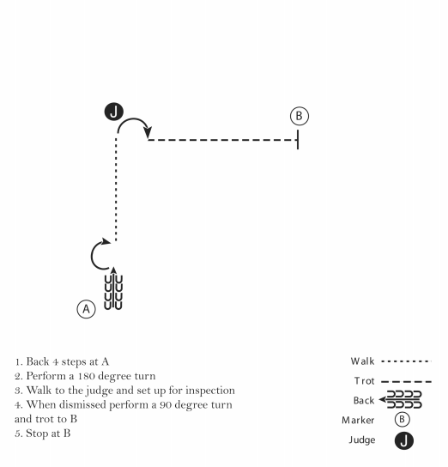

Show #3
Intermediate Showmanship

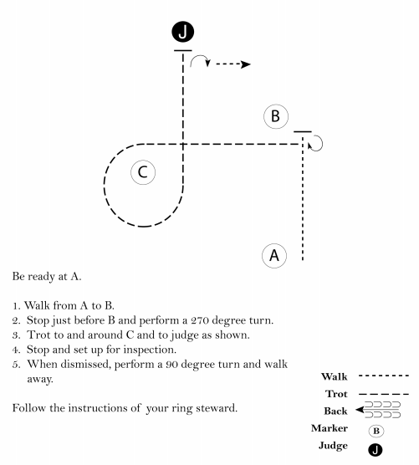

Show #1
Two Hand Showmanship
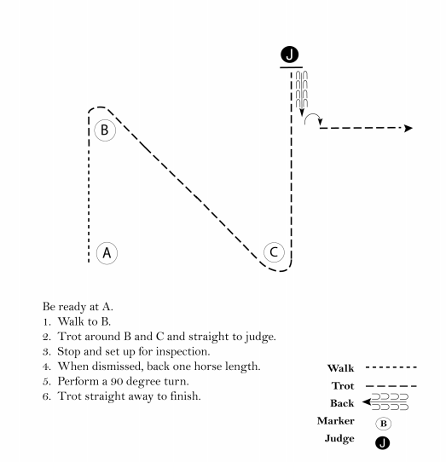

Show #2
Two Hand Showmanship
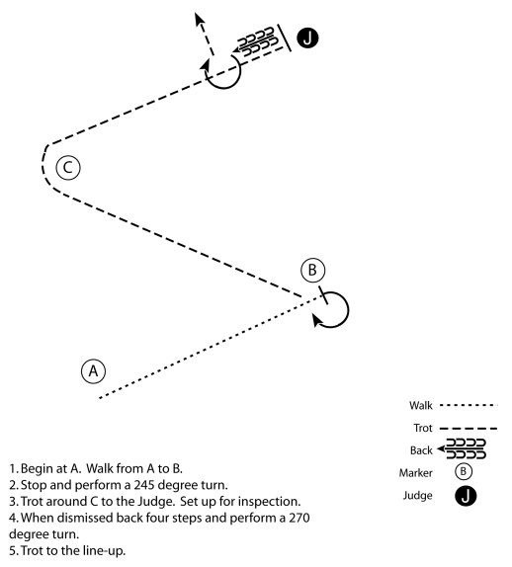

Show #3
Two Hand Showmanship
