Show #1
Junior Ranch Riding

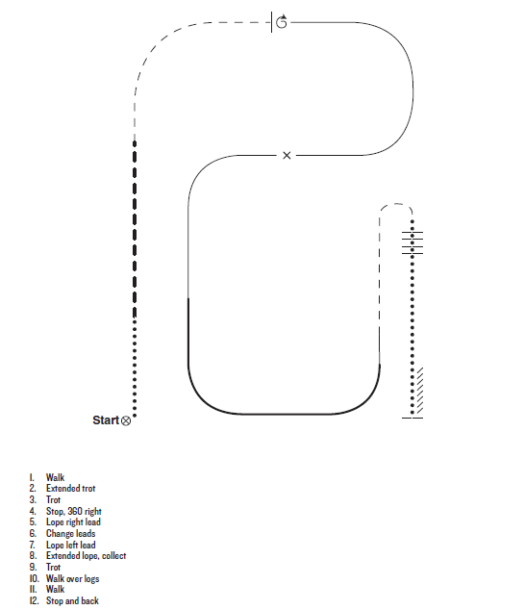

Show #2
Ranch Riding Pattern
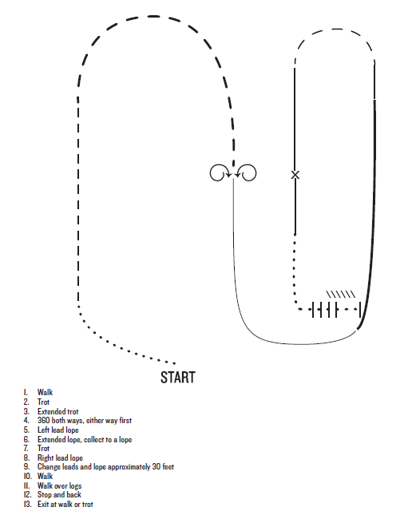
Show #3
Junior Ranch Riding
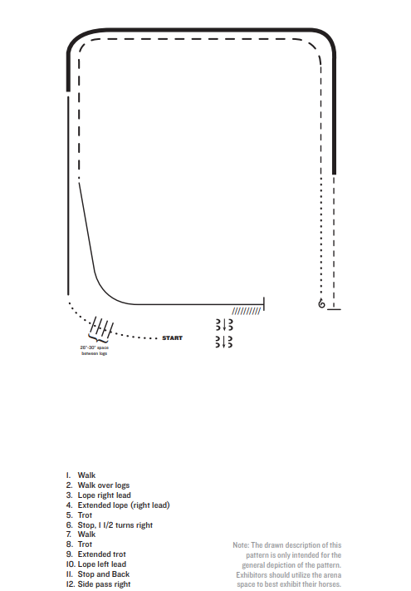

Show #1
Intermediate Ranch Riding

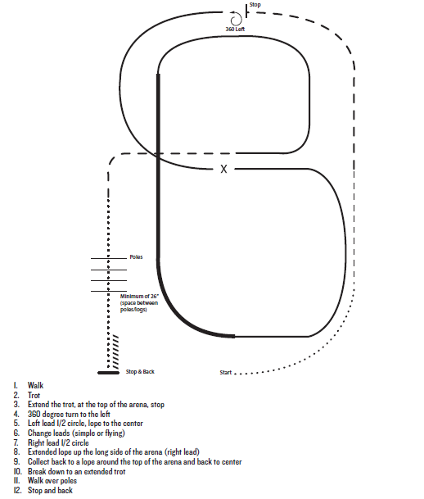

Show #2
Intermediate Ranch Riding

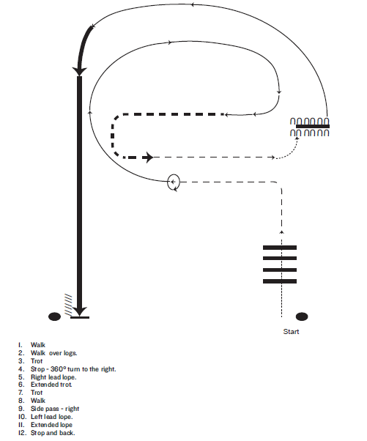

Show #3
Intermediate Ranch Riding

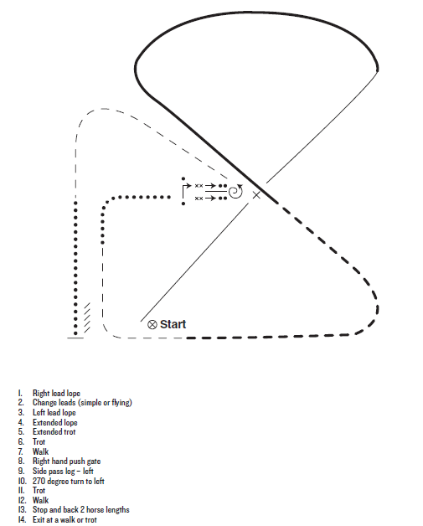

Show #1
Senior Ranch Riding
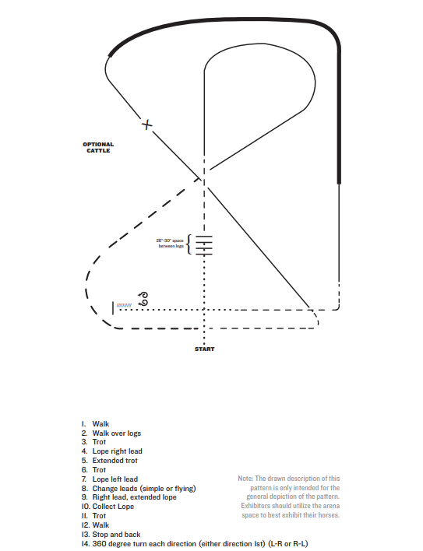

Show #2
Senior Ranch Riding

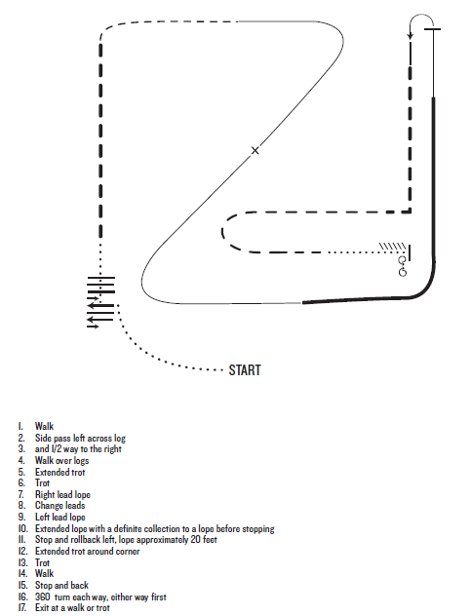

Show #3
Senior Ranch Riding

