Show #1
Two Hand Equitation
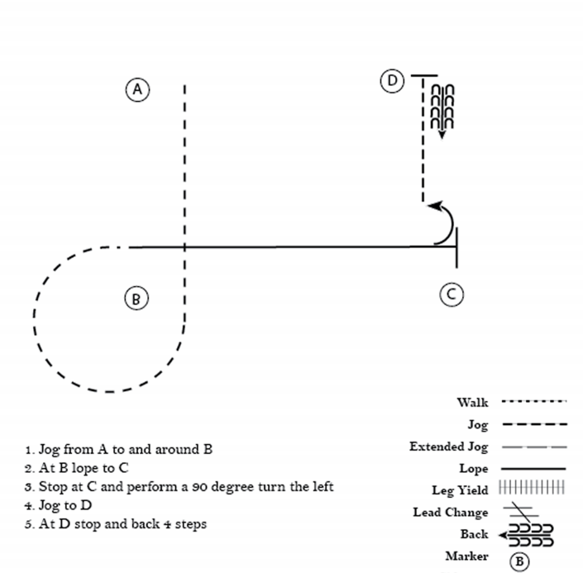

Show #2
Two Hand Equitation
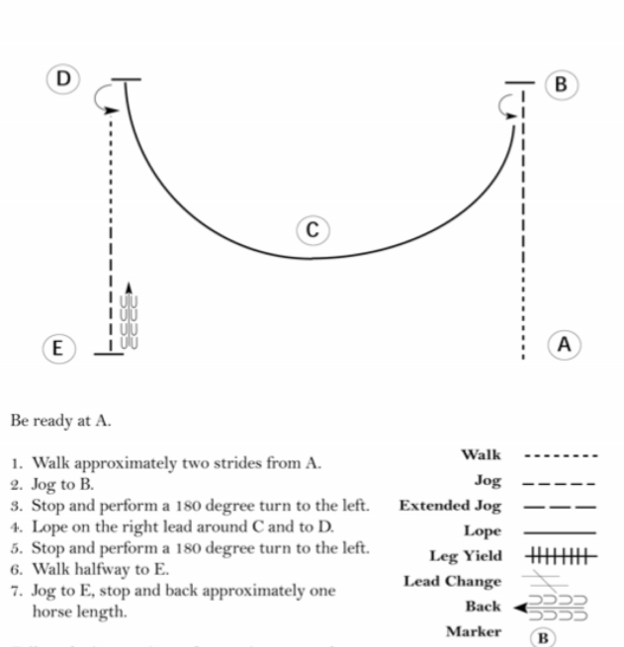

Show #3
Two Hand Equitation
