Box Elder Co-3rd Show
Junior/ Novice Trail
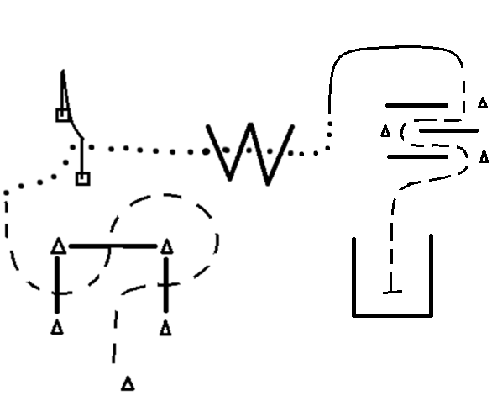

- Start on Left side of cone
- Jog the cone and log obstacle as drawn above; break to a walk
- Complete a RIGHT-handed push through gate
- Walk over ‘W’ placing a hoof in each space
- Lope on the RIGHT lead to top of obstacle; break to a jog
- Jog threw obstacle as drawn above; Continue jogging into open square; stop
- Complete a full ground tie
- When done gather reins (do not mount) and lead horse over front log and out of the arena

Box Elder Co-3rd Show
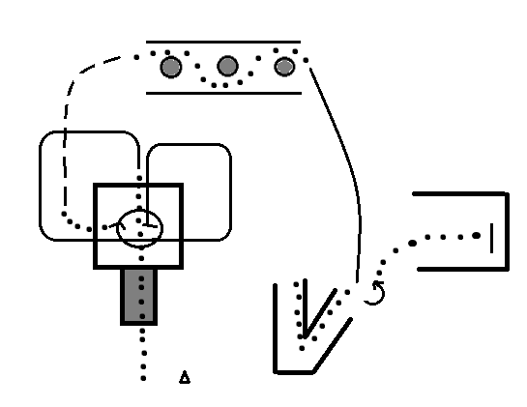
Intermediate Trail

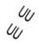

- Start on Left side of cone
- Walk over bridge and through square; Pick-up the LEFT lead
- Lope around corner of square; through square; rounding opposite top corner of square
- Stop in square; perform a 450* pivot to the RIGHT; walk out
- Transition to a jog; break to a walk before barrel
- Pick-up Object on first barrel and weave around the barrels staying inside the barriers and place object on third barrel
- Lope on the RIGHT lead to backing; break to a walk and walk through the angle
- Back out of angle; pivot LEFT 180*; walk into open square
- Complete a full ground tie
- When finished gather reins (do not mount) and walk horse over front log and out of arena

Box Elder Co-3rd Show
Seniors Trail
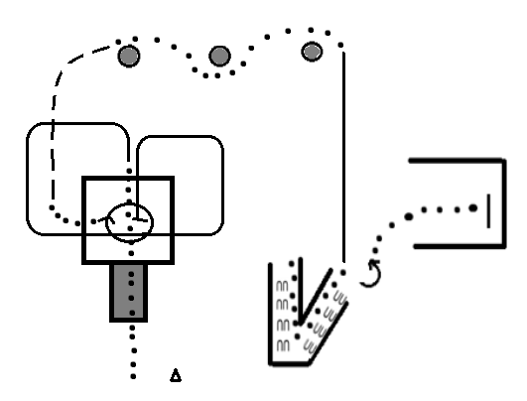
- Start on Left side of cone
- Walk over bridge and through square; Pick-up the LEFT lead
- Lope around corner of square; through square; rounding opposite top corner of square
- Stop in square; perform a 450* pivot to the RIGHT; walk out
- Transition to a jog; break to a walk before barrel
- Take and dally the drag log on first barrel and weave around the barrels and pull all the way to the third barrel and place rope on top.
- Lope on the RIGHT lead to backing; break to a walk and walk through the angle
- Back out of angle; pivot LEFT 180*; walk into open square
- Complete a full ground tie
- When finished gather reins (do not mount) and walk horse over front log and out of arena

Box Elder Co-3rd Show
In-Hand Trail

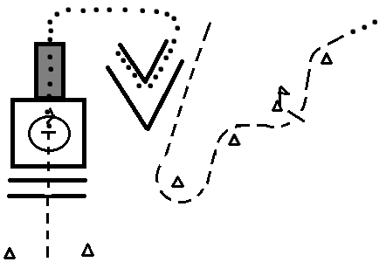
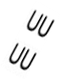

- Start between cones
- Jog over logs and into square; stop
- Complete a 360* pivot to the RIGHT
- Walk out and over bridge and to far side and angle
- Walk through the angle then back out until horses’ nose is clear
- Jog down to bottom cone and circle it to start weaving
- Stop at third cone; pick-up flag and wave then place back
- Continue jogging around last cone
- Break to a walk and exit the arena

Box Elder Co-3rd Show
Two-Handed Trail
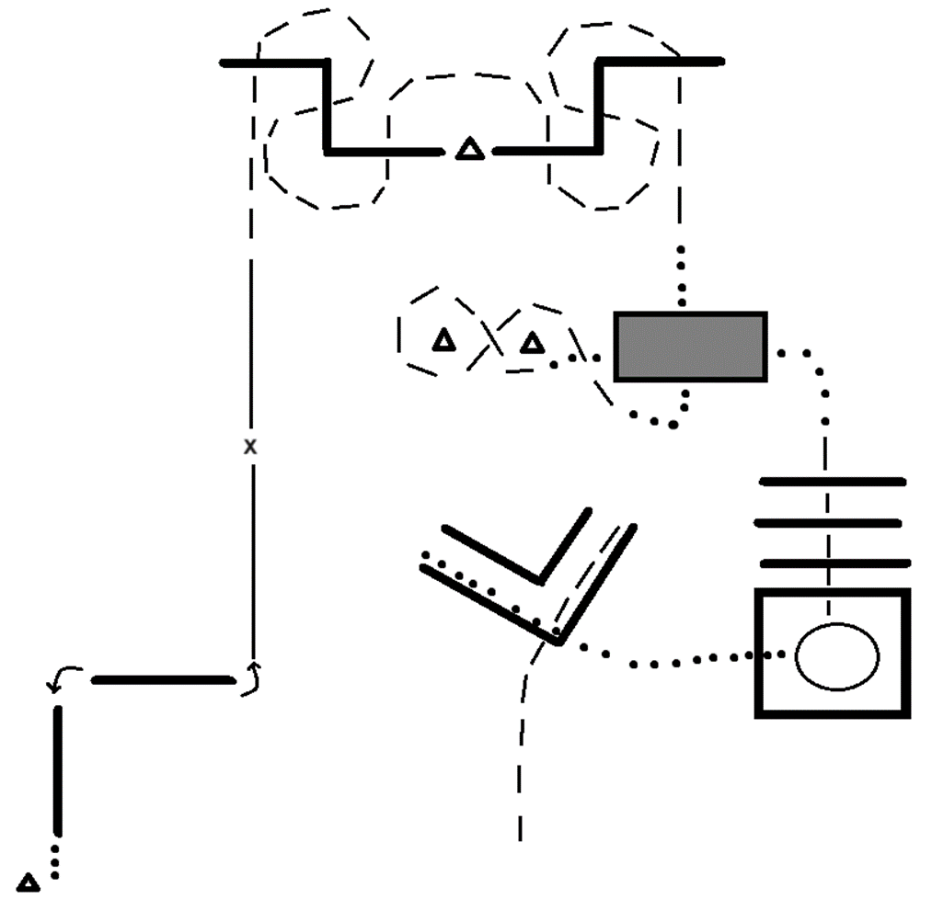

- Start on the 1-Start at cone; positioned to perform a RIGHT sidepass
- Sidepass over first log until legs are clear; 90* pivot to the LEFT; Sidepass LEFT over second log
- 180* pivot to the LEFT and pick-up the LEFT lead
- Half way complete a lead change to the RIGHT lead and continue to next obstacle
- Break to a Jog and continue threw and over logs as pictured.
- Break to a walk and walk over the bridge the short length then jog a figure’8’ around the cones/obstacles.
- Break to a walk and over the bridge again the long length.
- Jog over logs and into square; Complete a 450* pivot to the RIGHT and walk out and into the ‘L’
- Back threw the ‘L’ and Jog out over the log; and continue out to finish the pattern.

