Box Elder Co-3rd Show
Junior/Novice Showmanship

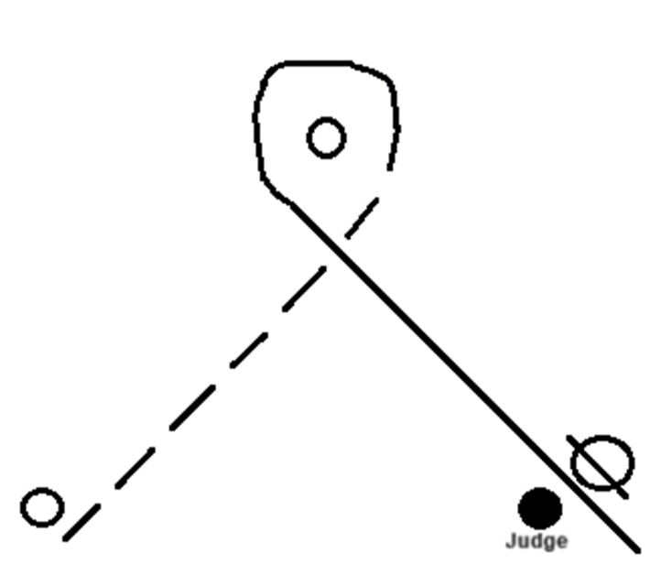

1-Start on RIGHT side of cone
2-Walk up to second cone and pick-up a jog
3-Go around the cone and continue down a horse length past the judge; stop
4- Back horse, then perform a 90* pivot ending with horse facing judge
5-Set-up for Inspection
6-When dismissed perform a 270* pivot and JOG away

Box Elder Co-3rd Show
Intermediate Showmanship
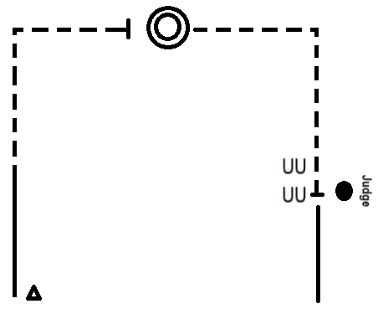

- Start on Left side of cone and walk
- Pick up a jog when across from Judge and jog a square corner
- Halfway; stop and perform 2 360* pivots
- Jog off and make a square corner down to Judge
- Stop and set for Inspection
- When dismissed Back one-horse length and walk out.

Box Elder Co-3rd Show
Senior Showmanship
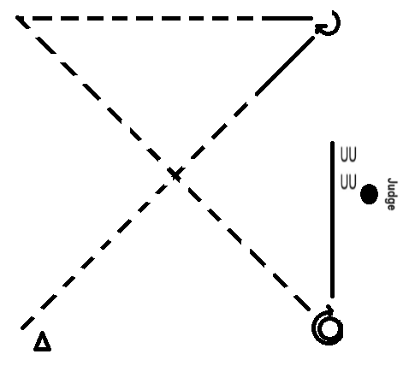

1-Start on Left side of cone;Jog diagonally across center to top and break to a walk one-horse length before corner; stop
2- Complete pivot just short of a 270*; walk one-horse length then pick-up a jog
3-Jog to next corner and make sharp turn and continue jogging all the down below the Judge; stop
4- Complete a 360* pivot and just under a 270* pivot to face direction of judge
5-Walk one-horse length past Judge then back until horses’ hip is lined up with Judge; Set for Inspection
6-When dismissed; walk forward and around judge and head to gate.
Box Elder Co-3rd Show
In-Hand Showmanship

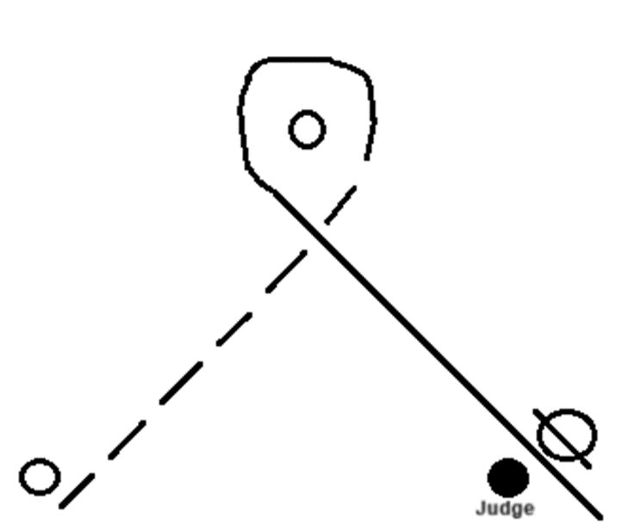

1-Start on RIGHT side of cone
2-Walk up to second cone and pick-up a jog
3-Go around the cone and continue down a horse length past the judge; stop
4- Back horse, then perform a 90* pivot ending with horse facing judge
5-Set-up for Inspection
6-When dismissed perform a 270* pivot and JOG away

Box Elder Co-3rd Show
Two-Handed Showmanship

1-Start on RIGHT side of cone
2-Walk up to second cone and pick-up a jog
3-Go around the cone and continue down a horse length past the judge; stop
4- Back horse, then perform a 90* pivot ending with horse facing judge
5-Set-up for Inspection
6-When dismissed perform a 270* pivot and JOG away

Box Elder Co-3rd Show
Two-Handed Horsemanship
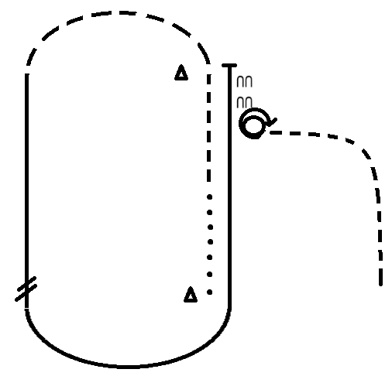

- Start at first cone and start walking to next cone
- Halfway up pick-up a jog
- At cone extend the jog round the top
- Pick-up a RIGHT lead lope
- Perform a Lead Change when even with first cone and on the LEFT lead round the bottom
- Stop at top cone and back one-horse length
- Perform a 450* pivot to the Right Jog away from cones and back to line-up

