Box Elder Co-2nd Show
Junior/ Novice Trail

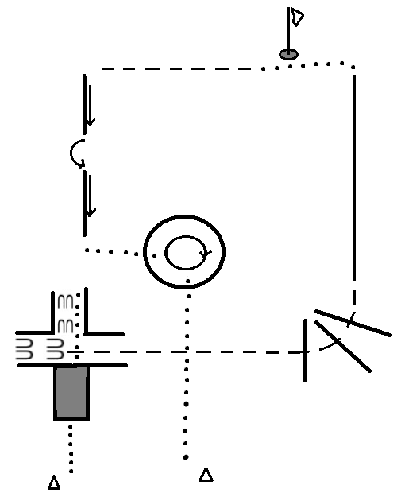

- Start at cone on Right side of cone
- Walk over bridge and between logs; Stop when hind legs are clear of logs
- Proceed to back an ‘L’ shape to the Left; Stop when front legs are clear of logs and Jog out
- Continue jogging over the corner logs then pick-up the LEFT lead
- Break to a walk; walk up to the jacket and pick up then place on saddle horn for 2 seconds then put back.
- Jog to sidepass logs; strattling the log begin sidepassing to the LEFT on first log.
- Between logs complete a 180* pivot to the LEFT then sidepass the second log to the RIGHT.
- Walk forward and into Circle; staying in the circle complete a 450* ( 1 ¼) pivot to RIGHT.
- When finished walk out of the circle and out of arena.

Box Elder Co-2nd Show
Intermediate Trail
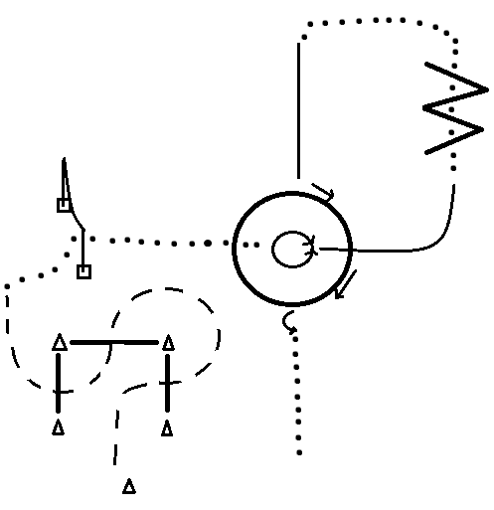

- Start on Left side of cone
- Jog the log and cone obstacle as drawn above; break to a walk
- Complete a Right-Handed push gate
- Walk into circle; stop; complete 360* pivot to the Left and then a 360* pivot to the Right
- Lope on the LEFT lead out of circle and to ‘W’; break to a walk and walk threw placing a hoof in each space.
- Walk around and line up with circle; lope on the RIGHT lead to circle
- Stop; then straddle the circle line and sidepass to the LEFT halfway around the circle
- Back till front legs are out of the circle complete a 180* pivot to the LEFT and walk out of arena

Box Elder Co-2nd Show
Seniors Trail
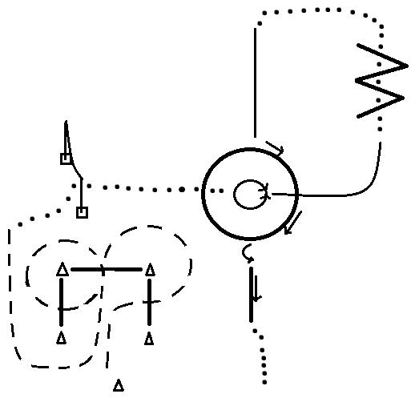
- Start on Left side of cone
- Jog the log and cone obstacle as drawn above; break to a walk
- Complete a Right-Handed push gate
- Walk into circle; stop; complete 360* pivot to the Left and then a 360* pivot to the Right
- Lope on the LEFT lead out of circle and to ‘W’; break to a walk and walk threw placing a hoof in each space.
- Walk around and line up with circle; lope on the RIGHT lead to circle
- Stop; then straddle the circle line and sidepass to the LEFT halfway around the circle
- Back till front legs are out of the circle complete a 270* pivot to the LEFT
- Straddling the log sidepass to the RIGHT; when finished walk off and out of arena

Box Elder Co-2nd Show
In-Hand Trail

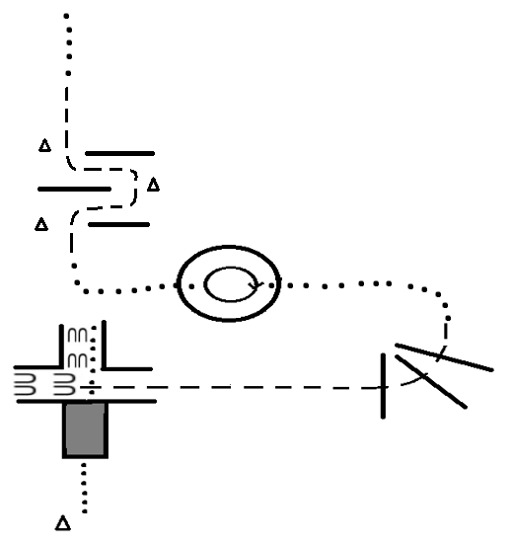

- Start on Right side of cone
- Walk over bridge and between logs; Stop when hind legs are clear of logs
- Proceed to back an ‘L’ shape to the Left; Stop when front legs are clear of logs and Jog out
- Jog over corner logs; break to a walk; walk into circle; stop
- Complete a 360* pivot to the RIGHT; walk out
- Transition into a jog and jog threw the cone and log obstacle as drawn above.
- When clear break to a walk and exit arena

Box Elder Co-2nd Show
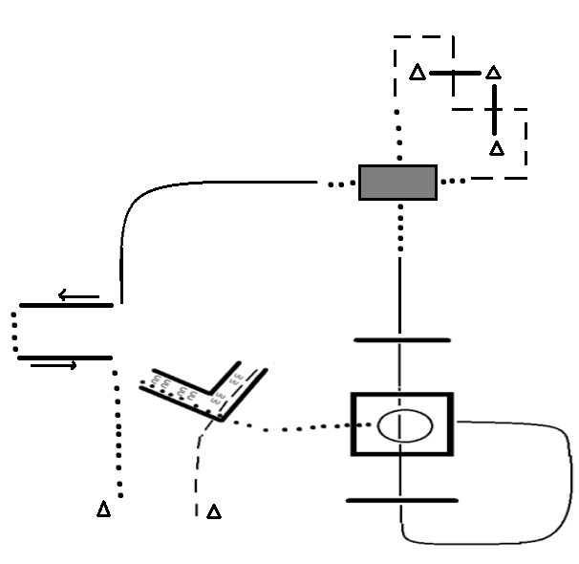
Two-Handed Trail

- Start on the Left side of the cone
- Jog into right side of ‘L’; stop and back the whole obstacle then walk out
- Walk into square and stop; Complete a 360* pivot to the LEFT. Walk out of square
- Pick-up RIGHT lead and lope rounding the obstacle and over the logs; break to a walk
- Walk over bridge, then jog weaving threw cones and over logs making sharp corners
- Break to a walk and go over the bridge again.
- Lope on the LEFT lead rounding to Left side of logs; stop
- Straddling log; sidepass RIGHT; walk forward to second log; Sidepass LEFT
- Walk off and out of arena

