Box Elder Co-1st Show
Junior/ Novice Trail

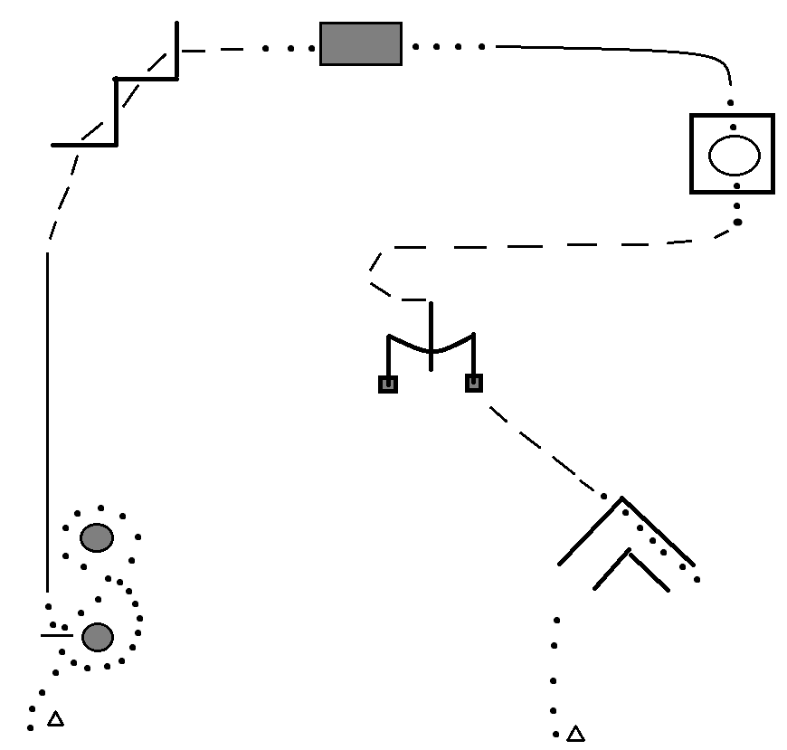
- Start at cone on Left side of cone
- Walk up to barrel and pick up bucket and continue around and figure ‘8’ the barrels before returning bucket to original spot.
- Lope on the LEFT lead; break to a jog before logs and continue over the logs
- Walk over bridge; Pick-up the RIGHT lead and continue down to the square. Then break to a walk.
- Walk into square; stop and perform a 360* pivot to the LEFT. Then walk out
- Jog to and position to sidepass RIGHT over the log; Once cleared of log perform a Right-handed PUSH gate.
- Jog to ‘L’ but break to a walk before entering. Walk over log and position to back through.
- Once clear; pivot and walk out.

Box Elder Co-1st Show
Intermediate Trail
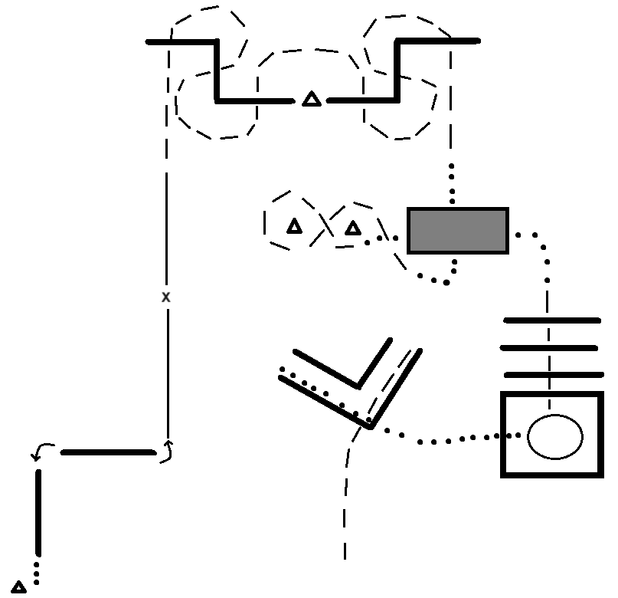

1-Start at cone; positioned to perform a RIGHT sidepass
2-Sidepass over first log until legs are clear; 90* pivot to the LEFT; Sidepass LEFT over second log
3-180* pivot to the LEFT and pick-up the LEFT lead
4-Half way complete a lead change to the RIGHT lead and continue to next obstacle
5-Break to a Jog and continue threw and over logs as pictured.
6-Break to a walk and walk over the bridge the short length then jog a figure’8’ around the cones/obstacles.
7-Break to a walk and over the bridge again the long length.
8-Jog over logs and into square; Complete a 450* pivot to the RIGHT and walk out and into the ‘L’
9-Back threw the ‘L’ and Jog out over the log; and continue out to finish the pattern.

Box Elder Co-1st Show
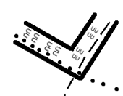
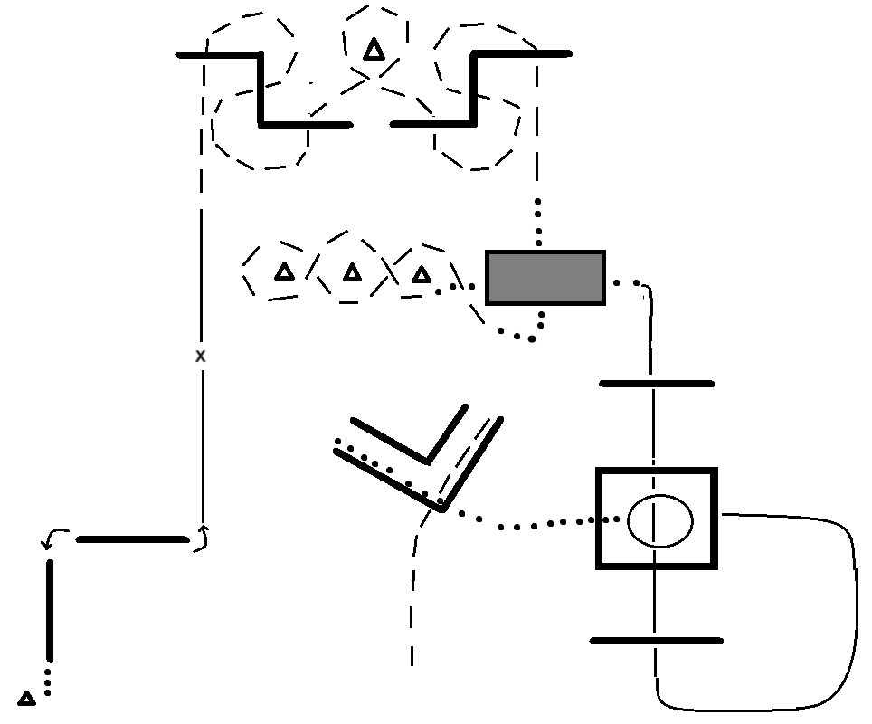
Seniors Trail
1- Start at cone; positioned to perform a RIGHT sidepass
2-Sidepass over first log until legs are clear; 90* pivot to the LEFT; Sidepass LEFT over second log
3-180* pivot to the LEFT and pick-up the LEFT lead
4-Half way complete a lead change to the RIGHT lead and continue to next obstacle
5-Break to a Jog and continue threw and over logs as pictured.
6-Break to a walk and walk over the bridge the short length then jog weaving around the cones/obstacles.
7-Break to a walk and over the bridge again the long length.
8-Lope on LEFT lead over logs/square circling around back to the square; lope into square and stop
9-Complete a 360* pivot to the RIGHT and walk out and into the ‘L’
10-Back threw the ‘L’ and Jog out over the log; and continue out to finish the pattern.

Box Elder Co-1st Show
In-Hand Trail

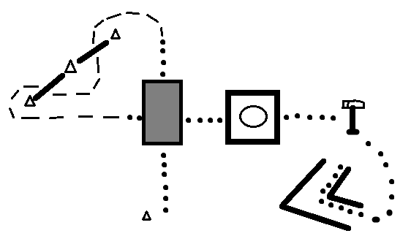

1-Start at cone
2-Walk over bridge and pick up a jog
3-Jog over logs and weave threw cones; break to a walk
4-walk over bridge again and into square
5-complete a 360* pivot to the RIGHT and walk out
6-Walk to Mailbox, open it and remove items, and close it.
7- walk to bottom on back threw; walk threw it and then proceed to back out
8-When clear of logs pause to show completion of pattern and exit arena

Box Elder Co-1st Show
Two-Handed Trail

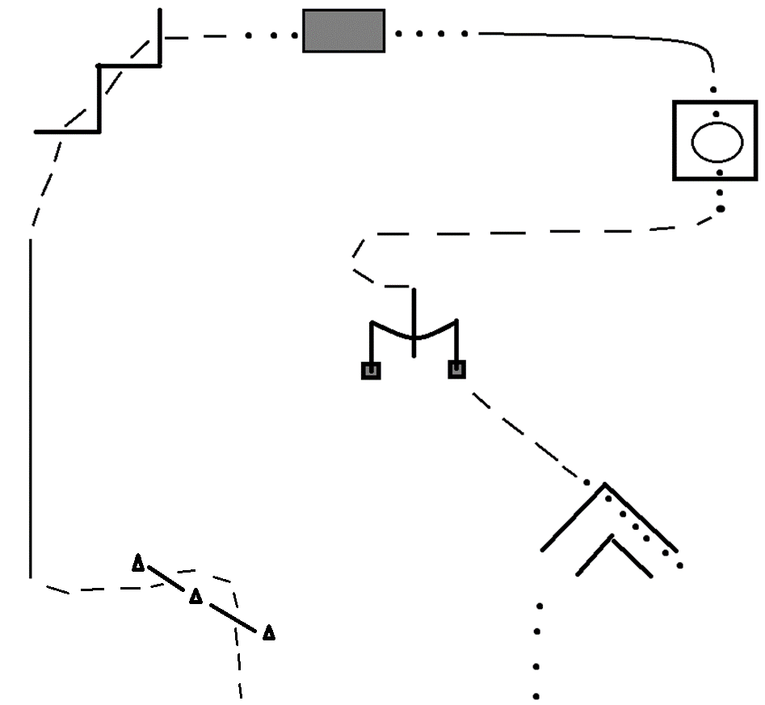

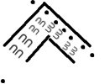

1- Start at a jog going over the logs and weaving through the cones
2- Lope on the LEFT lead; break to a jog before logs and continue over the logs
4- Walk over bridge; Pick-up the RIGHT lead and continue down to the square. Then break to a walk.
5- Walk into square; stop and perform a 360* pivot to the LEFT. Then walk out
6- Jog to and position to sidepass RIGHT over the log; Once cleared of log perform a Right-handed PUSH gate.
7- Jog to ‘L’ but break to a walk before entering. Walk over log and position to back through.
8- Once clear; pivot and walk out.

