NCERA-101 Instrument Packages

The NCERA-101 Instrument packages were funded by the NSF in 1972, as a “standardized instrument package” to provide a calibration reference for cooperating laboratories. The package has evolved over the years and now includes packages with unique instruments. These packages supplement the calibration standard packages.

Four packages are currently available for rental:

1. Photosynthetic radiation Calibration Package:
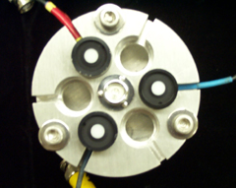
The calibration package includes 3, LI-COR Quantum sensors (400 – 700 nm), calibrated to an NIST-traceable lamp before each rental. The sensors output to a dedicated micrologger with display, which averages the output of the 3 sensors. A six-place leveling plate is included to hold the 3 LI-COR Quantum Sensors. There are 3 empty spaces for the user’s sensors.

Also included in this package are a Skye Instruments, Inc., red / far-red sensor and associated meter (660 nm and 730 nm); and a hand held UV meter (250 – 400 nm). These are not calibration standards, but they help users to characterize their radiation environments.
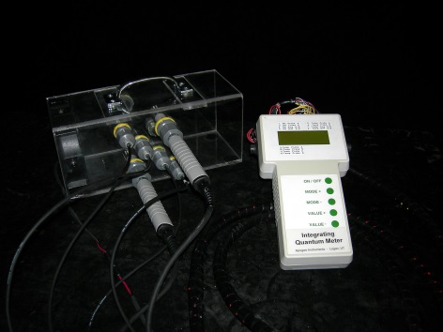
2. Humidity/temperature Calibration Package:
This new package includes two reference Vaisala HMP45 humidity sensors that are connected to a dedicated micrologger with display. The probes output relative humidity and temperature. The package includes a shielded, aspirated column with empty holes for the user’s sensors. The package also includes 4 reference thermistors, which supplement the two PRT temperature sensors in the Vaisala humidity probes. The humidity sensors are calibrated to a dew point reference at 20, 50 and 80% RH. The calibration is done by Campbell Scientific.

3. Spectroradiometer Package:
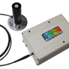
This is a StellarNet UV/Vis Spectroradiometer (300 – 850 nm) with an Apogee Instruments cosine corrected head and leveling plate. The package includes a laptop computer pre-programmed with the necessary software. It also includes a quick-start user’s guide.

This package is useful for a detailed characterization of light, and the effects of filters on light quality. It can also be used for reflectance measurement of leaves and plant canopies.

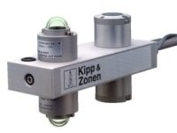
4. Net Radiometer package:
A Kipp & Zonen CNR1 net radiometer, which outputs to dedicated micrologger. The radiometer measures incoming and reflected short wave and long wave radiation. Spectral response: 305 to 2800 nm (pyranometer), 5000 to 50,000 nm (pyrgeometer).

This instrument is owned by the Crop Physiology Laboratory at Utah State University, which has made it available for rental. Proceeds go into the NCERA 101 instrument account.

Rental Terms:
- These instruments are available for rental by any member of NCERA-101.
- The rental period is two weeks, excluding shipping time.
- Return shipping and appropriate insurance is paid by the user. Insure all packages for $5000 (US) except for the Humidity/temperature package, which should be insured for $4000.

Rental Fees:
Any one instrument package $ 300
Any two instrument packages at the same time $ 450
Any three packages at the same time $ 600
All four packages at the same time $ 750

This fee includes shipping, recalibration costs, and account management. The fee also supports a fund that is used to purchase new instruments for the packages.

To rent any of these instruments, please contact: Alec Hay
Utah State University – Crop Physiology Laboratory 435-797-2600
Alec.Hay@usu.edu

