Tier 2 Sampling Instructions – Sample Collection and Processing
Scientists collect samples when they are interested in how much nutrients, metals or other chemicals are in the water (i.e. nitrate, phosphate, ammonia, dissolved nutrients, metals - zinc, copper, lead, iron). Water samples are collected in a standardized way to reduce the risk of contamination. Sometimes minerals and nutrients are dissolved in the water and require acid preservation to suspend their activity or filtering to capture the dissolved form.
State guidelines on proper sample collection and processing ensure consistency between sample collections by different monitors. When collecting samples, it is important to be familiar with the project specific procedures which may be found in the Sample Analysis Plan (SAP). The SAP will include detailed information about the sample locations, parameters to test for, special requirements and holding time required to return the samples to the lab.
The samples should be representative of the stream by collecting in the thalweg (deepest flow or main flow) and collected using the instructions below. For more detailed instructions check out the DWQ Standard Operating Procedure in your notebook, or follow this link:
Instructions:
Ensure you have all the equipment necessary; check the SAP or with the project coordinator for project specific requirements. You will be provided with a kit in advance.
Label all sample bottles with date, time, site and initials.
Some bottles may include acid for preservation of the sample. Care should be given to make sure these bottles are not overfilled. If filtering is required, a transfer bottle will be used for initial collection.
Collection by wading, when safe:
- Wade out to collect the sample in the thalweg (deepest flow or main flow of the stream)
- Wait until disturbed sediment has moved down stream before collecting sample
- Do not rinse the bottles unless you know they do not contain preservative. Bottles containing preservative are labeled as such. If using a transfer bottle, triple rinse it with stream water.
- Remove 1st sample bottle cap. Avoid touching the inside of bottle cap, container or lip.
- Reach forward with the bottle opening facing upstream and quickly plunge the bottle below the surface avoiding any surface scum, floating debris or the bottom of the stream.
- Be careful not to overfill the bottle unless otherwise directed by the lab (for volatile organic compound analysis). For bottles with prefilled with preservative, overfilling would cause a loss of preservative, so leave some headspace in the bottle and immediately replace the cap.
- Repeat with all sample bottles and return to shore.

Collection from bank edge, (when water is too deep or fast to wade safely):
- Use a dip sampler from bank to reach into the main flow.
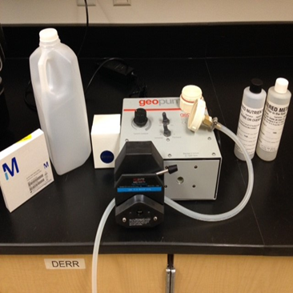
- If flow is too strong, sample may be collected by hand directly from the bank in a flowing, well- mixed area.
- Follow the same instructions as wading.
Filtering:
- Gently invert the sample you collected for filtering to mix thoroughly and place intake tubing in the sample container.
- Flush the filter holder and tubing with 500mLof sample water to rinse using either the GeoPump or hand pump.
- Unscrew the filter holder to access the filter stage, being careful not to touch the inside.
- Using clean forceps, load the filter holder with an unused membrane filter (0.45 µm), being careful not to touch the filter.
- You may use a glass-fiber pre-filter if there is visible turbidity in the sample. The pre-filter should be “upstream” of the membrane filter.
- Screw the filter holders back together.
- Remove caps from sample bottles, turn on the pump and hold the filter holder over the sample bottle without touching it to the bottle and the filter stream fills the bottles.
- Continuously swirl the raw water sample during filtration to ensure homogeneity.
- If the filter clogs before filling the bottle, stop the pump, remove and replace used filter with a new one.
- Be sure not to overfill the preserved sample bottles and leave some headspace. Overfilling pre-preserved bottles will cause a loss of preservative.
- Stop the pump and replace the bottle cap.
- Remove and discard used filter and rinse apparatus with 500mL DI water.
Post Collection Handling:
- Keep all samples on ice in a cooler out of the light until delivered to the lab. Make sure to deliver the samples within the holding time. If unsure what that is, refer to the SOP, SAP or check with the project coordinator.
- At the end of the day, clean the sampling equipment by soaking the filter holders and GeoPump tubing in a solution of Liqui-nox overnight followed by light scrubbing and rinse with DI water in the morning.
Quick guide:
- Label bottles, and note filtered and preserved bottles
- Collect sample from thalweg, standing downstream
- Collect from bank if water is too deep or dangerous
- Filter immediately following sampling
- Do not mix caps
- Store samples on wet ice
Collection of Water Chemistry Samples DWQ SOP:
http://www.deq.utah.gov/Compliance/monitoring/water/docs/2014/05May/SOP_WaterChemSampleCollection_5.1.14_Rev0.pdf

