Tier 2 Sampling Instructions – Stream Flow
Flow measurements tell us the amount of water that is flowing past a specific point in a stream at a given time. Irrigation withdrawals, precipitation, season, stream shape and local groundwater conditions are some ways flow vary. Flow is typically recorded in cubic feet per second (cfs) or cubic meters/second (cms). Flow measurements are performed for natural (rivers, streams) and engineered (outfalls, ditches, canals) surface water bodies.
Stream flow measurements for our purposes of assessment are to determine pollutant loads, characterize water quality conditions and the effect of hydrologic conditions on aquatic life.
Flow is often measured while wading, however when unsafe, it may be done from bridges, especially in deep or high-flow areas. While the tools used to measure water flow vary, the general principle remains the same. Familiarity with the different procedures associated with the use of a wading rod (e.g. Marsh-McBirney or MagnaRod) or flow probe (e.g. Global Water Flow Probe) will lend itself to other methods.

Instructions:

General Principles:
To determine flow in a stream you must know the stream’s average velocity (feet per second) and the cross sectional area (square feet). These are multiplied, which gives you flow. (velocity*width*depth) or (ft/sec * ft * ft = ft³/sec or CFS).
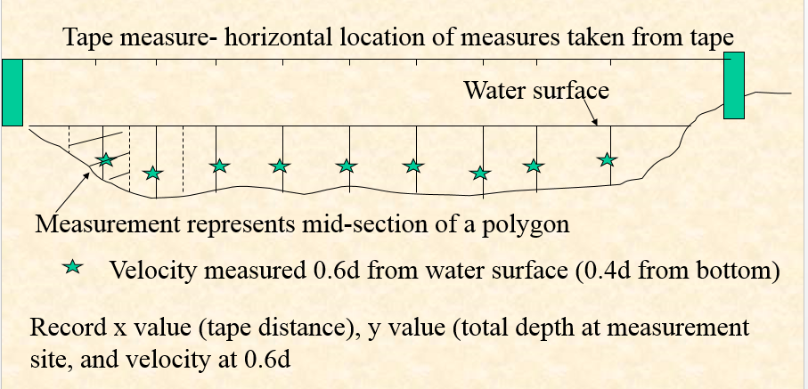
Velocity and depth vary across the stream, so you will take a series of measurements, depending on the size of the stream (see “conducting a measurement”). Measurements should be at least 0.3 feet apart.

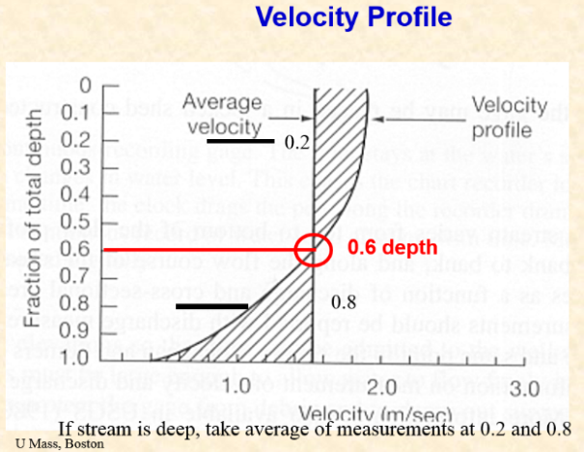
Average velocity in a wadable stream is located at 0.6 times the total depth at any site measured from the top (see figure).
- Wading rods will automatically put your velocity meter at this depth.
- The Globe velocity meter automatically calculates an average velocity.

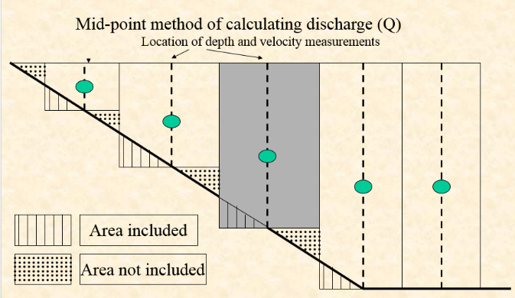
To calculate total flow, just add up all the flows for the smaller cross sectional areas (boxes) using the mid-point method (see figure).

We provide a spreadsheet that will do this for you, but it is always good to check your calculations to be sure they make sense.
Total Flow (combination of each box) = (W₁*SD₁*SV₁) + (W₂*SD₂*SV₂) + (W₃*SD₃*SV₃) +...

Where W = distance between measurements; SD = Stream depth; SV = Stream velocity;
1,2,3, etc. refer to each box.

Figures from University of Massachusetts, Boston, 2014. http://www.slideserve.com/sheadon/how-do-we-measure-how-much-water-is-in-a-stream

Choosing a Site:
Establish a stream cross section for flow measurement to occur. Desirable characteristics for the site location include:
- A straight section of stream, away from stream bends;
- Stream flow approximately parallel to stream banks;
- A constant stream gradient;
- No obstacles protruding from water surface (i.e. stones, plants, bridge piers).

When establishing the cross section, look for an area of laminar, smooth flow with minimal obstructions. Obstructions, including large rocks, can be moved out of the way of the cross section, but only before flow measurements begin, never during the measurement. If wading, depth should not exceed 3 feet.

Conducting a measurement:

- Stretch a tape measure across the stream and attach it on both ends. Make sure it is perpendicular to the flow and tightly stretched.
- Using the tape, measure the interval given below:
- If stream width < 10 feet, collect data every 0.5 feet; and take first reading at 0.25 feet (half of interval) from edge.
- If stream width > 10 feet, collect 20 evenly divided measurements across the entire stream; take the first reading at half of the determined interval from edge

Data Collection:
Collecting flow data works best with a team of two people. One person handles the flow meter while the other records the stream width, depths, and velocities.
- Make sure the flow meter is reading flow in feet per second (ft/s) and the allotted time for reading flow is set at twenty seconds.
- The sensor must be facing upstream and both members of the team must take care to stand to the side of the flow meter, to avoid impacting the measurement.
- The operator will measure the actual water depth using the wading rod and call it out to the recorder who will record it on the field sheet.
- The wading rod is then adjusted to the correct depth – place the flow meter at 0.6 (60%) of the water depth, measured from the surface.
- Begin measuring velocity once the depth is set. After 20 seconds, the operator will call out the average velocity to the recorder and then continue to the next site.
Calculating the flow:
Depth and velocity values need to be converted into a flow measurement by using the Excel template found on the Utah Water Watch website Tier 2 section (http://extension.usu.edu/utahwaterwatch/monitoring/field-instructions/flowmeasurements), or using the calculation below.
Remember, flow is (velocity*width*depth) or (ft/sec * ft * ft = ft³/sec or CFS)
Total Flow is a combination each measurement across the stream cross-section.
(Combination of each box) = (W₁*SD₁*SV₁) + (W₂*SD₂*SV₂) + (W₃*SD₃*SV₃) +...

Stream Flow Measurement DWQ SOP:
http://www.deq.utah.gov/Compliance/monitoring/water/docs/2014/05May/SOP_StreamFlow_5.1.14_Rev0.pdf

