Utah 4H Shooting Sports
General Outdoor Test and Animal Identification
State Shooting Sport Contest
May 3, 2021

General Rules
- The Test at the State Shooting Sports State Contest will be two parts:
  - PART 1 - 50 Question multiple choice, fill in the blank and true and false. All questions will be taken from the current TODAY’S HUNTER BOOK
  - 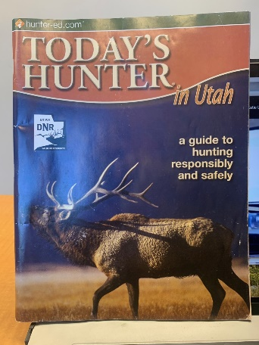
  - This book is the Hunter Education manual that you can find at any DWR office in Utah and I believe online.
  - PART 2 – 25 Animal Identification Youth will be identifying:
    - Large Mammals
    - Small Mammals
    - Upland Birds
    - Water fowl
    - Birds of Prey
  - All of the above identification categories are found in the TODAY’S HUNTER Book in the back pages.
- The Test will be taken on Monday May 3, 2021 at State Contest.
- If you have any question call or email blake.clark@usu.edu 208-390-7284

