Utah 4-H Poultry Program

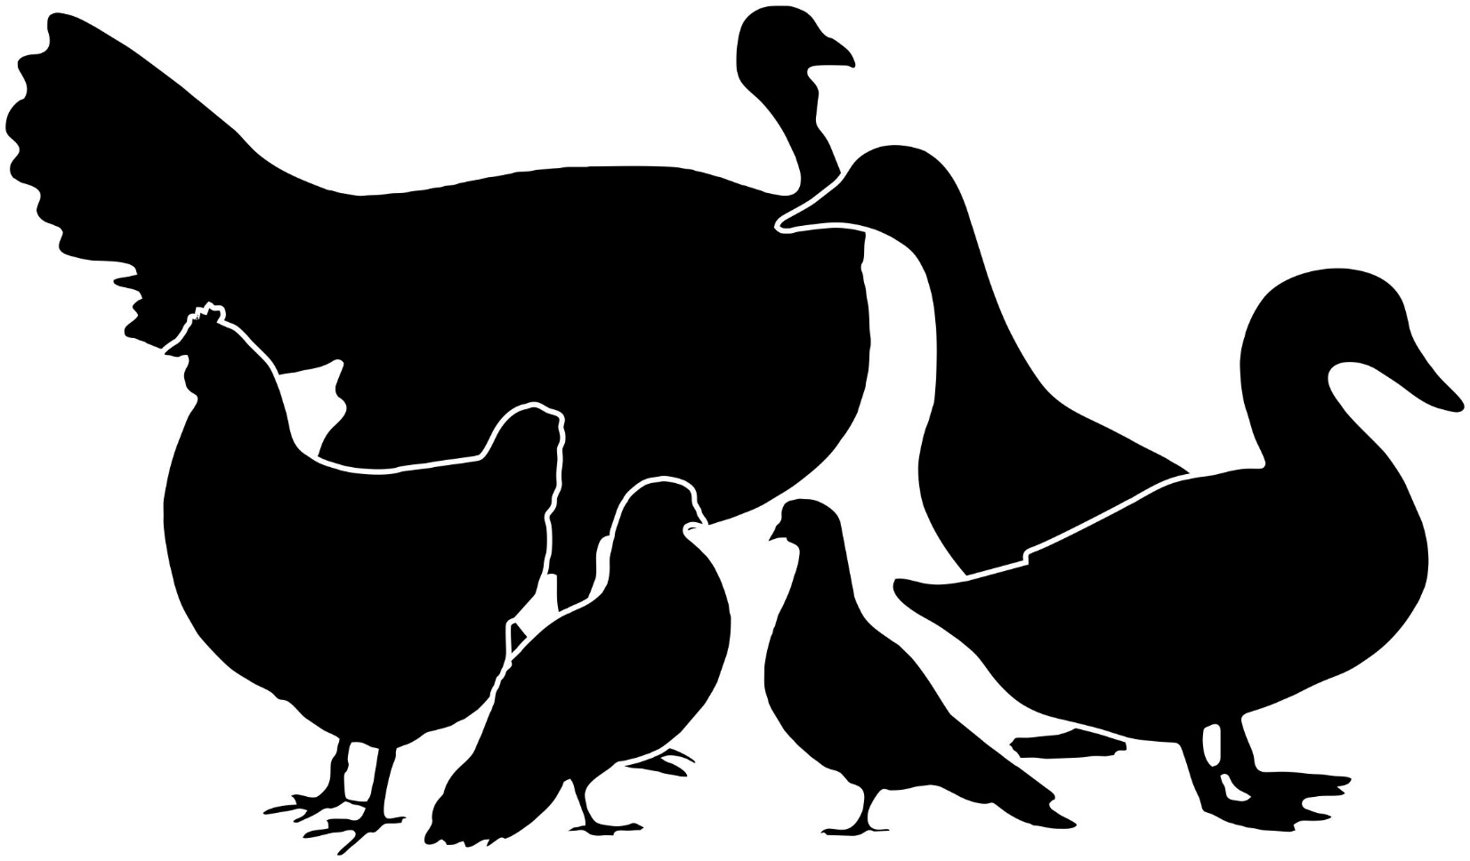

Rank Advancements

This book belongs to: ________________________________________
And my project: _____________________________________________

Rank Advancement Level 1
This rank covers the very basics of handling poultry or pigeons and being safe and successful in your project. This rank should be easily achieved by all ages, including youth who are not yet 8.
Name ________________________________________ Project type: ___________________________________
Club Leader ___________________________________ Phone_____________________________________
County Extension Contact_____________________________Phone_____________________________________
Date Completed ____________________________________________________
Poultry/Pigeon Project Skills  Pick 4 or more of the following | Date | Initials
Demonstrate how to lift, hold and carry your project bird.
Demonstrate that you are able to provide fresh water, clean feed, and shelter for your project birds.
Demonstrate how to hold a rabbit that is frightened.
Keep a record of your poultry or pigeon project, including expenses and income.
Demonstrate how to properly take your bird out of its cage and place in in its cage.
Name and locate the following: comb, beak, breast, back, thigh, wing, primary and secondary wing feathers, vent, keel.
Mastery and Education  Pick 3 or more of the following | Date | Initials
Identify and describe three different breeds of poultry or pigeons.
Explain what feeds are important for poultry or pigeons.
Explain the following poultry terms: chick, pullet, hen, cock, molt, hatch, set, brood, grit, mash, scratch, yolk, squab, duckling, drake, gosling, poult, goose, gander, tom.
Explain why and how poultry and pigeons are banded.
Name and describe two parasites that infest poultry and tell how to control them.
Explain why eggs are a nutritious food. In what food group are they in?
Citizenship and Personal Development  Pick 1 or more of the following | Date | Initials
Submit a portfolio to county or state contest.
Hold a leadership position in your club or at the county level.
Participate or help plan a community service project.
Work with a parent or club leader to set goals for your poultry or pigeon project and make a plan to achieve them.

By signing this form, I am verifying that the exhibitor mentioned has completed these tasks in a satisfactory manner and is ready to move on to the next level.
4-H Member ________________________________________ Club Leader Signature____________________________

Rank Advancement Level 2
This rank covers the basic skills and knowledge of nutrition and care needed to be safe and successful with a poultry or pigeon project. This rank is designed to be achievable by youth 8 – 11 years of age.
*Level 1 must be completed to achieve a Level 2 Rank
Name ________________________________________ Project Type________________________________
Club Leader ___________________________________ Phone_____________________________________
County Extension Contact________________________Phone_____________________Date Completed _____________
Poultry/Pigeon Project Skills  Pick 4 or more of the following | Date | Initials
Name and locate the following: Earlobe, ear, hackle, saddle and sickle feather, fluff, axil feathers, pubic bone, abdomen, crop and shank.
Demonstrate how to tell the sex of geese, ducks, chickens, turkeys or pigeons.
Participate in a poultry showmanship contest.
Care for and handle your bird quietly and without quick, sudden movements. Explain why.
Demonstrate how to sanitize your birds cage or coop, feeder, and watering system.
Keep a record of your poultry or pigeon project, including expenses and income.
Demonstrate how to prepare your bird for show using proper cleaning and grooming.
Mastery and Education  Pick 3 or more of the following | Date | Initials
Explain “rate of production”
Create a poster on Poultry Nutrition or Poultry Housing and present it to your club.
Ask your leader to interview you on your poultry project.
Explain how eggs are graded for both exterior and interior quality. Demonstrate the candling and grading of a dozen or more eggs for your club or other group.
Explain the following terms:
Broiler, roaster, capon, protein, calcium, carbohydrate, plumage, variety, finish,
molting and regrowth of primary and secondary feathers.
Name and describe 6 breeds of chickens, pigeons or other poultry.
Work with your club leader or county staff to come up with your own Mastery option.
Citizenship and Personal Development  Pick 2 or more of the following | Date | Initials
Submit a portfolio to county or state contest.
Hold a leadership position in your club or at the county level.
Volunteer to help at a poultry show.
Participate or help plan a community service project.
Work with a parent or club leader to set goals for your project and make a plan to achieve them.
By signing this form, I am verifying that the exhibitor mentioned has completed these tasks in a satisfactory manner and is ready to move on to the next level.
4-H Member ________________________________________ Club Leader Signature____________________________

Rank Advancement Level 3
This rank is for members that have owned poultry or pigeons for two or more years. Youth that are junior and intermediate 4-Hers should be able to obtain this rank. The requirements for Level 3 need to be completed within 2 years of the time the youth wishes to achieve this rank.
*Level 2 must be completed to achieve a Level 3 Rank.
Name ________________________________________ Project Type________________________________
Club Leader ___________________________________ Phone_____________________________________
County Extension Contact________________________Phone_____________________Date Completed _____________
Poultry/Pigeon Project Skills - Pick 5 or more of the following | Date | Initials
Draw a diagram of an egg, labeling the following parts: shell, inner and outer shell membranes, air cell, white or albumen, chalazae, yolk, and germ spot. Describe chick development.
Cook and serve a dish made with chicken.
Explain egg care for home consumption or by others. Include washing and storage procedures.
Demonstrate how to properly trim your bird’s beak and toenails.
Judge a poultry practice showmanship contest in your club.
Demonstrate how to properly handle and pose 3 different types of poultry or pigeons.
Keep a record of your poultry or pigeon project, including expenses and income.
Explain vaccinating your birds, what diseases they prevent and how to vaccinate your birds.
Research different styles of nesting boxes and then build your own nesting box
Mastery & Education - Pick 5 or more of the following | Date | Initials
Define the following poultry terms: avian, bantam, bill, clutch, cockerel, down, crossbred, embryo, pigmentation, purebred, rooster, web and brooder guard.
Name and describe 9 breeds of chickens, pigeons or other poultry. Discuss breeds used for meat and egg production.
Name three characteristics of poultry or pigeons that are inherited and three that result from feeding and management.
Demonstrate how to prepare your bird for show
Prepare a speech or demonstration on a topic related to your project. Present it to your family, club members or at a 4-H Public speaking contest. (discuss age appropriate options with leader).
Teach others how to do poultry or pigeon showmanship.
Work with your club leader or county staff to come up with your own Mastery option.
Citizenship and Personal Development - Pick 3 or more of the following | Date | Initials
Submit a portfolio to county or state contest achieving a blue ribbon score.
Hold a club or county leadership position.
Participate in a countywide community service project.
Organize a community service project for your club.
Participate or help organize a Poultry Workshop at the local level or participate in a show’s youth committee.
Work with a parent or club leader to set goals for your poultry or pigeon project and make a plan to achieve them.
By signing this form, I am verifying that the exhibitor mentioned has completed these tasks in a satisfactory manner and is ready to move on to the next level.
4-H Member ________________________________ Club Leader Signature____________________________________
Rank Advancement Level 4
This rank is for 4-H youth that have been showing and raising poultry or pigeons for several years and have developed excellent skills and knowledge about their project. Level 4 is a good goal for senior aged exhibitors to strive for. The requirements for this level do not need to be completed within the same year, but have to be completed within at least 3 years of the time the youth is seeking to obtain this level
*Level 3 must be completed to achieve a Level 4 Rank
Name ________________________________________ Project Type ___________________________________
Club Leader ___________________________________ Phone_____________________________________
County Extension Contact________________________Phone_____________________Date Completed _____________

Poultry/Pigeon Project Skills  Pick 7 or more of the following | Date | Initials
With a home incubator, hatch two dozen eggs. Explain chick development.
Play the role of judge and evaluate your club during a practice show.
Dress a chicken for home use. (Done with parental supervision.)
Perform a cull/keep evaluation of your flock. Give reasons for your decisions.
Earn a blue ribbon at a county or state level showmanship contest
Demonstrate how to provide basic first aid to an injured domestic bird
Keep a complete egg production record for 6 months
Demonstrate how to pose and handle 5 different breeds of rabbits.
Keep a record of your poultry or pigeon project, including expenses and income.
Develop a display or illustrate the development of an embryo of a poultry or poultry species.
Participate in a poultry show and win a blue ribbon for quality
Work with a parent or club leader to come up with your own skill
Mastery and Education  Pick 6 or more of the following | Date | Initials
Write a poultry related news story or article to be published in the local newspaper or newsletter.
Study and tell your club what APA and ABA are and what function they perform.
Explain cannibalism and how to prevent or stop it.
Run a summer project club related to the poultry or pigeon project (minimum of 6 hours).
Create a lesson plan and teach your club on one of the following topics: health, first aid, nutrition, sanitization, or other project related event.
Describe five disqualifications of poultry or pigeons when exhibited.
Participate at state 4-H contests giving a public speech or demonstration on a rabbit related topic (discuss age appropriate options with leader).
Volunteer or work at a pet hospital/veterinarian clinic for 20 or more hours.
Volunteer, shadow, or intern for a poultry producer for 20 or more hours.
Be a mentor to someone who is just getting started with their rabbit project.
Work with your club leader or county staff to come up with your own Mastery option.
Participate in a Poultry Judging Contest.
Citizenship and Personal Development  Pick 4 or more of the following | Date | Initials
Submit a portfolio to the state contest achieving a blue ribbon score.
Hold a county or state leadership position.
Organize a countywide community service project.
Help organize a statewide community service project.
Help organize a poultry show at the county level.
Contribute to your club, county, or state program by taking photos, posting to social media accounts, or other forms of publicity.
Organize and Teach a Poultry Showmanship Clinic.
Work with a parent or club leader to set goals for your rabbit project and make a plan to achieve them.

By signing this form, I am verifying that the exhibitor mentioned has completed these tasks in a satisfactory manner and is ready to move on to the next level.
4-H Member ___________________________________ Club Leader Signature__________________________________

Rank Advancement Level 5
This rank is for 4-H youth that have truly excelled in their poultry or pigeon project. Youth that complete Level 5 are prepared to move from the 4-H program into the world of adulthood. These individuals have developed skills pertinent to various careers within the poultry industry and are prepared to give back to the community. Level 5 is the highest level and is the hardest to obtain.
The requirements for this level do not need to be completed within in the same year, but have to be within at least 3 years of the time the youth is seeking to obtain this level.
*Level 4 must be completed to achieve a Level 5 Rank
Name ________________________________________ Rabbit’s Name ___________________________________
Club Leader ___________________________________ Phone_____________________________________
County Extension Contact ________________________Phone ____________________Date Completed _____________

Poultry/Pigeon Project Skills  Pick 8 or more of the following | Date | Initials
Demonstrate how to pose and handle 5 different breeds of poultry or pigeons.
Demonstrate how band birds for identification purposes.
Receive a blue ribbon at a county 4-H showmanship contest
Receive a blue ribbon at a county 4-H quality contest
Receive a blue ribbon at a state 4-H showmanship contest
Receive a blue ribbon at a state 4-H quality contest
Prepare a presentation on careers in the poultry industry.
Prepare a presentation on sanitation and the prevention of diseases.
Practice being the judge and evaluate three different breeds of poultry with your club as participants
Show two or more species of poultry or pigeons and a local show.
Complete one Project Skill from Rank #4 that you did not complete previously
Create a Power Point Presentation on some phase of poultry or pigeon production.
Explain the market procedure from producer to consumer.
Describe the use of chicken manure as a fertilizer and what compounds must be added for a balanced fertilizer.
Complete a year as a Teen Volunteer Leader in a poultry club.
Mastery and Education  Pick 8 or more of the following | Date | Initials
Write a news story or article to be published in the local newspaper or newsletter.
Describe the difference in feeding ration for various ages of birds.
Help organize a county or state poultry show or contest.
Run a summer project club related to the poultry project (minimum of 6 hours).
Create a lesson plan and teach your club on one of the following topics: health, first aid, nutrition, biosecurity, or other poultry project related event.
Help plan a countywide or regional poultry clinic and teach at least one class on showmanship, nutrition, or an event specific clinic.
Participate at state 4-H contests giving a public speech or demonstration on a poultry related topic (discuss age appropriate options with leader)
Volunteer or work at a pet hospital/veterinarian clinic for 40 or more hours (20 additional hours from level 4)
Volunteer, shadow, or intern for a poultry producer for 40 or more hours (20 additional hours from level 4)
Know and be able to demonstrate a complete veterinarian exam of your bird.
Judge a poultry showmanship contest.
Judge a poultry quality show.
Be a mentor to someone who is wanting to start their own poultry project.
Work with your club leader or county staff to come up with your own Mastery option.
Citizenship and Personal Development  Pick 4 or more of the following | Date | Initials
Submit a portfolio to the state contest achieving a blue ribbon score.
Hold a county or state leadership position.
Help organize a statewide community service project.
Help organize a poultry show or exhibition.
Organize and Teach a Poultry Clinic.
Contribute to your club, county, or state program by taking photos, posting to social media accounts, or other forms of publicity.

By signing this form, I am verifying that the exhibitor mentioned has completed these tasks in a satisfactory manner and is ready to move on to the next level.
4-H Member ___________________________________ Club Leader Signature_________

