**Slide 1**

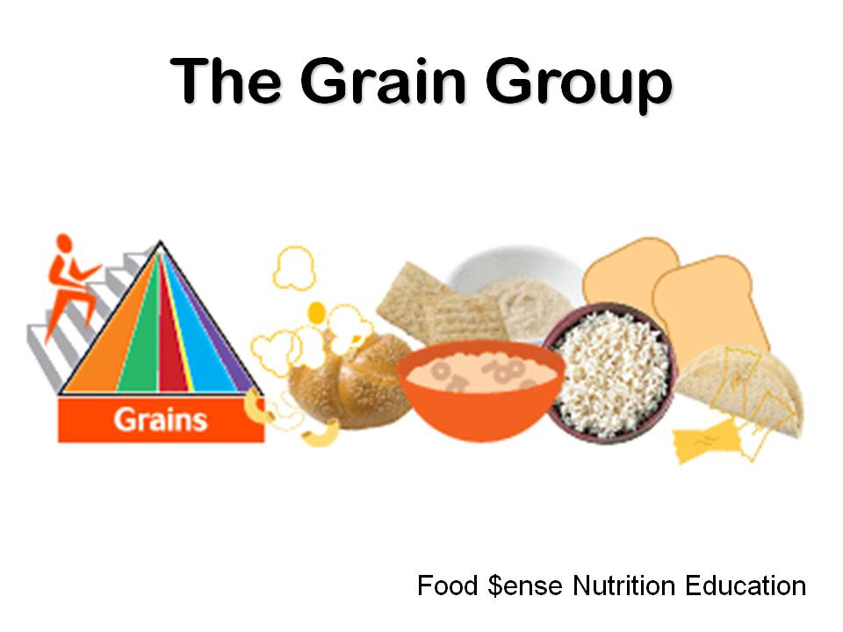

The grain group is an important part of a healthy diet.

**Slide 2**

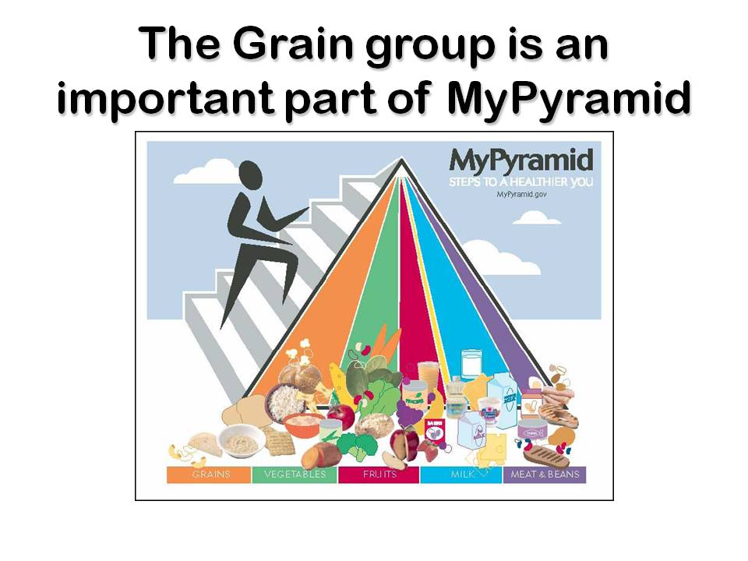

It is also part of the food guide pyramid.

* Where is the grain group in the pyramid?
* It is the orange column.

**Slide 3**

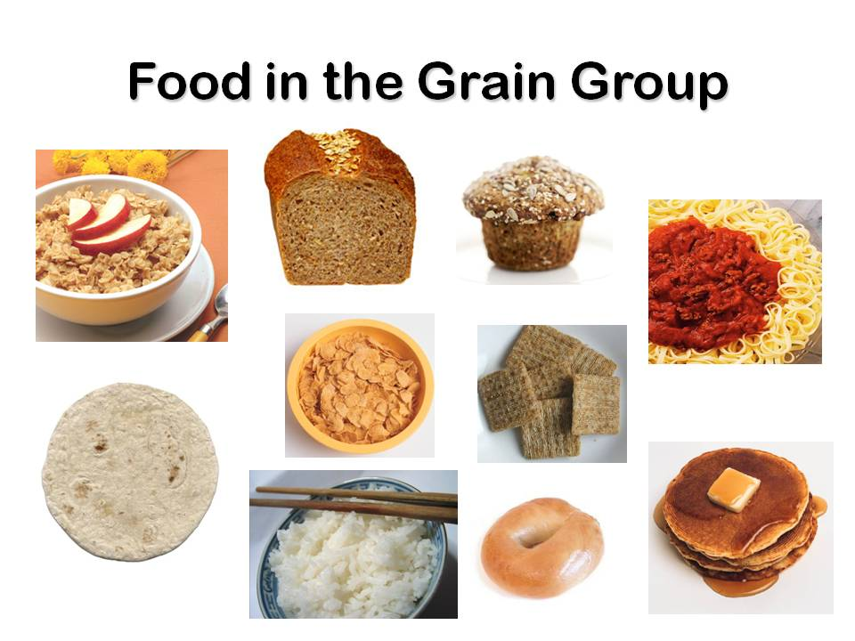

There are many foods to choose from in the grain group. The grain group includes bread, cereal, rice, pasta, tortillas, crackers, and pancakes.

* What food from the grain group do you like to eat? (Prompt as needed)

**Slide 4**

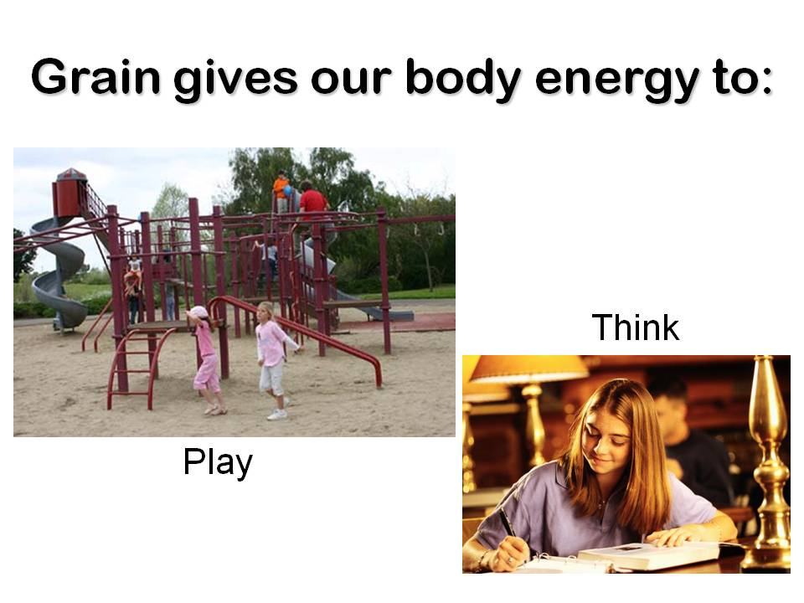

Grain is good for your body. Grain helps your brain think at school or at work. It also helps your body have energy to work, play, and exercise.

* What do you like to do when you play?

**Slide 5**

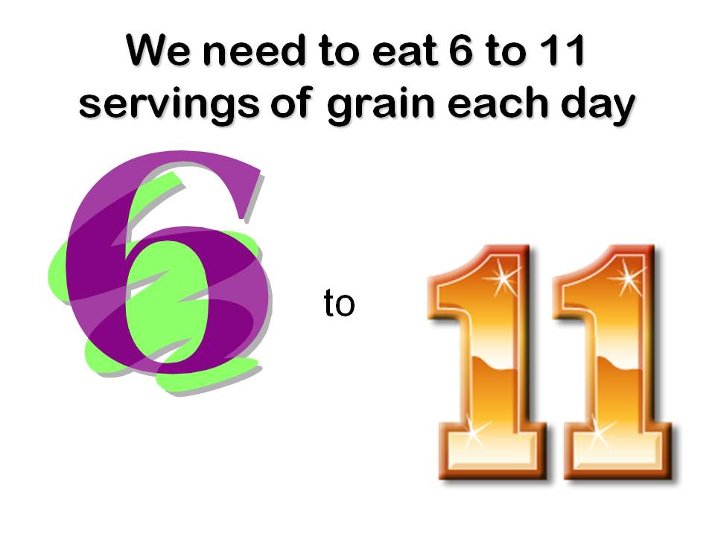

We need to eat 6-11 servings of grain each day. This will give us energy to work and to play.

* How many servings do we need each day?

**Slide 6**

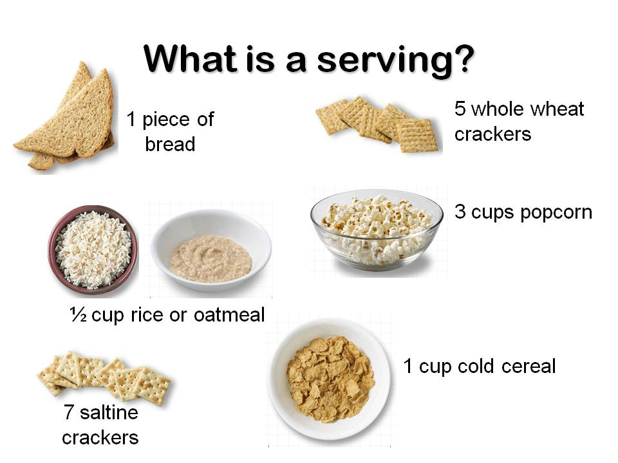

* What is a serving?
* A serving size is 1 piece of bread, ½ cup oatmeal, ½ cup rice, 1 cup cold cereal, or 5-7 crackers.
* If you eat a sandwich for lunch with two slices of bread, how many servings are you eating?
* 2 servings
* If you eat 1 cup of cold cereal, how many servings is that?
* 1 serving

**Slide 7**

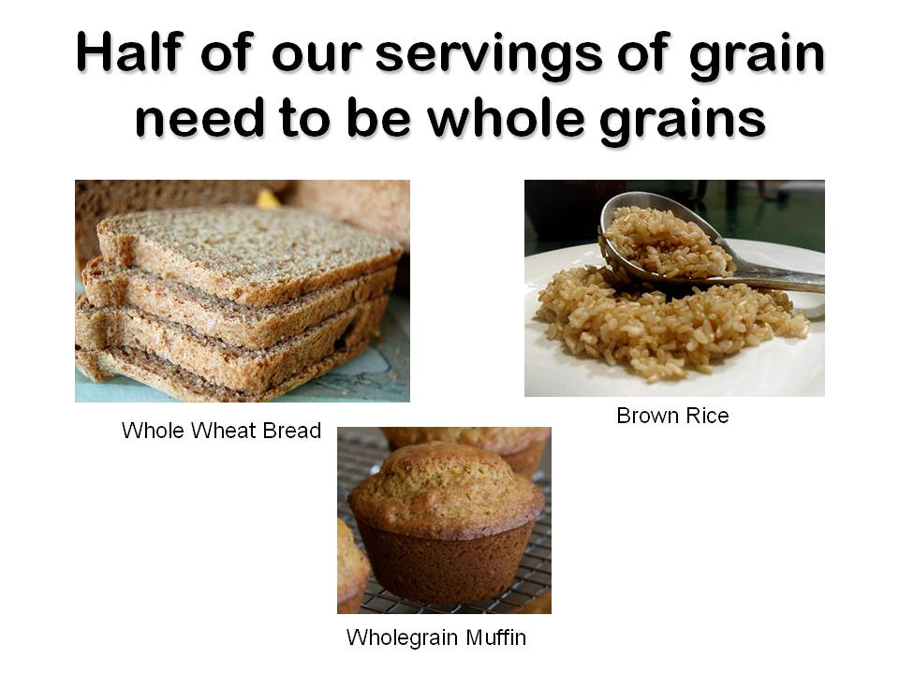

Half of our servings of grain need to be whole grains.

Whole grain has fiber which helps move the food we eat through our body to stop constipation.

Try whole grain cereals, crackers, rice or pasta. Choose whole wheat bread instead of white bread.

Eat a whole grain muffin instead of a doughnut.

* What whole grain food can you eat to stop constipation (help you go to the bathroom easier)?

**Slide 8**

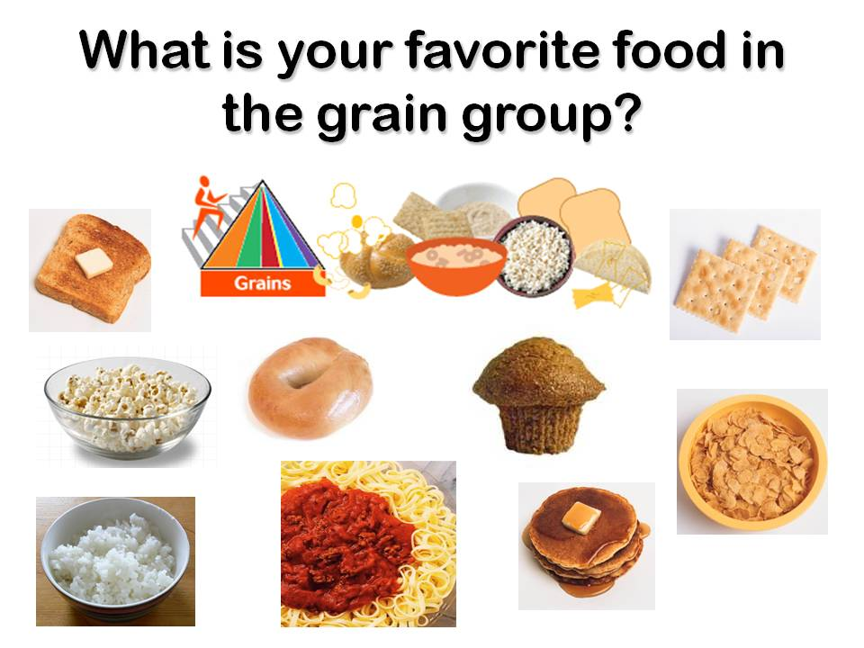

* What is your favorite food in the grain group?

**Slide 9**

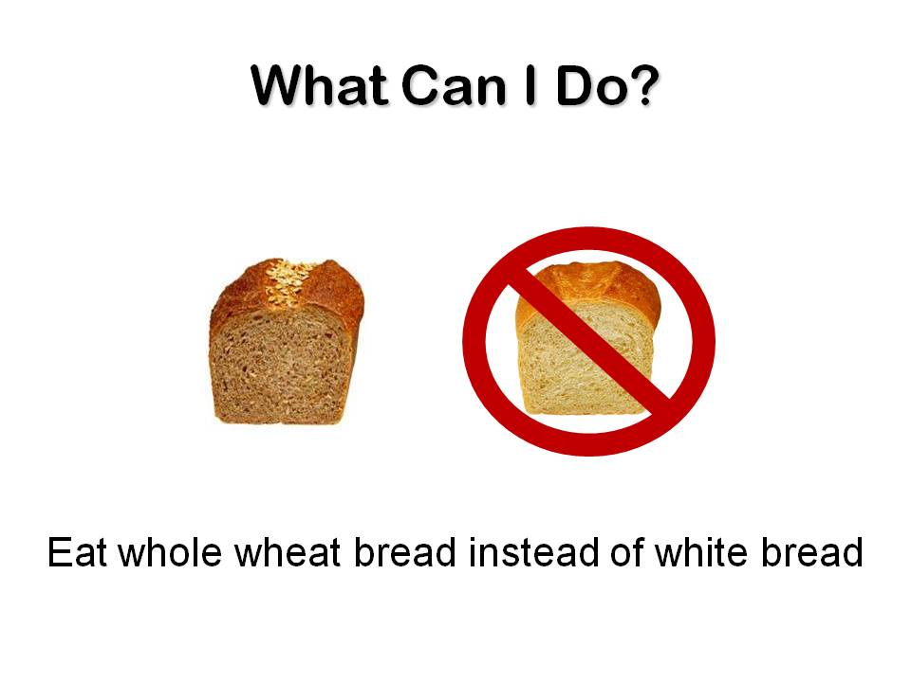

* What change can you make because of what you learned today?

Choose to eat whole wheat bread instead of white bread.

**Grain Group Activity**

Draw or color your favorite foods from the Grain Group.

MCFD01037_0000[1]

