C:\Documents and Settings\labuser\Local Settings\Temporary Internet Files\Content.IE5\QZPIF47N\MCj02326890000[1].wmf C:\Documents and Settings\YETC\Local Settings\Temporary Internet Files\Content.IE5\IIF0LT4E\MCFD00921_0000[1].wmf C:\Documents and Settings\YETC\Local Settings\Temporary Internet Files\Content.IE5\SZ57ZFCK\MCj03254680000[1].wmf http://www.artclips.com/clipart/free/clipart/SodaCan.gifC:\Documents and Settings\YETC\Local Settings\Temporary Internet Files\Content.IE5\TNTE921K\MCFD00028_0000[1].wmf C:\Documents and Settings\labuser\Local Settings\Temporary Internet Files\Content.IE5\K8D3SWSB\MCj00893540000[1].wmf C:\Documents and Settings\YETC\Local Settings\Temporary Internet Files\Content.IE5\SZ57ZFCK\MCj02153580000[1].wmf C:\Documents and Settings\labuser\Local Settings\Temporary Internet Files\Content.IE5\CGM9FCOX\MCj04125100000[1].wmf C:\Documents and Settings\YETC\Local Settings\Temporary Internet Files\Content.IE5\IIF0LT4E\MCj02322610000[1].wmf C:\Documents and Settings\YETC\Local Settings\Temporary Internet Files\Content.IE5\TNTE921K\MCj03470590000[1].wmf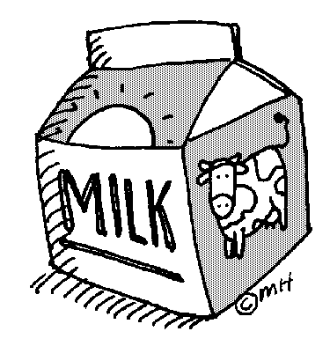web graphic cookies

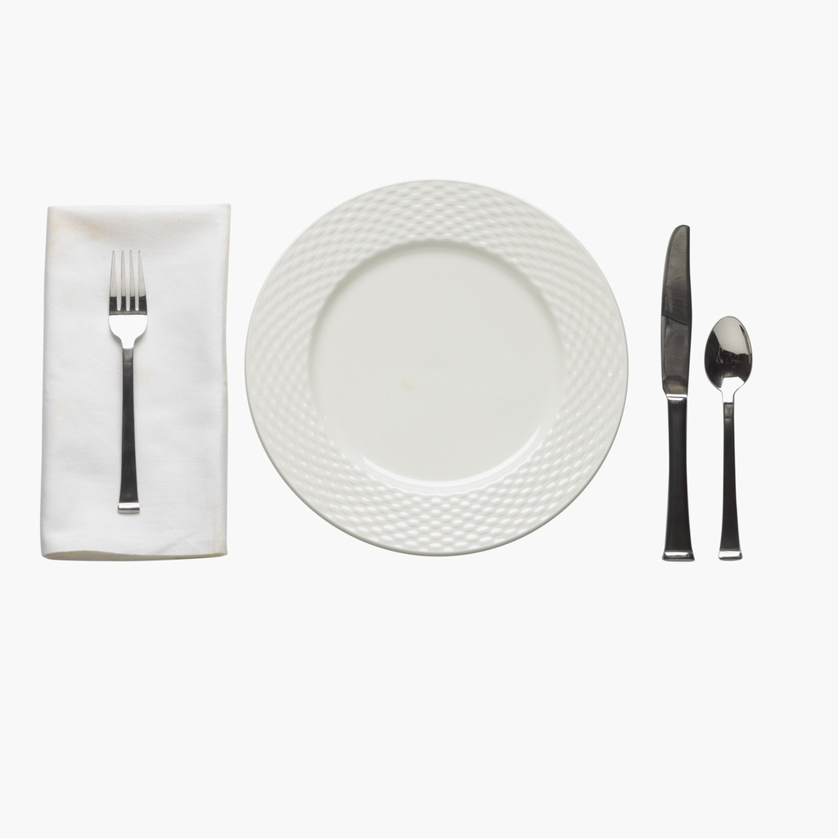

Cut out the breakfast foods and practice choosing healthy breakfast foods to put on your plate.