Daily Lesson Plan

Instructor:
Lesson Title: | SaferFarm.org Supervised Agricultural Experience (SAE) safety
Estimated Time: | 30 minutes
Objective(s) of Lesson: What you want your students to KNOW and/or be able to DO
- Explain the importance of agricultural safety
- Explain how to use the SaferFarm.org website to identify potential safety hazards
- Describe strategies used in SaferFarm.org to correct safety hazards
Materials, Supplies, Equipment, References, and Other Resources:
- SaferFarm.org PowerPoint presentation
- note cards
- pencils
- student worksheet
- picture of safety hazard and safe sites
- possible tour at a local farm/business that practices safety pending access and availability
Situation:
Students with production or entrepreneurial based SAEs or community members, parents of students with production based SAEs that could have potential safety hazards.

Interest Approach (Motivation):
- Have students look at a mix of pictures of agricultural hazards and safe worksites. Have students separate and identify the hazards.
- Have students write down at least 3 agricultural hazards on a note card that they have seen in a workplace, at home, or on a farm. Have students share hazards that they have seen to the rest of the class.
Communicate Objectives, Define Problem or Decision to be Made, or Identify Questions to Investigate:
Today we will be learning more about how to identify safety hazards and correct them with in SAE projects using the SaferFarm.org resources website.

Instructor Directions / Materials  HOW you will teach | Content Outline, Instructional Procedures, and/or Key Questions  WHAT you will teach
What is SaferFarm.org?
- An online tool that makes agricultural health and safety knowledge accessible and easy to use.
- Provides information about hazards, evaluating hazards and correcting hazards.
What tools can be used for your SAE project?
- Analysis tool that points out possible improvements
- Grading system to itemize structures in a priority list

Parents
- Help prepare students fill out the SaferFarm.org worksheet
- Encourage students to address potential hazards and provide help when needed
- Make yourself aware of potential risks and safety measures
- Keep record of hazards found and how they were addressed for reference. Be sure to keep records of all hazard inspections and corrective actions to reduce injury risks

Transition the lesson into talking about how we can assess the risks students may encounter in their SAE project and how to use the SaferFarm.org website to inspect them. | Agriculture Teacher  - Make SaferFarm.org inspections apart of SAE requirements for production-based or entrepreneurial SAE  - Educate students about what agricultural hazards and why the importance of corrective actions to reduce injury risks.  - Provide feedback to the parents, and students about the injury risks they may be facing in their SAE projects or worksites.
Student
- Identify potential hazards within worksite or SAE projects
- Use the SaferFarm.org website and tools
- Provide ideas and solutions to provide corrective actions to reduce injury risks presented by hazards

Discuss how students can identify potential risks and correct them while working on SAE projects using the SaferFarm.org resources.
How can we assess the risks that students may encounter?
- Using the SaferFarm.org multi-step process to inspect potential safety hazards of work sites.
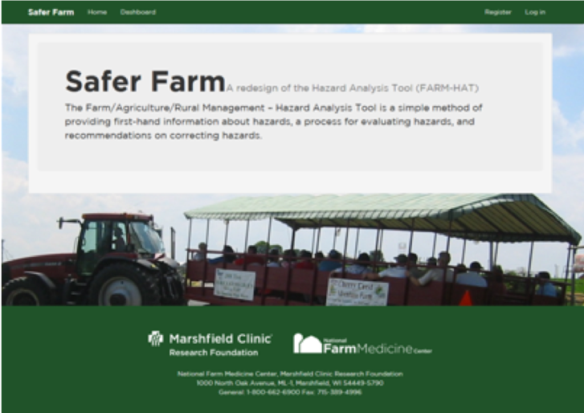 | Step 1: register/login to the SaferFarm.org website  - Create username and password  - Only you will have access to this information to login
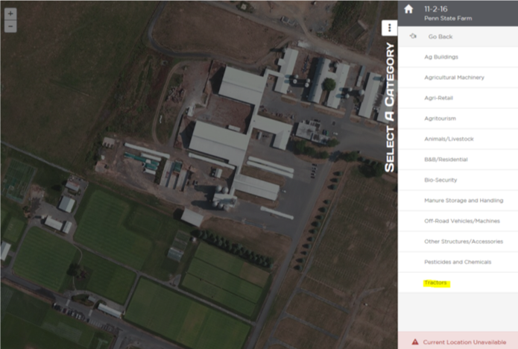 | Step 2: categories and items  - Add any Ag buildings, retail, animals/livestock, residential builds, bio security, manure storage and handing, vehicles/machines, pesticides/chemicals, tractors and other structures or accessories.
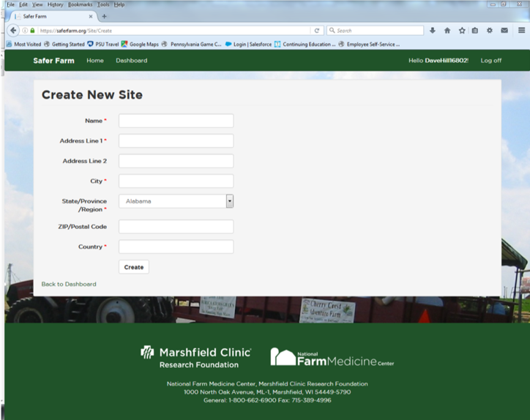 | Step 3: Site info-new inspection  - Create new inspection for site  - Multiple inspections can be created
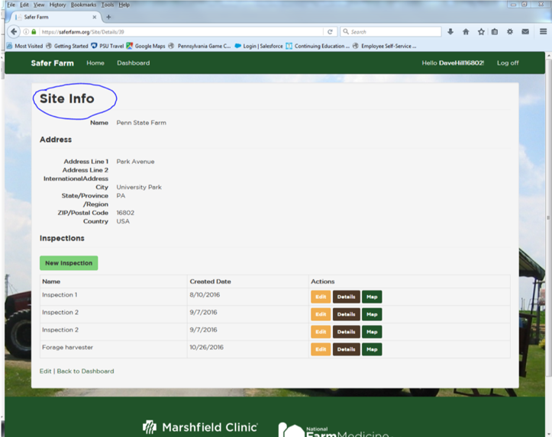 | Step 3: begin new inspection  - Pick a category or item to perform the inspection on  - Read over details and suggestions for the site
 | Step 4: Correct hazards identified in the inspection
 | Conclude with a summary of the hazards that had been discussed and the importance of everyone’s involvement in promoting and providing safe workplaces for farmers and workers.

Student worksheet: SaferFarm.org 30 points possible:

Name: _______________ SAE project name: ___________________ Date: ______________

*Parents- Please attend your student on their site walk and create a list of hazards you see to compare to your students list. **oversee all hazards that are being corrected by students as a safety precaution**

1) Site Walk (6 points)-Walk around SAE project site and try to identify any possible hazards yourself before using the SaferFarm.org program.

- List potential agricultural hazards that you identified and why you consider them to be a hazard (2 points). (must provide one example at minimum)
- Provide list that your parents or another adult have identified and compare your two results, share items that you missed or added. (2 points)
- How would you implement corrective actions to reduce the injury risks of the hazards that you listed above? (2 points) ?

2) Using SaferFarm.org website (4 points)- log into SaferFarm.org and fill this portion out while going through the set-up steps.
- Categorize and items (2 points) : List all Ag buildings, retail, animals, residential buildings, bio security, manure storage, vehicles/machines, pesticides/chemicals, tractors, and other structures that are in/near your SAE project site. (must at least add one item but to perform the evaluation correctly you should have multiple items)
- Provide a reason why you selected each item or may have left an item out (2 points).

3) site info/new inspection- Create new inspection for your SAE site then fill out information below. (5 points)
- List the address of you site.(2 points)
- Pick one category/ item to perform an inspection on. (3 points)
  - What category/item did you choose and why?
  - What inspection did you preform?
c) Take a picture of the hazards identified (this will be submitted as part of your grade)

4) inspection Results (5 points)
- What are the results of your inspection? (2 points)
- How will you correct the hazards found? (3 points)
- Take a picture after you correct the hazard (this will be submitted as part of your grade)

5) Site Photos (10 points, 5 per photo)
Please attach the before and after photos of your site here.

Grading rubric
Criteria | Ratings for full marks | Points
Site walk | Students provided at least one identified hazard which includes an adequate explanation of why it is considered a hazard. A parent/adult list of hazards are given and compared. Realistic ways to correct hazards identified are provided with an explanation. | 6 points possible
Using SaferFarm.org website | Students provided at least one item/site to evaluate and perform an inspection on. An adequate explanation is given to explain why each item/site was chosen. | 4 points possible
Site information/ site inspection | Address provided by students is the correct location of their SAE project. Students justify why they picked the specific item/site to perform the inspection on. The inspection performed is listed and is the correct inspection to use on the item/site provided. | 5 points possible
Inspection results | Student fully explains the results of the inspection, and how the student will correct the hazards identified by the inspection. | 5 points possible
Site photos | Photos are clear and of good quality. There are two photos provided of the hazard before its fix and after the hazard is corrected. An obvious correction has been make to the hazard shown in the picture. | 10 points possible

