Learning Activity: How to build a gas senor circuit
Participant instructions:
Step 1: Check to make sure you have all your supplies

- One Arduino UNO R3
- One MQ-135 gas sensor
- One 0.96” OLED display
- Eight colored jumper wires (red, orange, yellow, green, blue, white, grey, black)
- One 9V AC/DC power adapter

Step 2: Make the following connections provided in table 1 to build the sensor circuit. You should connect components using colored jumper wires as shown in figure 1. Be sure to note the proper connection in the table. For the components, each connection pin will be labeled. Note: Arduino connection female sockets will only receive the male end of the wire.

Table 1. Connection pins and sockets with wire colors.

OLED Display Connection Pin Label  (use female connector on wire) |  | Arduino Connection Socket Label  (use male connector on wire) | Wire Color
VCC | to | 3.3V | Orange
GND | to | GND | Grey
SCL | to | SCL | Blue
SDA | to | SDA | Green

MQ-135 Gas Sensor Connection Pin Label  (use female connector on wire) |  | Arduino Connection Socket Label  (use male connector on wire) | Wire Color
VCC | to | 5V | Red
GND | to | GND | Black
AO | to | A2 | Yellow
DO | to | 4 | White

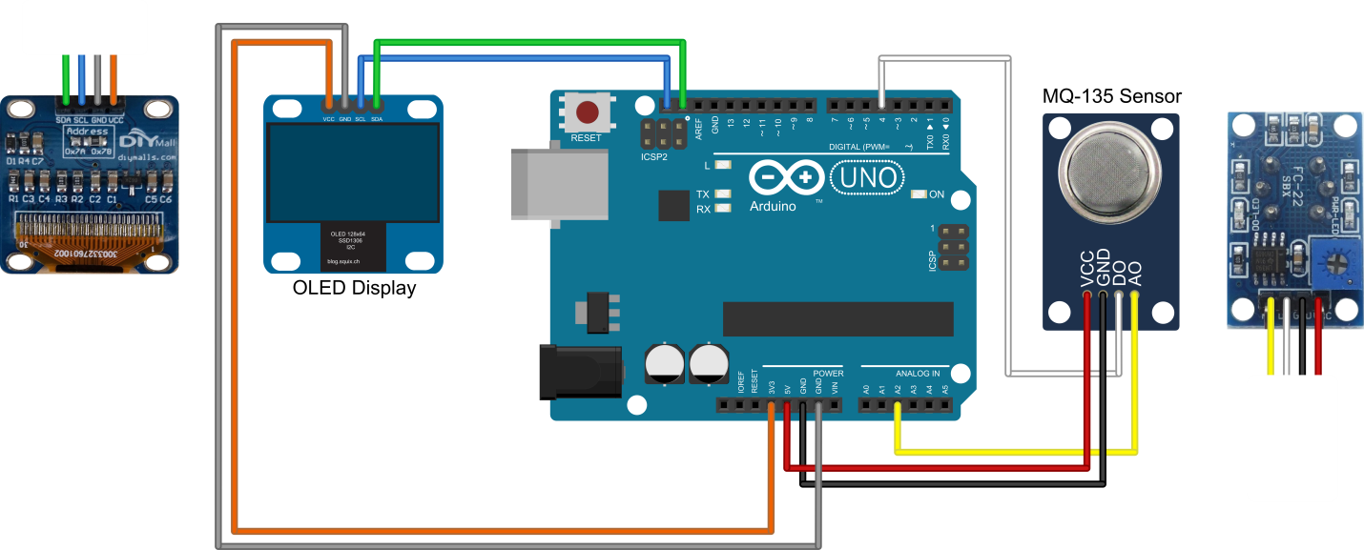
*
**
MQ-135 Sensor
Bottom View
Top view
Top view
OLED Display
Bottom View
Figure 1. Wire connection diagram for connecting OLED display and MQ-135 gas sensor to Arduino.
This image was created with Fritzing (http://fritzing.org)
* For clarity of wire connections, bottom view shown of the OLED display
** For clarity of wire connections, bottom view shown of the MQ-135 gas sensor

STOP! Wait until instructed to continue.

Step 3: Ask your instructor to check your wiring connections before plugging in the 9V power source. Pin layout may vary, so check pin labels on your components to make sure wires are connected to the correct pins. Connecting components with reversed polarity (VCC and GND switched) will damage components.
Step 4: Engage in Instructor-led discussion on sensors. Follow directions from your instructor.
Safety notes:
- Static electricity can destroy electronic components, so use care when handling parts. If the air is very dry and it is easy to create static, such as during winter, have students’ “ground” themselves periodically by touching something metallic to discharge any static buildup. Suggestions might be a metal desk or chair leg, toolbox, or filing cabinet – anything nearby that is safe to touch.
- When powered on, the voltage regulator on the Arduino board may get hot (the area circled in red in Figure 2 on both the top and bottom of the circuit board). This is normal and is due to the voltage regulator dissipating power as heat while reducing the 9VDC input to 5VDC used by the Arduino and the MQ-135 sensor. It should not get hot enough to cause injury (i.e. a person should be able to hold their finger to the area without causing burns, but it will feel very warm to the touch).
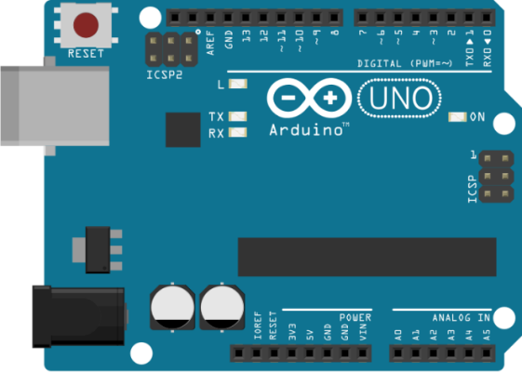
This area gets hot
Figure 2. Voltage regulator location on Arduino board.
This image was created with Fritzing (http://fritzing.org)

- The reset button location on the Arduino board is shown in Figure 3.
Reset button

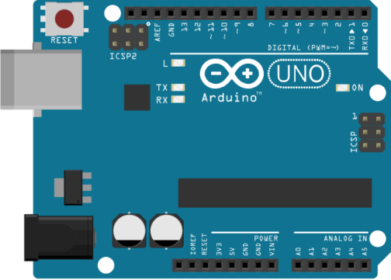

Figure 3. Reset button location on Arduino board.
This image was created with Fritzing (http://fritzing.org)

